Player Name: | Career Highlights:
Rosato, Luca  C’25 | One of the steadiest defensemen in the history of the team, Luca logged huge minutes over his three + seasons of play and had the role to contain the top lines of opposing teams. His stay at home style forced players wide to bad angles and as such he was seldom out of position. In addition to his defensive reads he was an underrated puck mover with the ability to rush the puck into the attacking zone when needed.  His 34 points tied him with 2005 grad Jason Ruehl for 13’th place just behind Tyler Brinton for points by a blue liner. He currently holds 7’th place in +/- for defenseman.  Even though Luca was a defense first player, he was still able to record 5 multiple point games and consistently contributed to the offense. First point was an assist against IUP on a Zach Motil goal in an exciting 6-5 SVC win. He came up huge with a game winning power play goal and an assist in a critical win over Penn West Cal in his junior year and netted a point against the #1 ranked Lawrence Tech again setting up Zach Motil for SVC’s only goal against the #1 ranked team in the ACHA D3 Nation tournament in 23-24. He did not play his freshman year but was critical in the back-to-back CHE championship seasons of 23-24 and 24-25. He suited for a handful of games when in gad school and although he did not play the second semester of that season is still counted in the threepeat story of SVC.

Yr | # | Pos | GP | G | A | TP | S | Pct | + | - | +/- | PM | W | T | P | S
2223 | 53 | D | 22 | 1 | 13 | 14 | 50 | 2.0 | 42 | 27 | +15 | 56 | 0 | 0 | 0 | 0
2324 | 53 | D | 23 | 1 | 9 | 10 | 38 | 2.6 | 39 | 19 | +20 | 45 | 1 | 0 | 1 | 0
2425 | 53 | D | 30 | 1 | 9 | 10 | 27 | 3.7 | 35 | 21 | +14 | 52 | 0 | 0 | 1 | 0
2526 | 53 | D | 4 | 0 | 0 | 0 | 1 | 0.0 | 1 | 4 | -3 | 0 | 0 | 0 | 0 | 0
Totals |  |  | 79 | 3 | 31 | 34 | 116 | 2.6 | 117 | 71 | +46 | 153 | 1 | 0 | 2 | 0

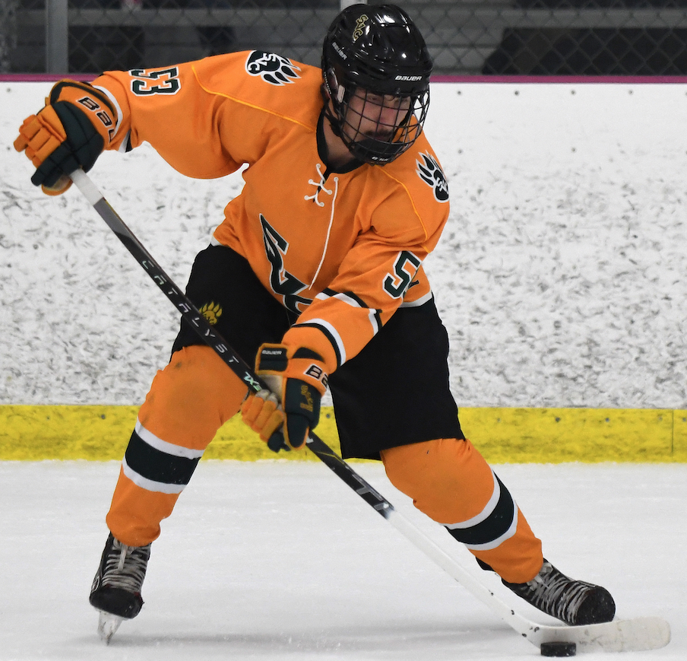
Noted for his hard low shot, Luca created a lot of offense by getting pucks on net.

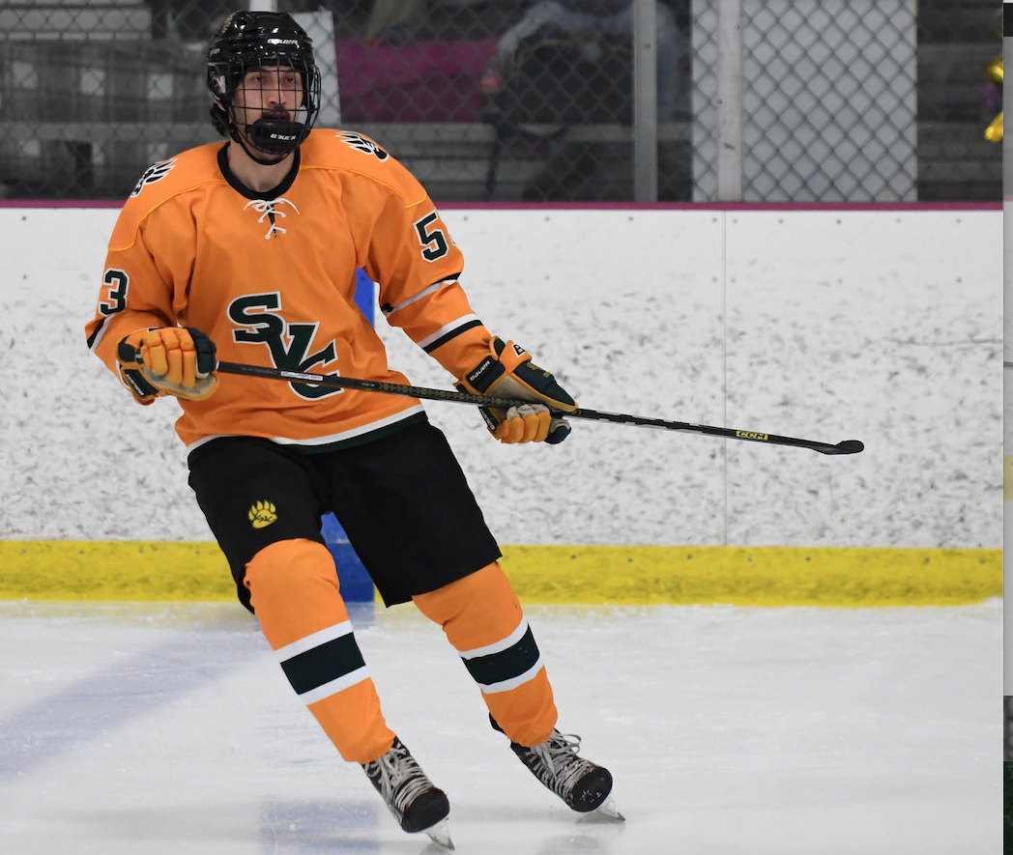
With size, reach and a touch of mean, Luca was a top defender and a critical piece of multiple SVC championships.

