Player Name: | Career Highlights:
Ridilla, Zach  C’26 | Zach had numbers near the top of all players when he graduated. He ranked #5 in goals, assists and total points, #2 in games played, #7 in plus/minus, and #1 in career shorthanded goals (13) and the most in a single season when he netted 8 as a freshman. When he had his motor going he menaced defenders and goalies with his tall frame, stick handling and shot.  The stats tell the story. His first goal was against Kent State and he has had 7 hat tricks, 9 two goal games, 3 or more assists 7 times and a total of 29 multiple point games. His best efforts include a 5 assist game against Case, a 5 goal 1 assist game with Case, a 4 goal 1 helper game with Stevenson, a five point , 2 goal 3 assist match with Duquesne and a 2 goal 2 assist performance over Colby in the National tournament. He had the only goal for SVC against Arkansas, also a shorty and three times stole pucks and converted shorthanded goals into game winners, against twice against IUP and once against Akron.  What matters most was the timeliness of three goals, each one critical in the SVC CHE threepeat. He scored the game winner in the first ever SVC CHE championship playoff game over IUP (3-2), the second goal to lock up the 2-0 win over Penn West Cal in the second championship season, and a patient goal from an almost impossible angle when Saint Vincent beat Kent State in the first round of the 2025-2026 CHE tournament that ended with a thrilling 3-2 OT win against UPJ.

Yr | # | Pos | GP | G | A | TP | S | Pct | + | - | +/- | PM | W | T | P | S
2223 | 19 | C | 26 | 33 | 20 | 53 | 136 | 24.3 | 57 | 39 | +18 | 16 | 8 | 0 | 7 | 8
2324 | 19 | C | 23 | 20 | 20 | 40 | 128 | 15.6 | 38 | 15 | +23 | 27 | 3 | 0 | 0 | 2
2425 | 19 | C | 30 | 13 | 23 | 36 | 127 | 10.2 | 44 | 24 | +20 | 16 | 2 | 1 | 2 | 3
2526 | 19 | C | 27 | 5 | 23 | 28 | 86 | 5.8 | 27 | 13 | +14 | 8 | 2 | 0 | 0 | 0
Totals |  |  | 106 | 71 | 86 | 157 | 477 | 14.9 | 166 | 91 | +75 | 67 | 15 | 1 | 9 | 13

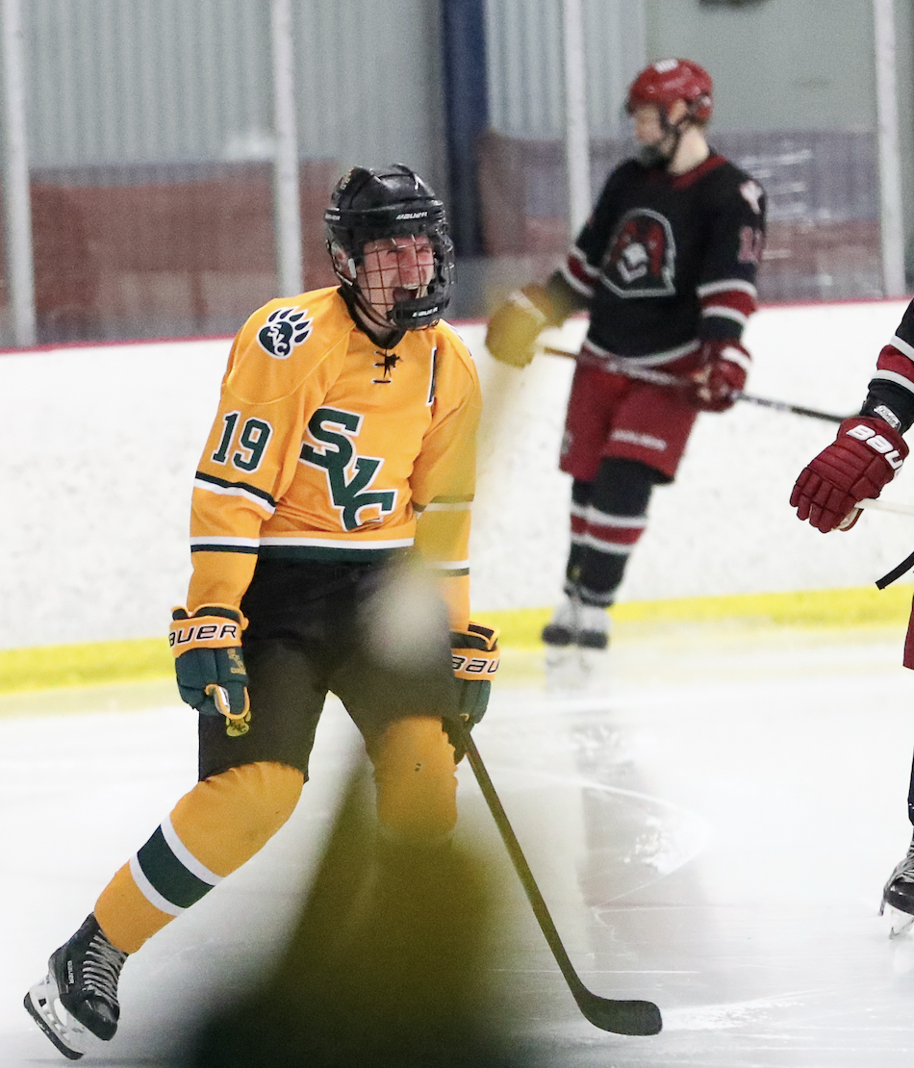

THE BIG ONE!

Zach celebrates his eventual game winning goal in the CHE Championship game against IUP in 2023-2024. It was the first Saint Vincent playoff final win! The dejected look of the IUP player in the background says it all.

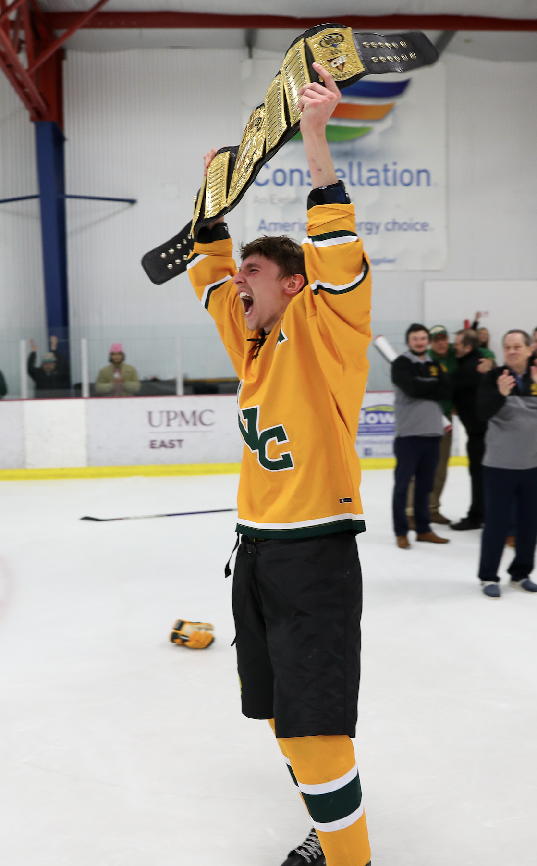

The skate that followed the goal. Zach lifts the belt declaring SVC the 2023-2024 College Hockey East Champions.
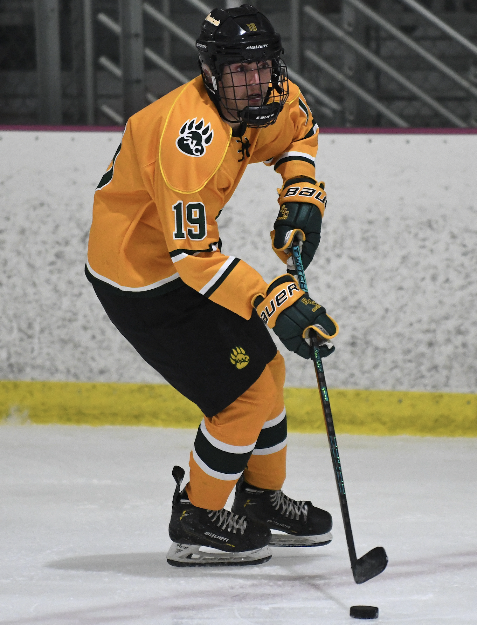
Classic Ridilla. Head up. Puck in position. Ready to move. When he was in gear it was over.
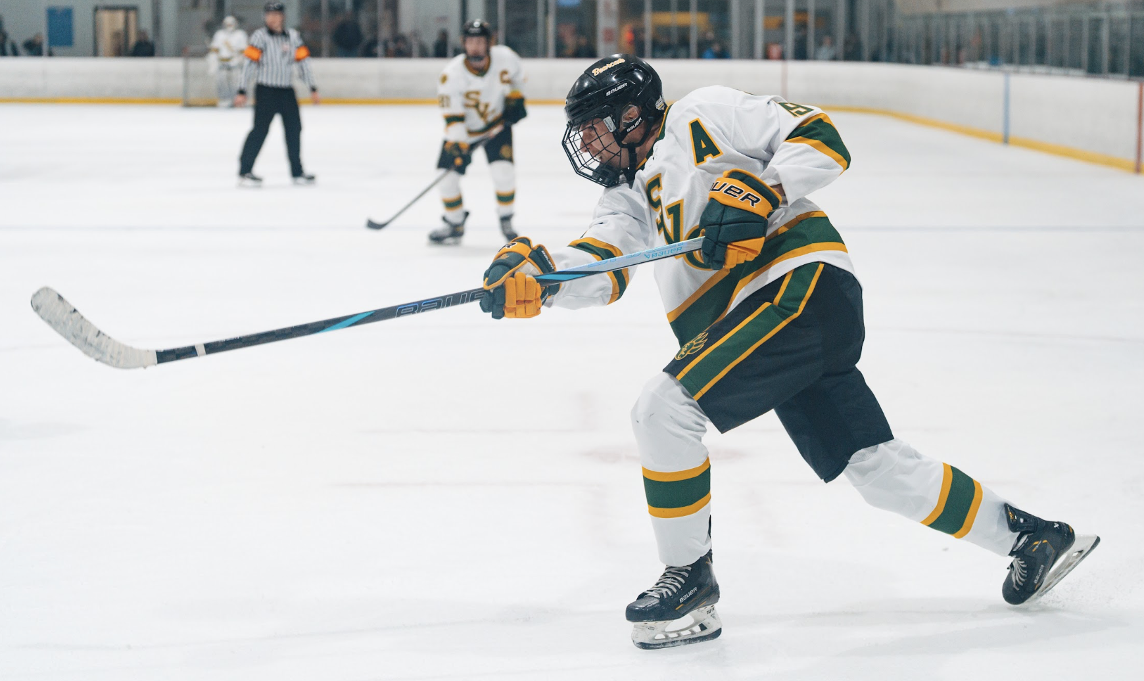

When he broke from a defender and had time and space, Zach had a laser like shot. He frequently set up on the off wing on the powerplay as shown in this picture.

