Player Name: | Career Highlights:
Ridilla, Mike  C’ 26 | “Big Mike” was a core member of one of the greatest runs in SVC hockey history playing in four consecutive CHE finals and winning back to back to back titles. He skated in three ACHA DIII National tournaments in Saint Louis. He has the all-time team record of being the only regular player to have zero penalty minutes in his four years! Mike’s 1’st point was an assist in a game against Penn West Cal with his first goal coming in a game with Robert Morris. He has two game winners in identical 4-2 SVC wins over Case and Cal. Mike collected 4 multi point games including a hat trick in an away contest at Robert Morris. He has had four point streaks of two games or more including a 6-game streak. The teams Mike played on had an incredible record of 75-29-3 for a .715 points percentage!

Yr | # | Pos | GP | G | A | TP | S | Pct | + | - | +/- | PM | W | T | P | S
2223 | 14 | Lw | 26 | 6 | 9 | 15 | 47 | 12.8 | 25 | 25 | E | 0 | 0 | 0 | 0 | 0
2324 | 14 | Lw | 23 | 3 | 1 | 4 | 22 | 13.6 | 5 | 12 | -7 | 0 | 1 | 0 | 0 | 0
2425 | 14 | Lw | 30 | 2 | 3 | 5 | 21 | 9.5 | 7 | 7 | E | 0 | 1 | 0 | 0 | 0
2526 | 14 | Lw | 20 | 2 | 6 | 8 | 10 | 20.0 | 9 | 2 | +7 | 0 | 0 | 0 | 0 | 0
Totals |  |  | 99 | 13 | 19 | 32 | 100 | 13.0 | 46 | 46 | E | 0 | 2 | 0 | 0 | 0

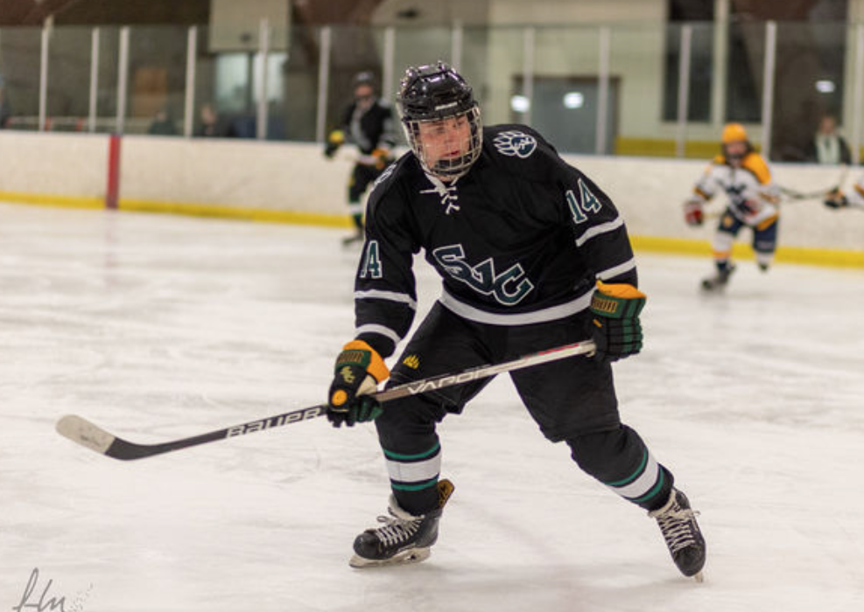
99 Games played, zero penalty minutes, three consecutive CHE Titles and three consecutive trips to the ACHA DIII National tournament. #14, Mike Ridilla in action against WVU.

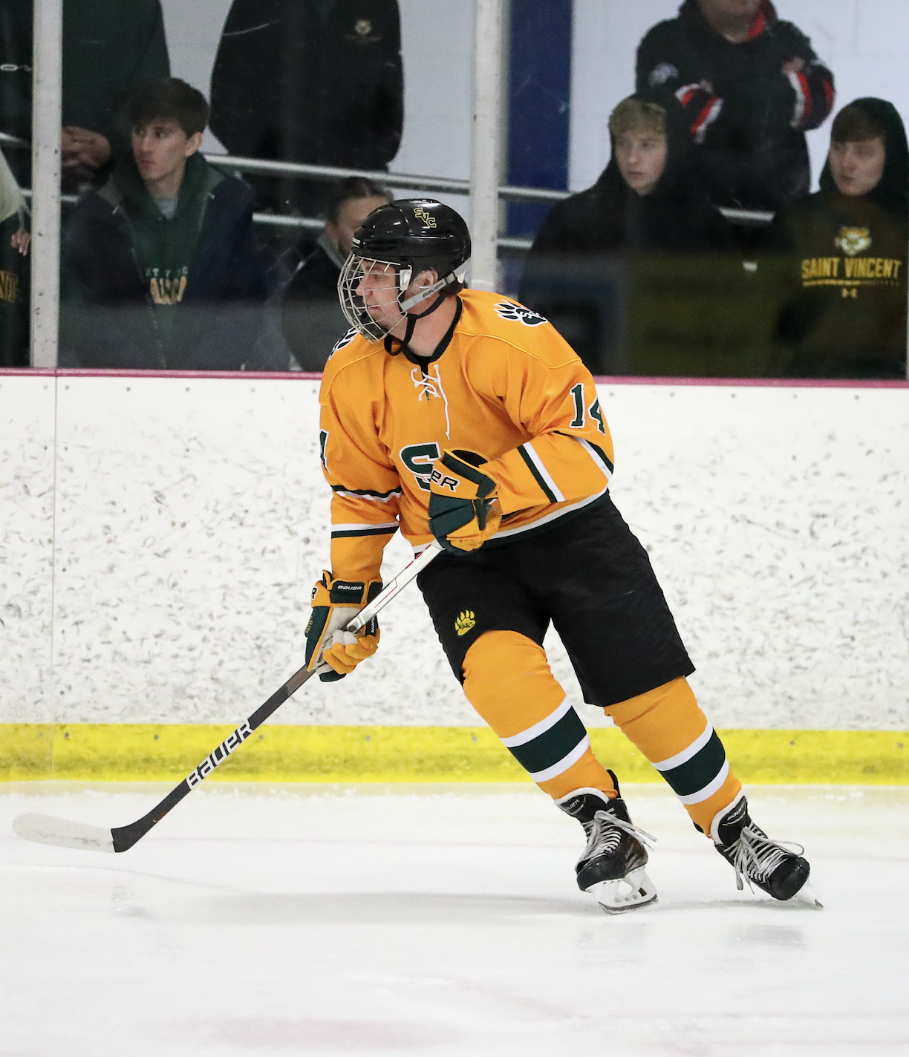
Mike celebrates with the CHE Championship belt in the first ever SVC playoff title game win after a 3-2 decision over long time rival IUP.
Once is never enough. Big Mike in the 2024-2025 championship game against Penn West California. Saint Vincent would take the win 2-0 over the Vulcans.
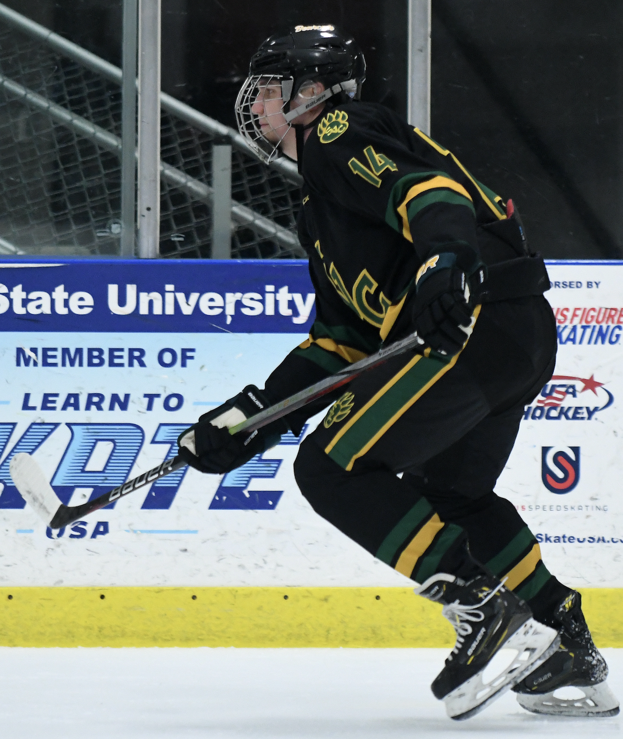
Another day at the office. Mike in an away game against Kent State University. SVC tortured Kent State with two playoff wins 4-2 in 2022-2023, when the Golden Eagles were the favorites and 2-1 in 2025-2026 when it was the Polar Bearcat’s turn to be the favorite.

