Player Name: | Career Highlights:
Porco, Giovanni  C 29 | Good hands, a heavy wrist shot and size defined Giovanni’s game. He recorded his first point, an assist in his very first game as a freshman in a 7-1 win over WVU. He had two goals in an away game when SVC beat Akron and notched the game winner over West Virginia. He was a member of the team that won the second of back-to-back CHE championships.

Yr | # | Pos | GP | G | A | TP | S | Pct | + | - | +/- | PM | W | T | P | S
2425 | 17 | Rw | 25 | 3 | 1 | 4 | 18 | 16.7 | 6 | 3 | +3 | 0 | 1 | 0 | 0 | 0
Totals |  |  | 25 | 3 | 1 | 4 | 18 | 16.7 | 6 | 3 | +3 | 0 | 1 | 0 | 0 | 0

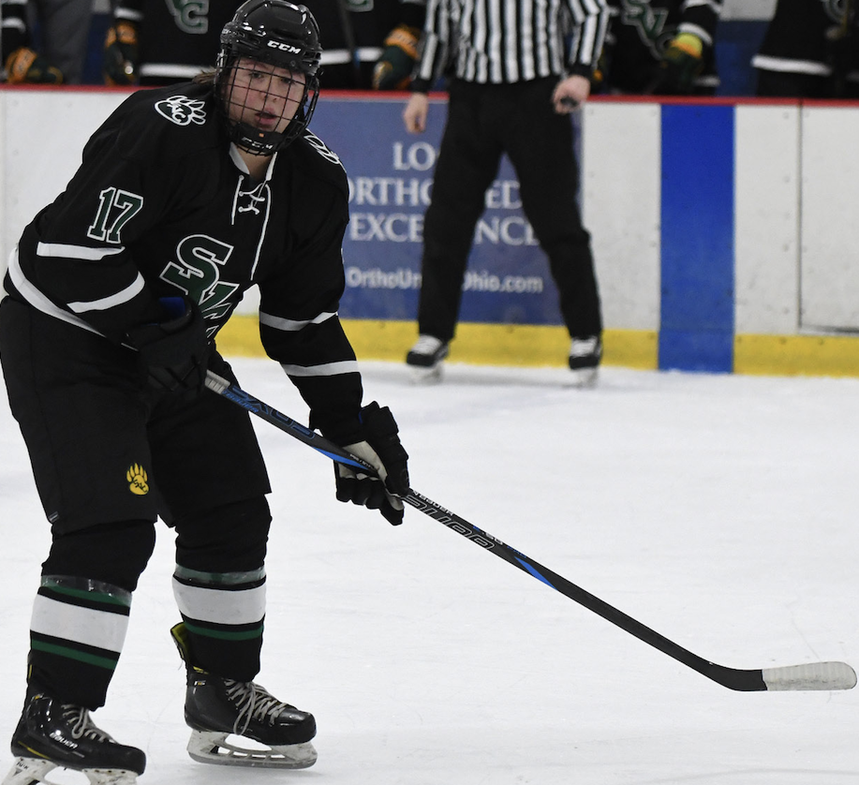
Giovanni in action against the Akron Zips. His two goals in the game propelled Saint Vincent to a 10-2 road victory.

