Player Name: | Career Highlights:
Marino Rocco  C 27 | Rocco played so much better than his stats. He had great size and reach, was a beast in the corners and that matched with his hustle made him an excellent penalty killer. He has his name on two championship banners during the back-to-back CHE titles in each year he played. He was also captain of the SVC volleyball team His assist came in a home win over Case Western.

Yr | # | Pos | GP | G | A | TP | S | Pct | + | - | +/- | PM | W | T | P | S
2324 | 32 | C | 9 | 0 | 0 | 0 | 9 | 0.0 | 1 | 4 | -3 | 2 | 0 | 0 | 0 | 0
2425 | 32 | C | 8 | 0 | 1 | 1 | 3 | 0.0 | 2 | 1 | +1 | 4 | 0 | 0 | 0 | 0
Totals |  |  | 17 | 0 | 1 | 1 | 12 | 0.0 | 3 | 5 | -2 | 6 | 0 | 0 | 0 | 0

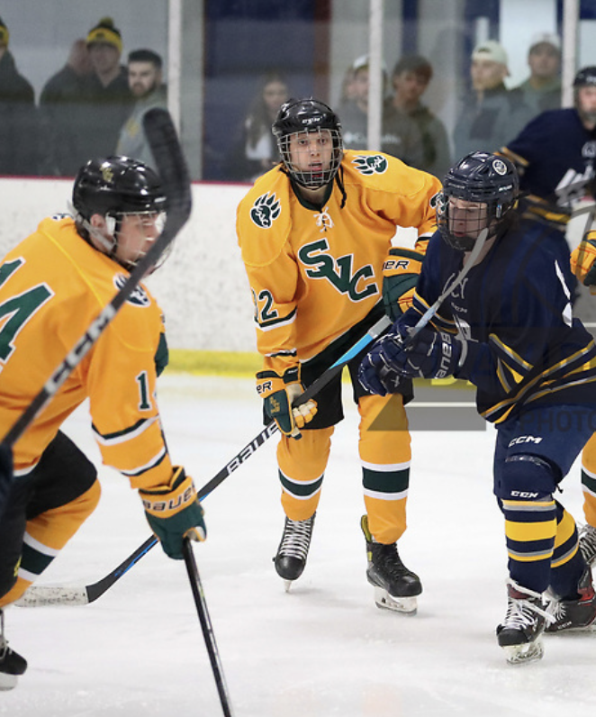
Rocco (center) was a responsible defensive forward who took pride in cleaning up his own end. Game action against UPJ in the 24-25 CHE playoffs. It was the second of back-to-back CHE championships for SVC. #14 Mike Ridilla is also in the frame.

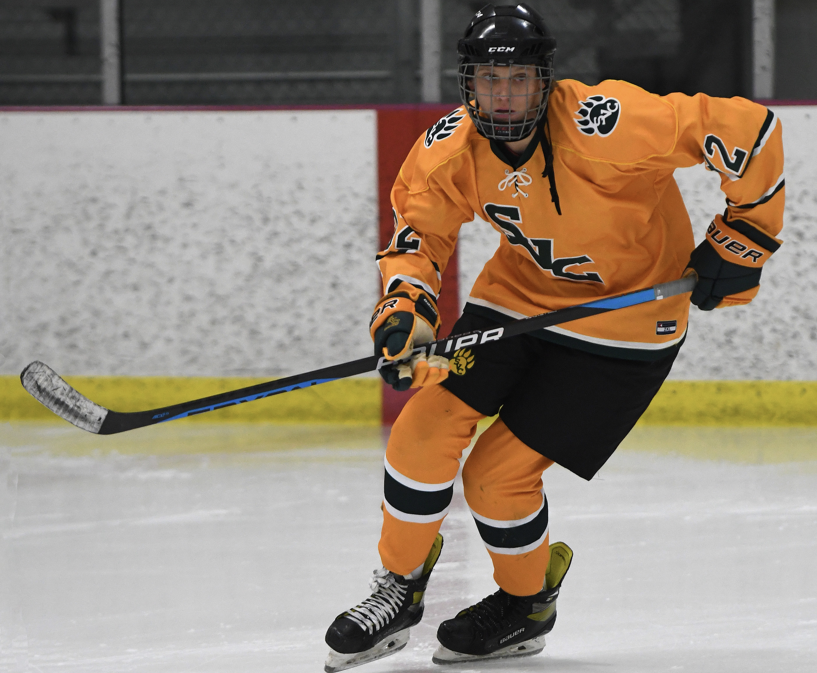
Rocco was an imposing sight on the ice. A hunter looking for his prey!

