Player Name: | Career Highlights:
Holtzman, Jacob  C’25 | If championships define success for a Captain, “Holtzy” would rank as a best-in-class player. His game was defined by power, hitting, strength and ferocity. Statistics aside, he played all three forward positions, and thundering checks and had a dog on a bine mentality in puck protection and pursuit. He ended his career with four consecutive CHE finals, three straight CHE playoff titles and three in a row ACHA D III National Tournaments. He ended as the all-time leader in games played, never missing in a contest. He is 7’th all time in scoring. His career +97 puts him at #4 on the list. The team had an 88-38-3 for a .694 winning percentage when he played.  His first goal in his first game freshman year was the game winner over IUP. Jacob had 33 multi point games including 5 goals against RMU and a hat trick against Duquesne. One of his best efforts came in the 23-24 National Tournament when he had a power play goal and two assists in a 9-5 SVC over Colby College from Maine. He sealed the ’22-’23 upset over Kent State on their home ice with an empty net goal to advance SVC to the CHE finals.

Yr | # | Pos | GP | G | A | TP | S | Pct | + | - | +/- | PM | W | T | P | S
2122 | 28 | C | 22 | 24 | 17 | 41 | 151 | 15.9 | 45 | 26 | +19 | 28 | 4 | 0 | 3 | 1
2223 | 81 | RW | 26 | 20 | 20 | 40 | 117 | 17.1 | 49 | 22 | +27 | 67 | 1 | 0 | 2 | 1
2324 | 81 | LW | 23 | 7 | 13 | 20 | 62 | 11.3 | 25 | 12 | +13 | 10 | 0 | 0 | 1 | 0
2425 | 81 | LW | 30 | 13 | 16 | 29 | 124 | 10.5 | 43 | 14 | +29 | 28 | 0 | 0 | 1 | 1
2526 | 81 | LW | 28 | 6 | 13 | 19 | 89 | 6.7 | 21 | 12 | +9 | 22 | 2 | 0 | 0 | 0
Totals |  |  | 129 | 70 | 79 | 149 | 543 | 12.9 | 183 | 86 | +97 | 155 | 7 | 0 | 7 | 3

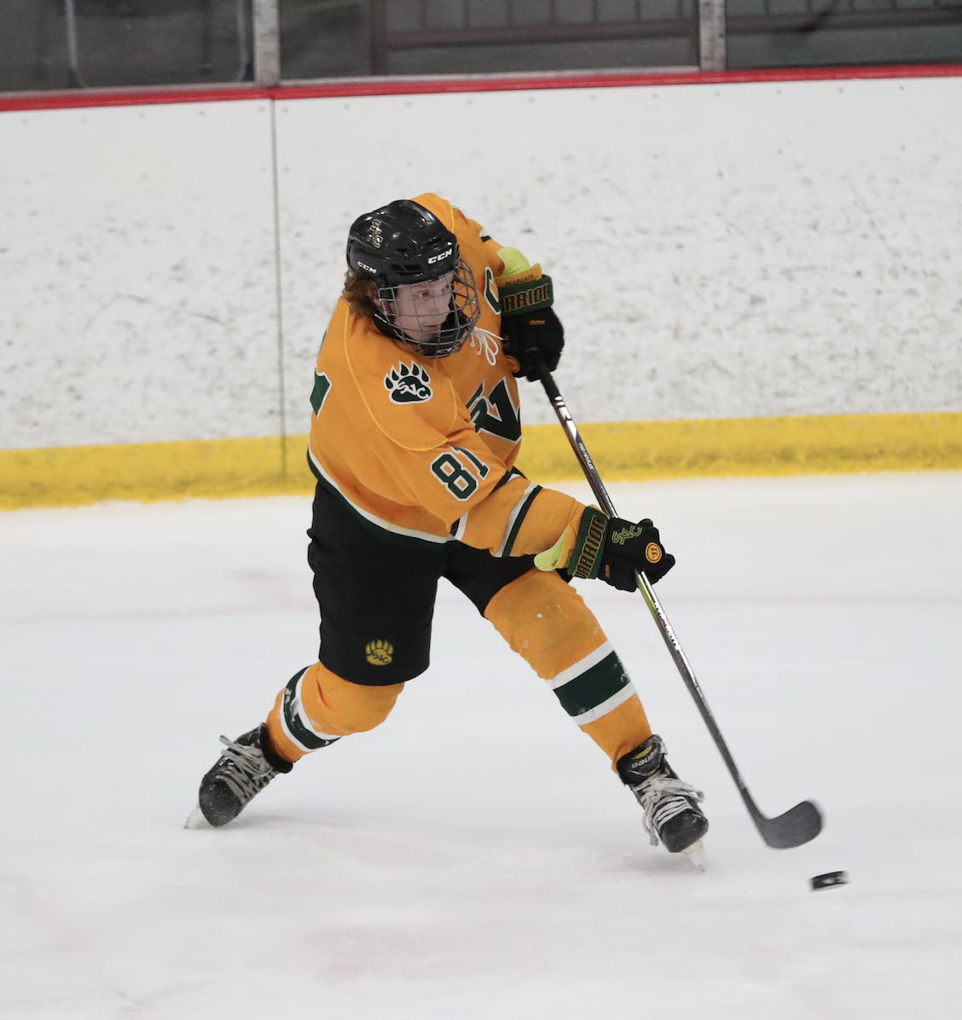
“Holtzy” had a complete game. Not only was he physical, he had blistering slap and wrist shots and frequently blew pucks by opposing goaltenders.

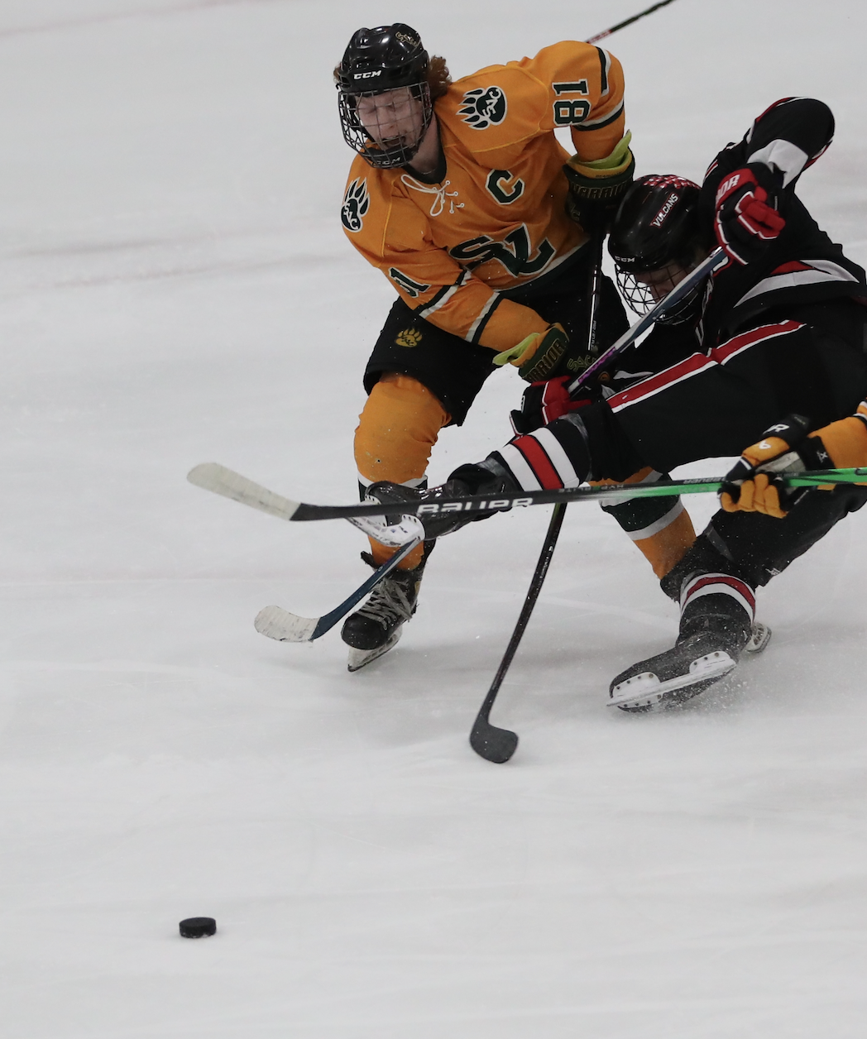
Jacob excelled at the physical part of the game. His ability to win puck battles was legendary. In this still he destroys a Penn West Cal Vulcan in pursuit of the prized disk.

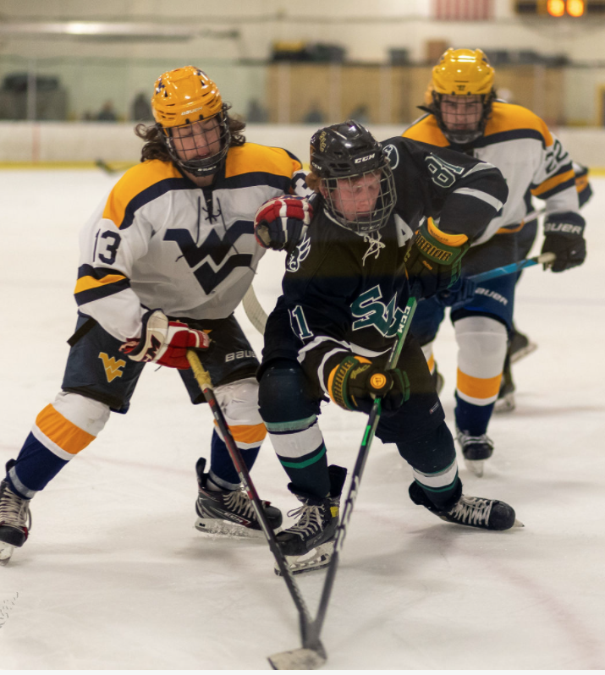
How many Mountaineers does it take to slow #81? Apparently more than two. Plating in traffic was specialty of Holtzman.
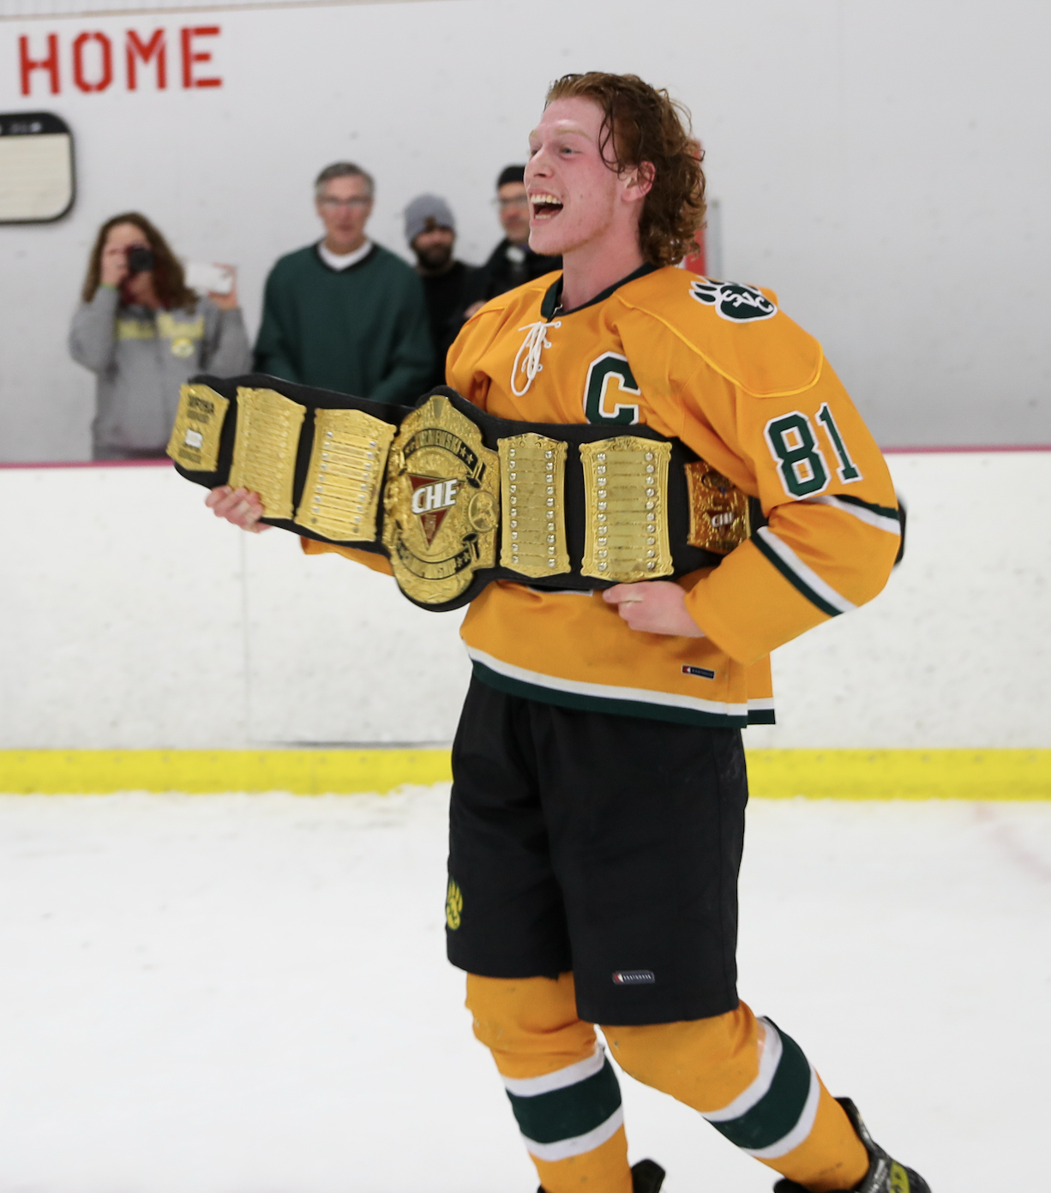
CHE Title #1. SVC 3 IUP 2.
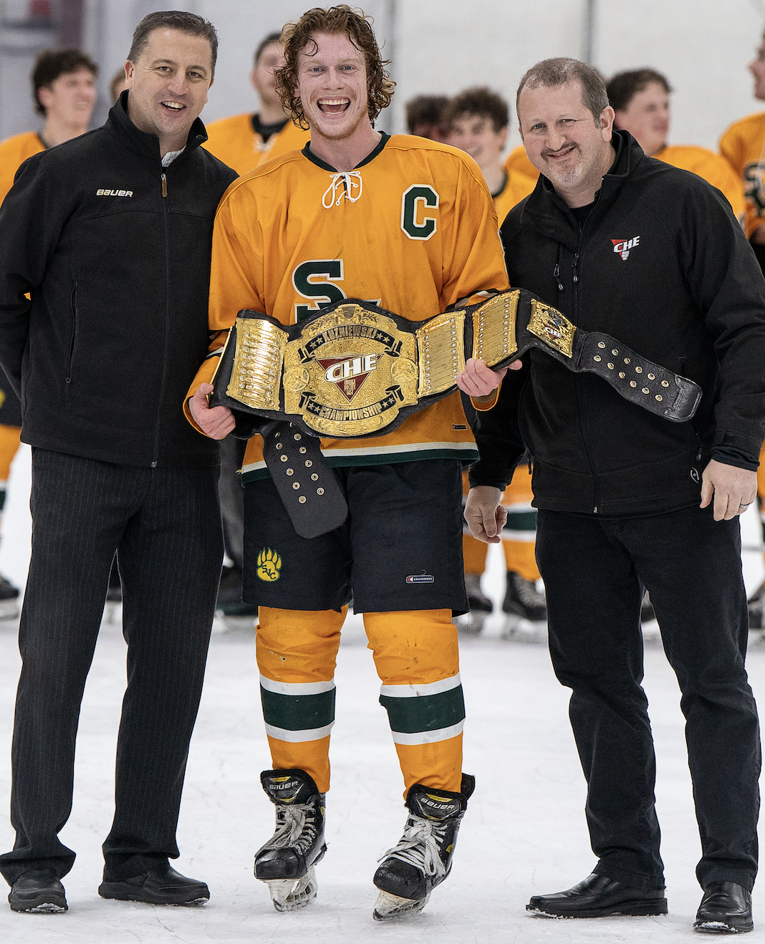
CHE Title #2. SVC 2 Penn West Cal 0.
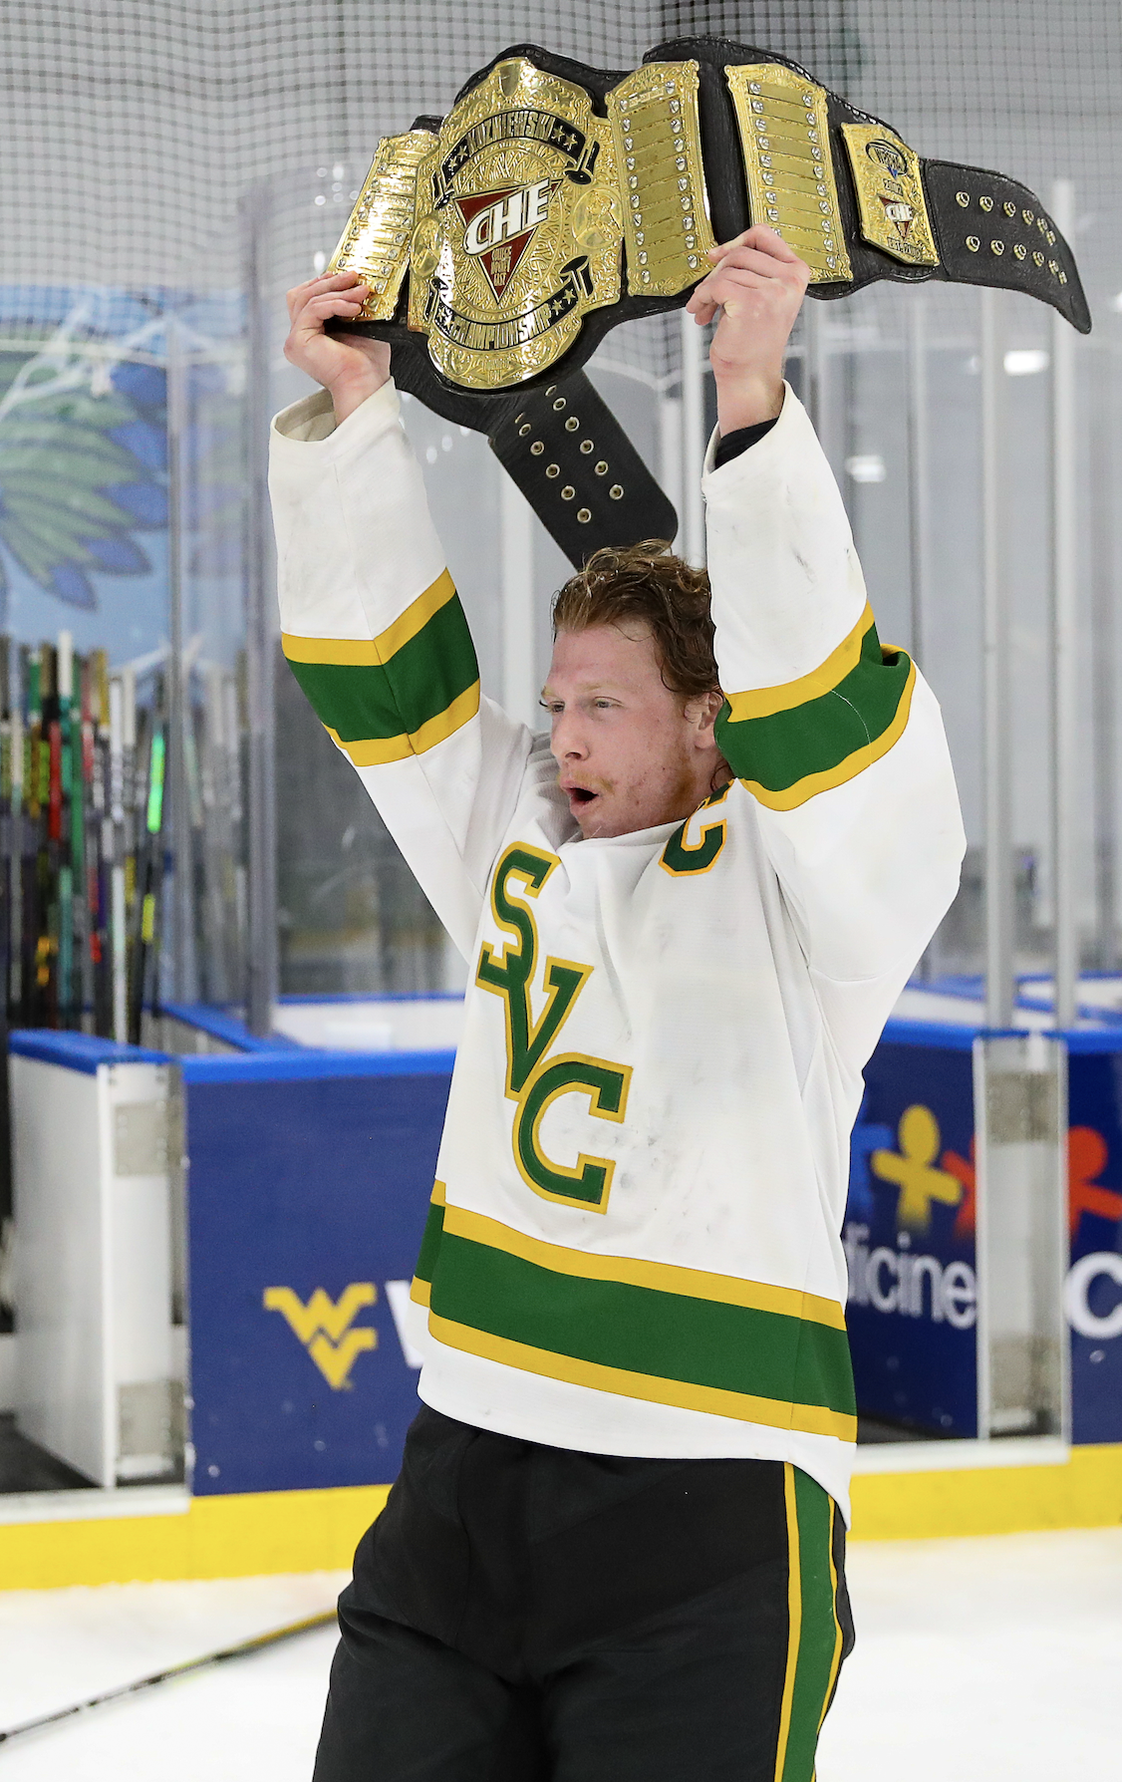

CHE Title #3. SVC 3 UPJ 2 in overtime. The Polar Bearcats overcame a 2-0 third period deficit with a final period shot advantage of 19-5!

