Player Name: | Career Highlights:
Gage, Mason  C 25 | As an energy player, Mason created chaos for opposing teams. He was extremely coachable and often used to spark the team when games turned lethargic for SVC. His first assist came against Duquesne in a 9-1n SVC win and popped in his first goal in a two point game loss 9-5 with WVU. He also collected a goal against UPJ in a tough 3-2 loss and ended his scoring with a goal in a 6-5 SVC win at Akron. He played in the CHE Championship Tournament when SVC lost in the finals to Cal.

Yr | # | Pos | GP | G | A | TP | S | Pct | + | - | +/- | PM | W | T | P | S
2122 | 11 | Lw | 21 | 2 | 3 | 5 | 19 | 10.5 | 11 | 11 | E | 12 | 0 | 0 | 0 | 0
2223 | 11 | Rw | 11 | 1 | 1 | 2 | 7 | 14.3 | 5 | 8 | -3 | 4 | 0 | 0 | 0 | 0
Totals |  |  | 32 | 3 | 4 | 7 | 26 | 11.5 | 16 | 19 | -3 | 16 | 0 | 0 | 0 | 0

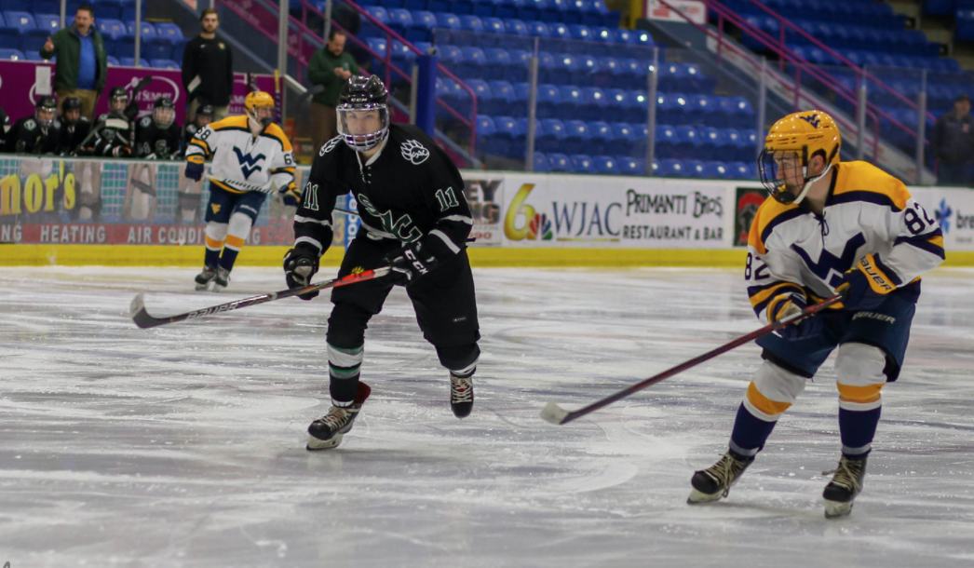
Mason playing WVU at the Cambria County War Memorial where the movie Slap Shot was filmed.

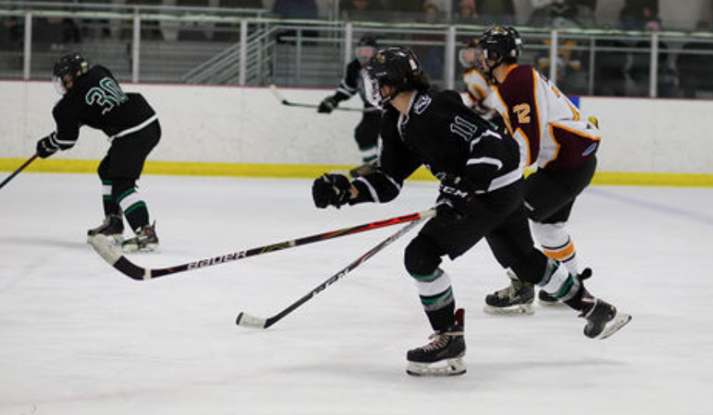
Mason skated against Kent State in the upset of the 22-23 CHE playoffs when SVC denied heavily favored KSU the chance to advance to the finals in a 4-2 thriller.

