Player Name: | Career Highlights:
Bower, Evan  C 27 | A classic stay at home defender, “Chetty” focused on details, positional play, and making choices that fit his style of play. His game was steady and calm and that approach was critical in solidifying the blue line for SVC as it won its first ever CHE title in 23-24 and an appearance in the National ACHA DIII Tournament in Saint Louis. His first point was an assist on a Zach Radilla goal in a 4-1 Saint Vincent win over Cal. He had a two-assist game against the Akron Zips (7-2 SVC) and recorded a goal against the Case Western Spartans (9-3 SVC). His last helper supported a 7-5 win Over UPJ.

Yr | # | Pos | GP | G | A | TP | S | Pct | + | - | +/- | PM | W | T | P | S
2324 | 8 | D | 21 | 1 | 4 | 5 | 20 | 5.0 | 34 | 22 | +12 | 8 | 0 | 0 | 0 | 0
Totals |  |  | 21 | 1 | 4 | 5 | 20 | 5.0 | 34 | 22 | +12 | 8 | 0 | 0 | 0 | 0

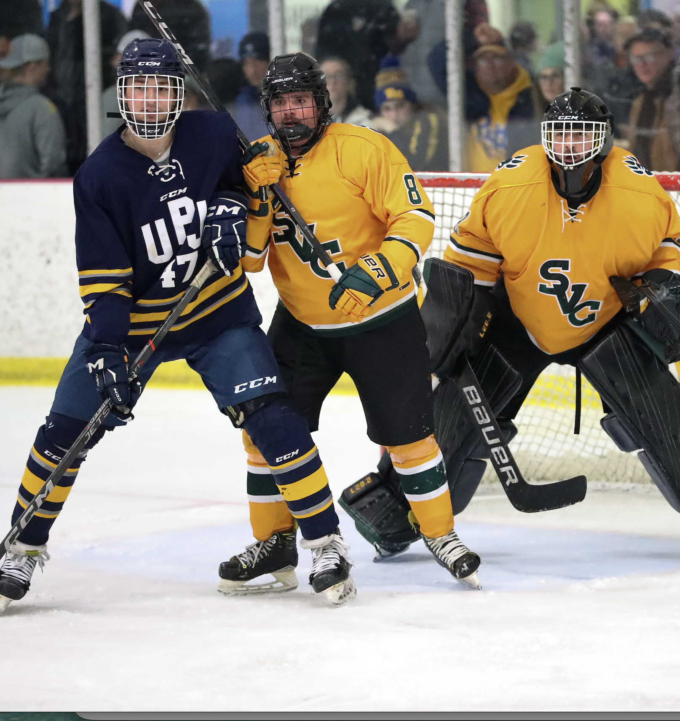
Focus on the details. Evan boxing out a Pitt Johnstown forward in the first round of the CHE playoffs giving goalie Vinny Amatucci a clean sight line to the puck.
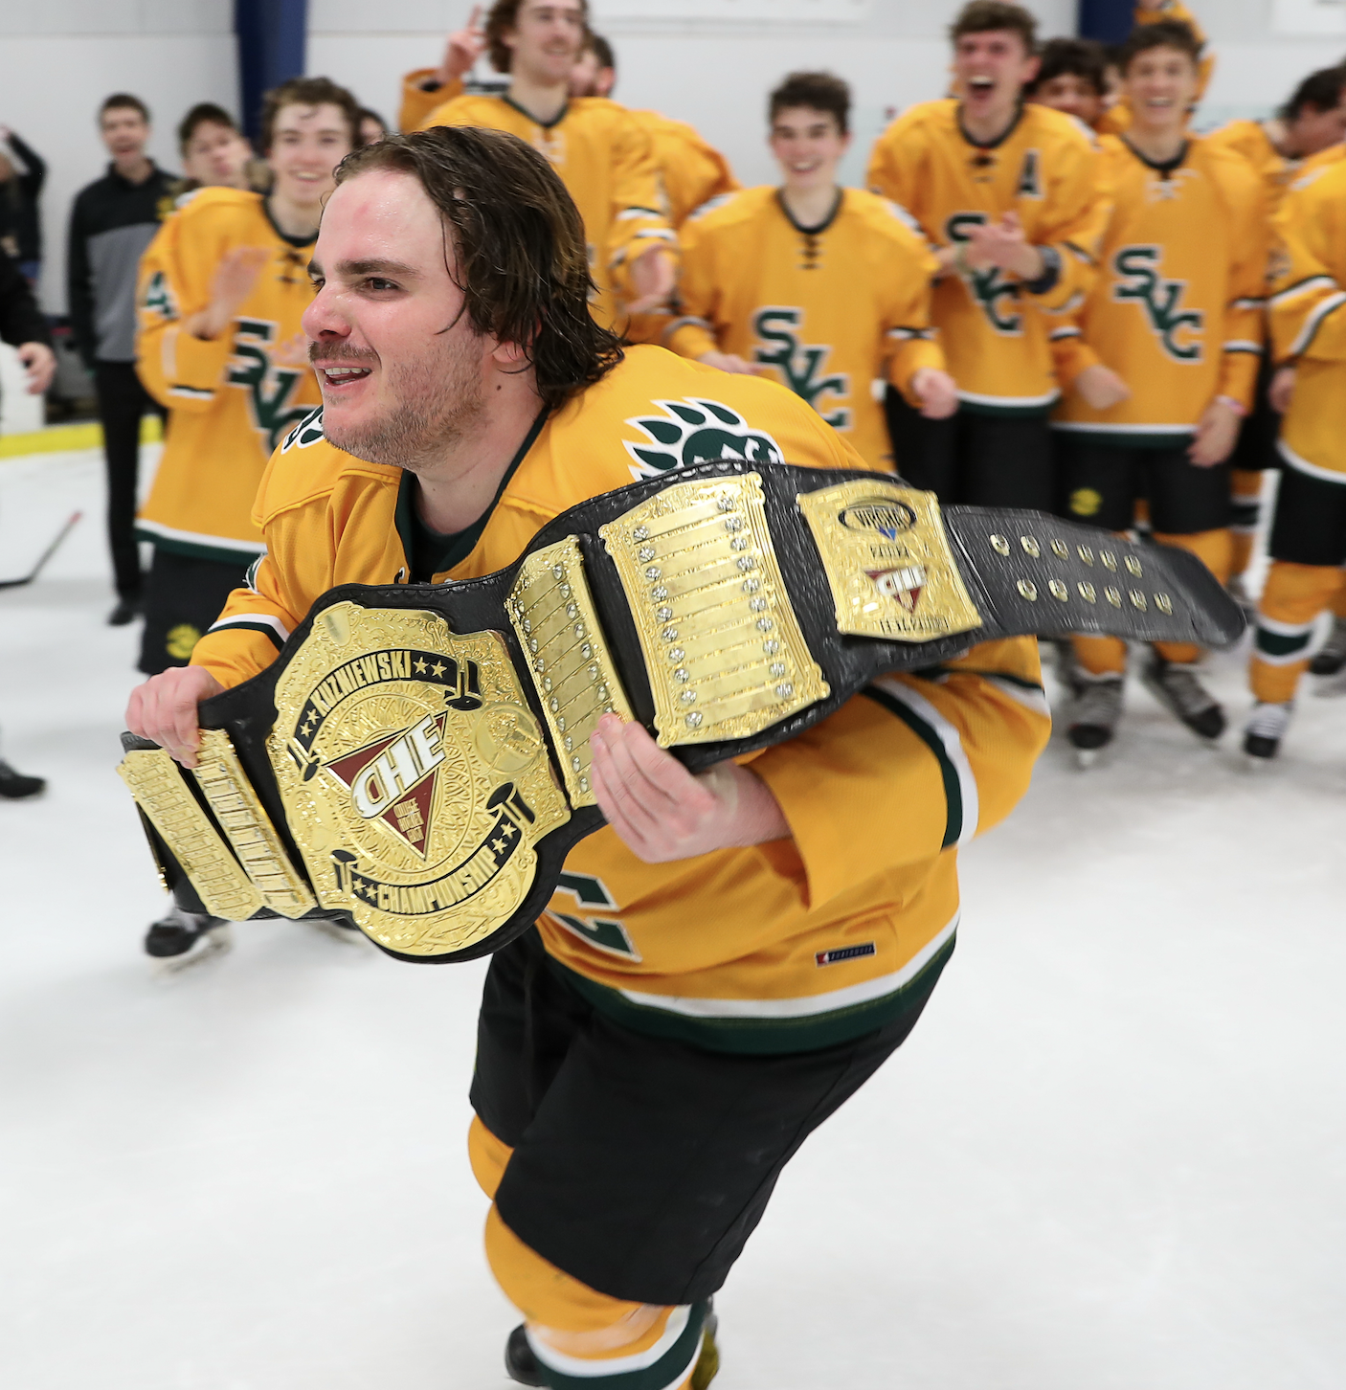
When you play your role and the team performs, the rewards come large. Evan skates with the CHE Kuzniewski Championship Belt in celebration of the team’s first ever playoff title, a 3-2 besting of IUP.

