Player Name: | Career Highlights:
Hunter, Bergman  C’25 | The Bergie Flyer, Hunter transfered from WVU and made an immediate impact on upgrading the blue line. A fast skater with incredible edge control, he fearlessly pursued attackers and demonstrated an ability to rush the puck to create attacking options. Had his first point, an assist against Akron and a 2-assist game against RMU. His first collegiate goal was a power play score against Rober Morris. One the best performances in his career came against Colby in the ACHA D3 National Tournament in the 23-24 season when he collected an assist and a spectacular bar down wrist shot to help SVC to a 9-5 victory. He made a heroic return to the lineup after a serious injury in the 24-25 season. His only goal his senior year was a marvelous spinning back hand while on his back as he whirled a puck into the net against Case. A solid +/- rating he was never been in the minus range at the end of a season. His game winning goal came in a 3-1 win over Case. He was a member of three College Hockey East Championships and played in back to back ACHA D III National tournaments in 2024 and 2025.

Yr | # | Pos | GP | G | A | TP | S | Pct | + | - | +/- | PM | W | T | P | S
2223 | 74 | D | 26 | 2 | 5 | 7 | 28 | 7.1 | 39 | 33 | +6 | 18 | 1 | 0 | 1 | 0
2324 | 74 | D | 23 | 1 | 3 | 4 | 20 | 5.0 | 35 | 27 | +8 | 8 | 0 | 0 | 0 | 0
2425 | 74 | D | 17 | 0 | 3 | 3 | 8 | 0.0 | 9 | 4 | +5 | 2 | 0 | 0 | 0 | 0
2526 | 74 | D | 18 | 1 | 3 | 4 | 18 | 5.6 | 17 | 8 | +9 | 4 | 0 | 0 | 0 | 0
Totals |  |  | 84 | 4 | 14 | 18 | 74 | 5.4 | 100 | 72 | +28 | 32 | 1 | 0 | 1 | 0

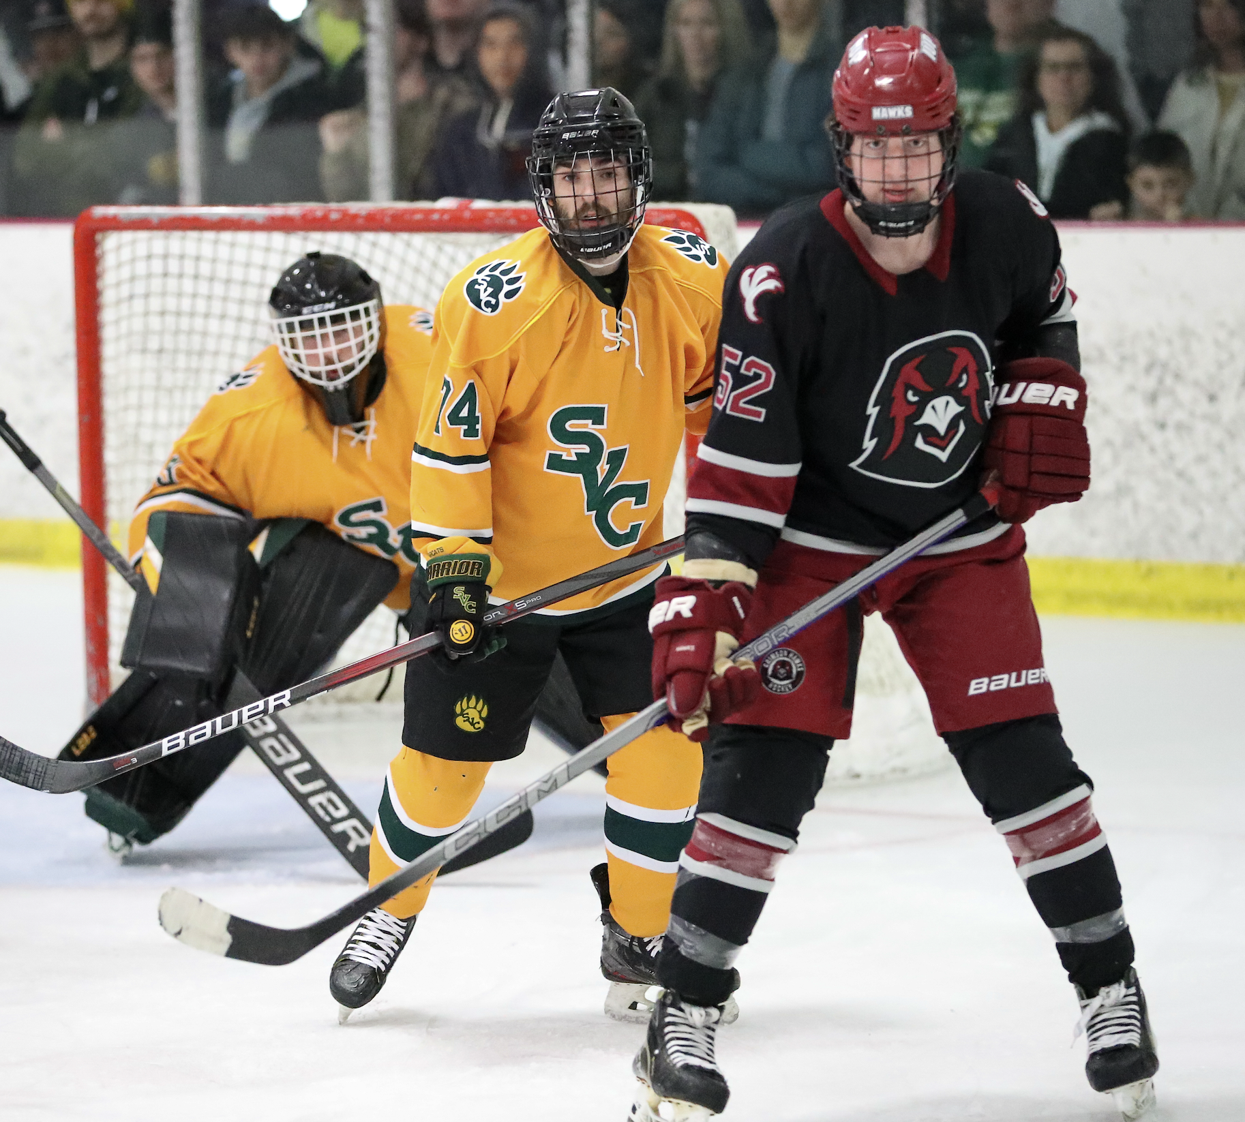
In spite of his size, Hunter was an aggressive defender, using his skating ability to close gaps, track down attackers and spring plays out of the zone. Seen here boxing out an IUP forward as Vinny Amatucci tracks the puck. Action form the SVC victory, 3-2, over IUP in the CHE 2023-2024 title game.

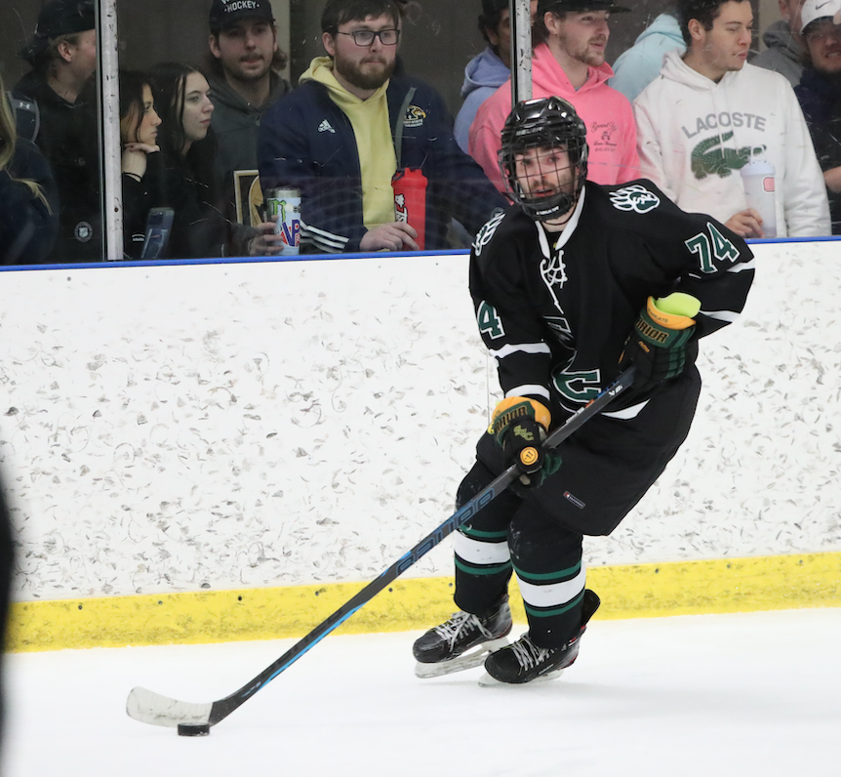
Bergie’s strength was his skating. His speed and edge control were phenomenal assets in his game. Moving past checkers with the puck seemed effortless.

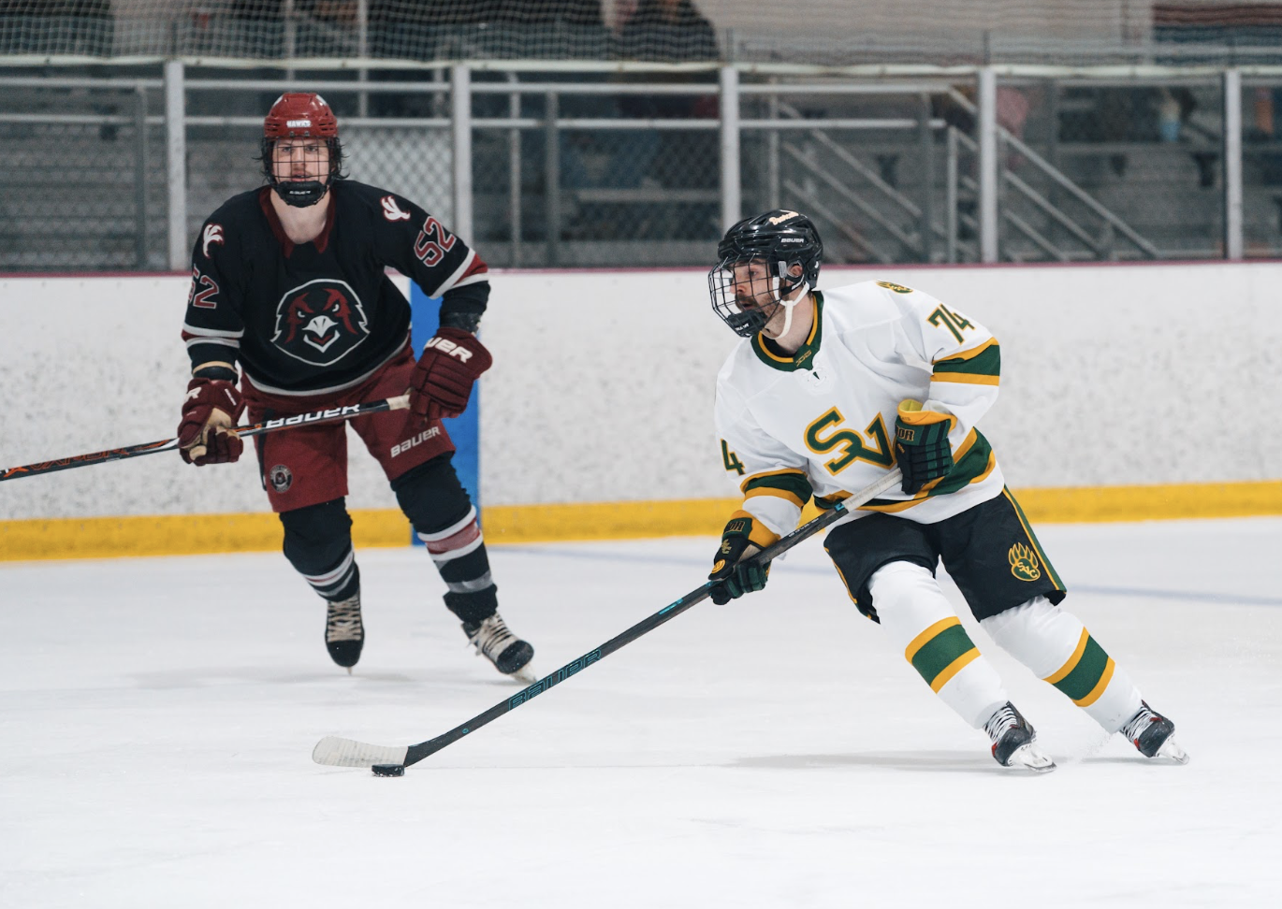

A champion. Hunter takes a skate with the CHE Belt after the 2-0 win over Penn West Cal in 2024-2025

