Player Name: | Career Highlights:
Rendulich, Anthony  C’25 | With 76 points “Rendo” ended as the #2 in all-time scorer for defenseman in club history only behind 2010 Team Captain and legend Tim Legath. With a +65, he is 5’th in that category for defenseman. Using his reach, size, and speed he turned into a sold two-way blue liner who could handcuff goalies with point shots. He was the last remaining rostered player to have participated in the one game COVID season of ’20-’21 when Saint Vincent defeated RMU 4-2 in what felt like the 7’th game of the Stanley Cup playoffs.  His physical presence enabled him to dominate games. During his 4+1 seasons he had 23 multiple point games. His first point was an assist in a game against Duquesne and first goal was on a power play against Allegheny. Four times he has had a goal and two assists in games (IUP, Duquesne, RMU and Kent State), one two goal game against RMU, a 3 assist game in an SVC win over Stevenson, and his single biggest offensive effort, a goal and 3 assists against the Robert Morris Colonials.  Matched to his point totals, he frustrated opponents with his toughness and size logging huge minutes in close games and playoff series. He could rock players into the boards or the front of the net. SVC made the CHE finals in each of his last 3 seasons and won the championship in each of his last two years. It was capped by two consecutive ACHA D3 National Tournament appearances in Saint Louis.

Yr | # | Pos | GP | G | A | TP | S | Pct | + | - | +/- | PM | W | T | P | S
2021 | 5 | D | 1 | 0 | 0 | 0 | 3 | 0.0 | 2 | 0 | +2 | 0 | 0 | 0 | 0 | 0
2122 | 5 | D | 20 | 3 | 11 | 14 | 75 | 4.0 | 44 | 36 | +8 | 61 | 0 | 0 | 2 | 0
2223 | 5 | D | 26 | 7 | 20 | 27 | 97 | 7.2 | 56 | 43 | +13 | 46 | 0 | 0 | 1 | 1
2324 | 5 | D | 23 | 1 | 18 | 19 | 73 | 1.4 | 38 | 21 | +17 | 46 | 0 | 0 | 1 | 0
2425 | 5 | D | 30 | 2 | 14 | 16 | 75 | 2.7 | 52 | 27 | +25 | 36 | 0 | 0 | 0 | 0
Totals |  |  | 100 | 13 | 63 | 76 | 323 | 4.0 | 192 | 127 | +65 | 189 | 0 | 0 | 4 | 1
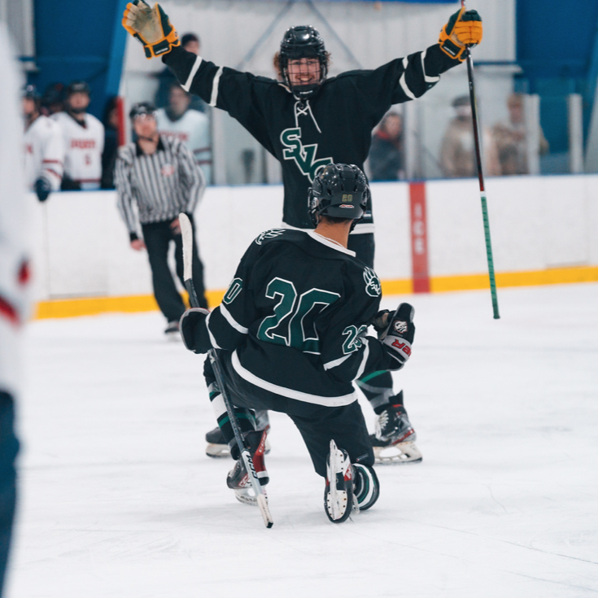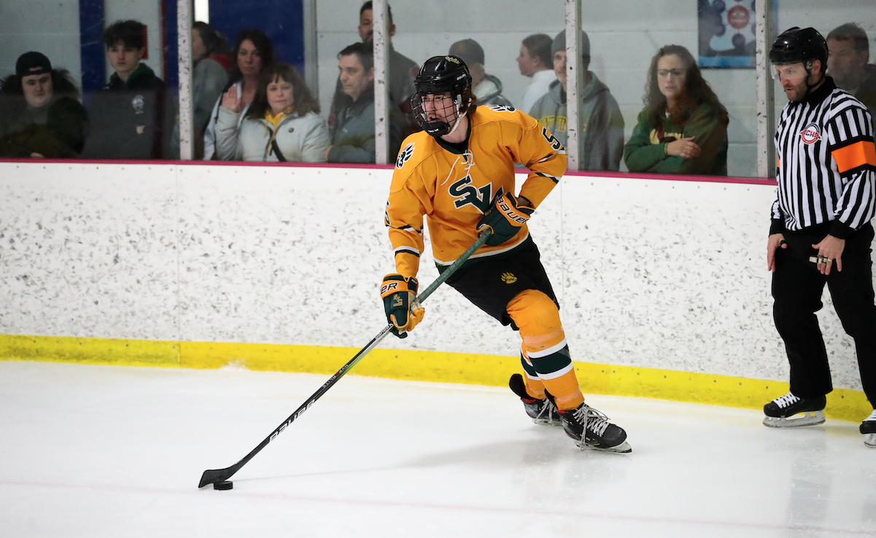
Anthony simply loved to play and enjoyed winning. Here he shares a moment with Dominic Costantino after #20 scores against Duquesne in an away match.
Anthony was very adept at puck movement balancing carries to create offense off the rush with passes to forwards to clear the zone.

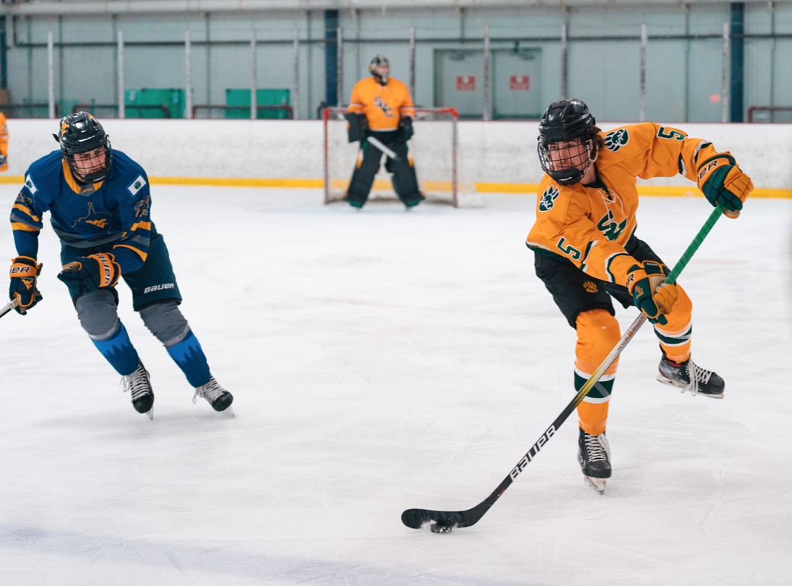
Bounce pass master. Rendo used the boards well for clears, dumps, and connections to his forwards. Game action against WVU.

