Player Name: | Career Highlights:
Connelly, Logan  C ‘24 | In spite of only being able to play in one game his freshman season because of COVID, Logan sailed into one the all-time leading scorers in SVC history becoming the 14’th player in 50+ years to pass the 100-point mark. He had a huge effort in the one game COVID season with a shorthanded goal and an assist in the 4-2 victory against Robert Morris. He collected 27 multi point games including hat tricks against UPJ, Cleveland State and Allegheny, three assist efforts with Allegheny and Duquesne (twice) and game winning scores over Allegheny, UPJ, Cleveland State and Loyola. tonight’s contest. He was the 7’th player in club history to record 400 shots on goal in a career. An Assistant Captain his senior year, Logan was an integral part of the CHE League and Championship Team. He used his seed to dart past opposing wingers to score. He could get lost in the play and suddenly pop into a seem and grab a goal. In spite of his numbers, he had no bigger goal than the opening power play score with IUP in the CHE Playoff Championship game.

Yr | # | Pos | GP | G | A | TP | S | Pct | + | - | +/- | PM | W | T | P | S
2021 | 27 | Rw | 1 | 1 | 1 | 2 | 8 | 12.5 | 2 | 0 | +2 | 4 | 0 | 0 | 0 | 1
2122 | 24 | Lw | 20 | 25 | 18 | 43 | 151 | 16.6 | 47 | 26 | +21 | 23 | 4 | 0 | 4 | 2
2223 | 24 | Lw | 26 | 18 | 20 | 38 | 184 | 9.1 | 48 | 33 | +15 | 16 | 1 | 1 | 2 | 1
2324 | 24 | Lw | 23 | 13 | 12 | 25 | 100 | 13.0 | 25 | 23 | +2 | 12 | 3 | 0 | 3 | 0
Totals |  |  | 70 | 57 | 51 | 108 | 443 | 12.9 | 122 | 82 | +40 | 55 | 8 | 1 | 9 | 4

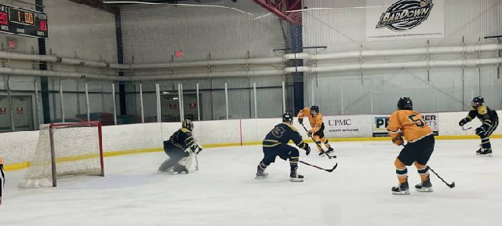
Logan deposits a puck into the Akron Zips net in game action at Palmer Imaging Arena in Delmont.
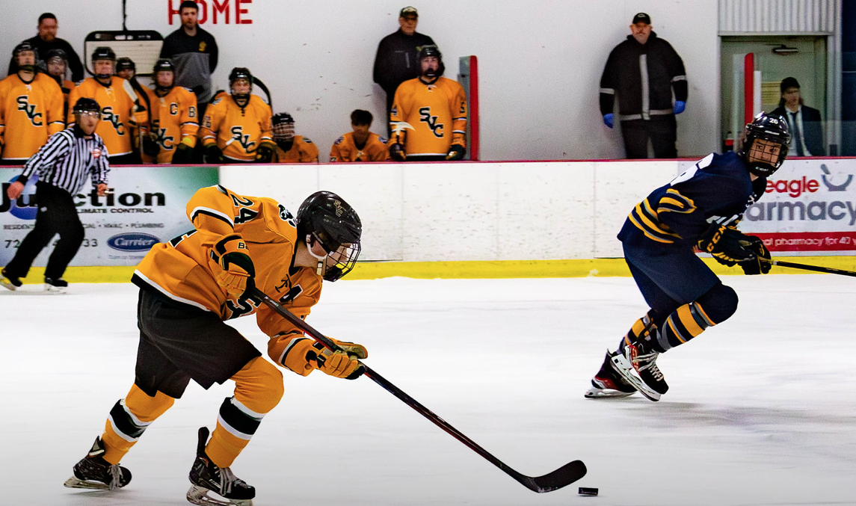

A solid CHE Playoff performance rewarded Logan and the Polar Bearcats with the CHE championship. Above Logan rushes the puck against UPJ en route to an 8-1 SVC win. Below, a clear view of Logan’s opening power play goal in the finals.

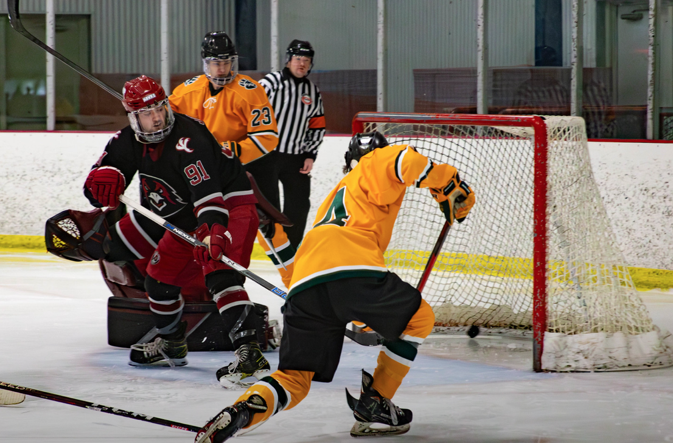

Skating with the CHE Championship Belt. SVC 3. IUP 2. The first Polar Bearcat CHE Championship in team history.

