Player Name: | Career Highlights:
Capozzoli, Dino  C ‘24 | Joining after his sophomore year, Dino immediately contributed to the increasingly strong SVC hockey program. His quick skating and tenacity in in his forecheck and penalty killing roles gave him versatility to play in a variety of situations. He easily filled in as a top 6 forward when called to that role. His first two points, a goal and an assist, came in a 6-5 SVC win over IUP with the goal opening the scoring for the Polar Bearcats. Dino had three multi point games against IUP, RMU and the West Virginia Mountaineers. He was a member of the CHE Regular Season and Playoff team his senior year that went to Saint Louis to play in the ACHA D3 National Tournament.

Yr | # | Pos | GP | G | A | TP | S | Pct | + | - | +/- | PM | W | T | P | S
2223 | 2 | Rw | 25 | 5 | 9 | 14 | 41 | 12.2 | 19 | 17 | +2 | 12 | 0 | 0 | 0 | 0
2425 | 2 | Rw | 21 | 1 | 5 | 6 | 18 | 5.6 | 6 | 8 | -2 | 14 | 0 | 0 | 0 | 0
Totals |  |  | 46 | 6 | 14 | 20 | 59 | 10.2 | 25 | 25 | E | 26 | 0 | 0 | 0 | 0

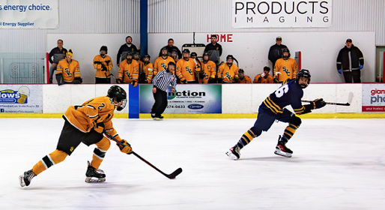

Dino against UPJ in the CHE playoffs his senior year. Not only could Dino zip by opposing players, he was an absolute pest on the forecheck.

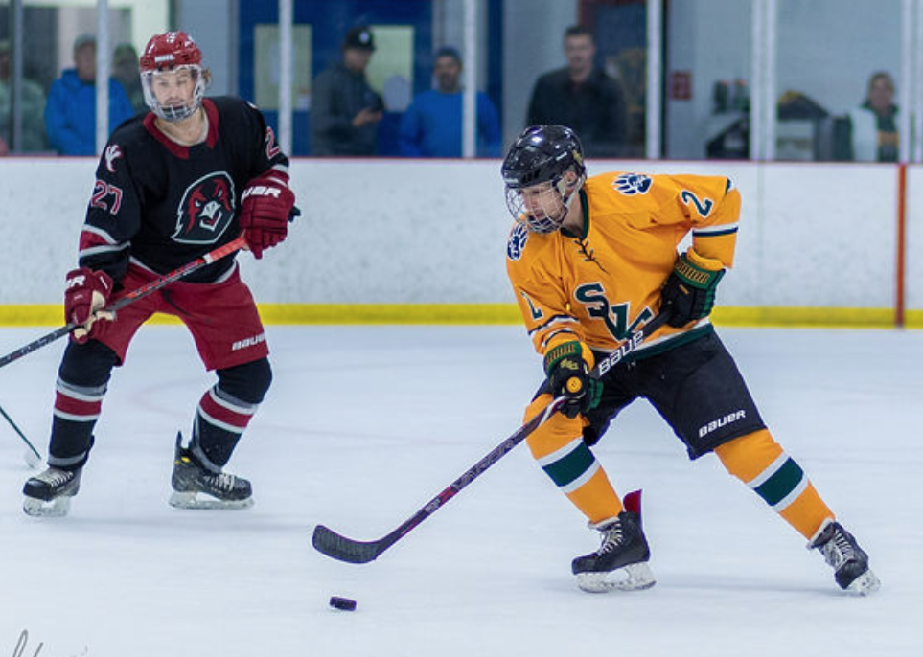
#2 against IUP in the CHE Finals against IUP. SVC 3 IUP2.

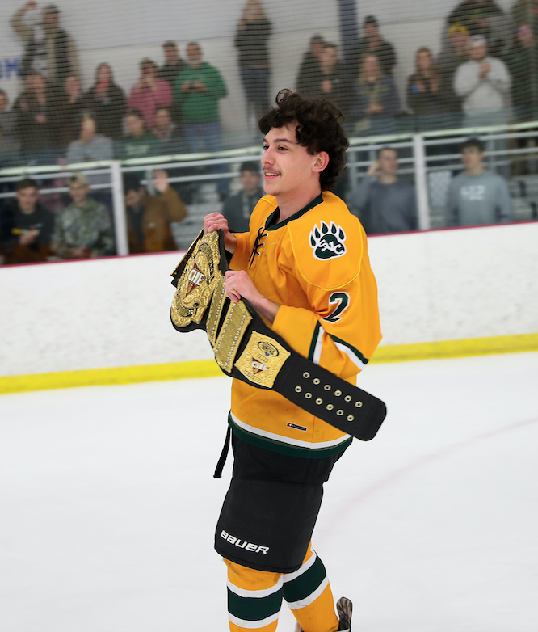
A well-deserved skate with the CHE Championship belt. Going out a winner!

