Player Name: | Career Highlights:
Baxter, Donavan  C ‘24 | When SVC was desperate for a goaltender in a last-minute invitation to the annual UPJ tournament, Saint Vincent’s only netminder Shane Stone was injured. Donavan took the stage to become one of the great stories in club history. After not playing for several years and learning the game and position well after most college goalies, he blew away his teammates with two incredible performances that included a shutout over Cleveland Stade and an even bigger win when he made 16 saves over a startled WVU team in the Cambria County War Memorial. He beat Duquesne in his only start of the 23-24 season during Senior Recognition Day. Donny finished his career by playing the final minutes of the Saint Vincent win over Colby in the ACHA D3 National Tournament in Saint Louis.

Yr | # | Pos | GP | G | A | TP | S | Pct | + | - | +/- | PM | W | T | P | S
2122 | 29 | G | 4 | 0 | 0 | 0 | 0 | 0.0 | - | - | - | 0 | 0 | 0 | 0 | 0
2223 | 29 | G | 3 | 0 | 0 | 0 | 0 | 0.0 | - | - | - | 0 | 0 | 0 | 0 | 0
2324 | 29 | G | 3 | 0 | 1 | 0 | 0 | 0.0 | - | - | - | 0 | 0 | 0 | 0 | 0
Totals |  |  | 10 | 0 | 1 | 0 | 0 | 0.0 | - | - | - | 0 | 0 | 0 | 0 | 0

Yr | # | Pos | GP | MP | GA | AVG | SO | EN | W | L | T | SHOTS | SAVES | PCT
2122 | 29 | G | 4 | 241 | 15 | 3.73 | 1 | 0 | 3 | 1 | 0 | 96 | 81 | .844
2223 | 29 | G | 3 | 34 | 4 | 7.06 | 0 | 0 | 0 | 0 | 0 | 16 | 12 | .750
2324 | 29 | G | 3 | 68 | 5 | 4.41 | 0 | 0 | 1 | 0 | 0 | 29 | 24 | .828
Totals |  |  | 10 | 343 | 24 | 4.20 | 1 | 0 | 4 | 1 | 0 | 141 | 117 | .830

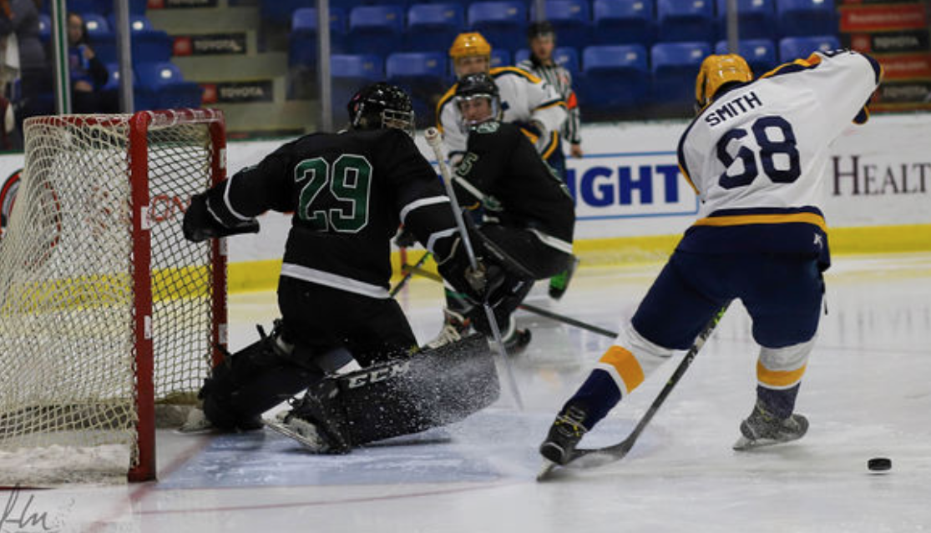
It’s not Fleury. It’s Donny! #29 stuns WVU in the UPJ Invitational. One of his saves against the Mountaineer in a 4-3 SVC win..

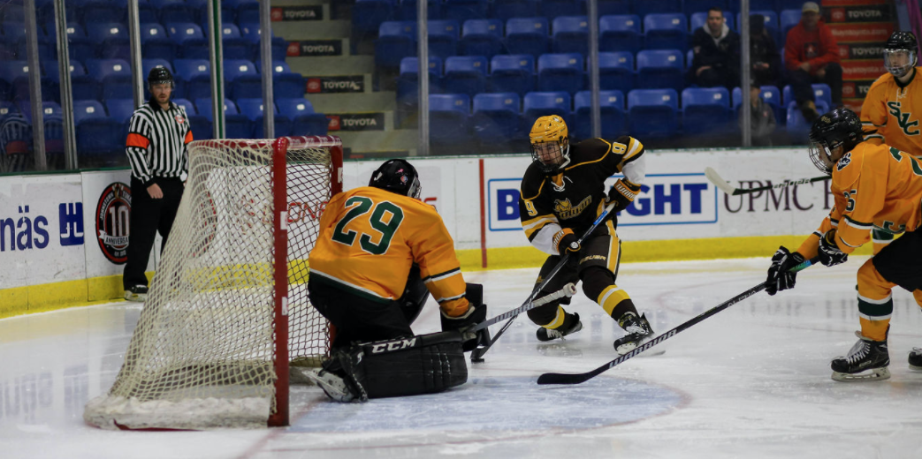

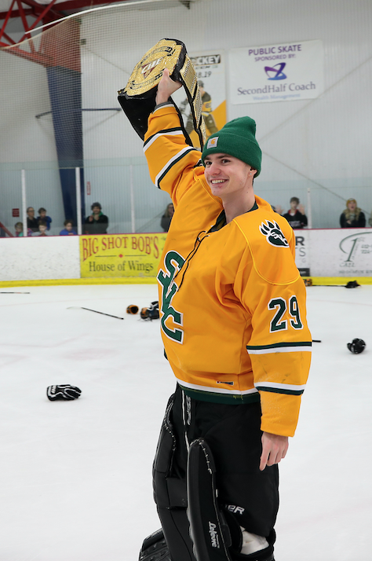
(Top) Competing against Rowan in the Cambia County War Memorial in Johnstown. The same rink of the famous hockey film “Slapshot”.

(Right) Donny has his chance to skate with the CHE Championship Belt after SVC pinned arch rival IUP by a score of 3-2 for the schools’ first CHE Playoff Title.

