Player Name: | Career Highlights:
Barrett, Devin  C 24 | Devin was one of the most cerebral players in team history. His ability to read plays and have on ice awareness of opposing players and his teammates made him a +/- machine. He angled attackers deftly, blocked shots and had a patten on rushing the puck to center red and dumping the puck to forwards as a way to get the team out of trouble or create offence. In his freshman year he played in the famous one game COVID season with a 4-2 win over RMU. Noted for his steady and smart play he typifies the quintessential stay at home defenseman. His first assist came in a 9-1 SVC win over Duquesne and his first goal was scored shorthanded against RMU. Along with a power play score against Duquesne, he had two multi point efforts with a goal and three assists in another RMU contest and two helpers in a game with Case. How important was his defend? He was one of the 5 players Coach Martz had on the ice in the final minute of play in the 3-2 final championship win over IUP.

Yr | # | Pos | GP | G | A | TP | S | Pct | + | - | +/- | PM | W | T | P | S
2021 | 9 | D | 1 | 0 | 0 | 0 | 1 | 0.0 | 0 | 0 | E | 0 | 0 | 0 | 0 | 0
2122 | 25 | D | 21 | 1 | 6 | 7 | 42 | 2.4 | 45 | 42 | +3 | 8 | 0 | 0 | 0 | 1
2223 | 25 | D | 25 | 2 | 13 | 15 | 25 | 8.0 | 59 | 42 | +17 | 24 | 0 | 0 | 1 | 0
2324 | 25 | D | 22 | 0 | 5 | 5 | 20 | 0.0 | 36 | 13 | +23 | 8 | 0 | 0 | 0 | 0
Totals |  |  | 69 | 3 | 24 | 27 | 88 | 3.4 | 140 | 97 | +43 | 40 | 0 | 0 | 1 | 1

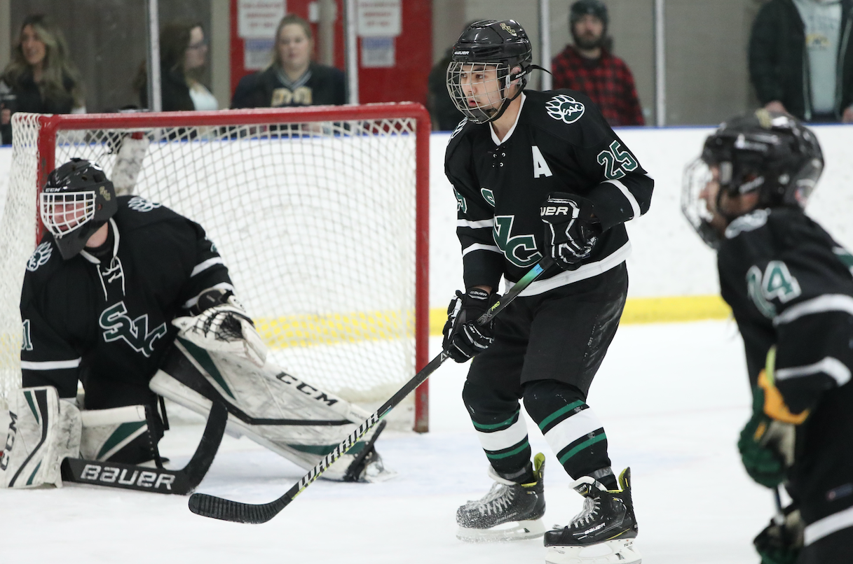
Devin simply found ways to calm a game. He always seemed to be in great defensive position and took few penalties. Reading the play against Kent State.
Devin takes his turn with the CHE Championship Belt after the SVC 3-2 win over IUP. It was only the second championship in team history and the first as a member of College Hockey East.

He was a blue line fixture for 4 years, an adept penalty killer and great teammate. His demeanor exemplified sportsmanship and competitiveness.

