Player Name: | Career Highlights:
Stone, Shane  C 23 | After waiting 3 years, Shane was finally able to get #30 his senior year. His career record of 19-12-0 and .633 winning percentage puts him in the top 7 goalies statistically in team history.. Playing 1,780 minutes he passed 1970’s goaltender Bob Matthews to take over 9’th place all-time in that category. A two sport athlete, Shane was also an outstanding Lacrosse player.  His first victory came in his freshman year against Pitt Bradford and he recorded multiple wins over Cleveland State, Duquesne, Allegheny, Pitt Bradford and Robert Morris, including a shut out over the Colonials his junior season. His biggest win probably came the first game of that year when a 33 save effort shocked a top rated IUP team leading to an 8-5 SVC win.

Yr | # | Pos | GP | G | A | TP | S | Pct | + | - | +/- | PM | W | T | P | S
1920 | 15 | G | 5 | 0 | 0 | 0 | 0 | 0.0 | - | - | - | 0 | 0 | 0 | 0 | 0
2021 | 15 | G | 0 | 0 | 0 | 0 | 0 | 0.0 | - | - | - | 0 | 0 | 0 | 0 | 0
2122 | 15 | G | 18 | 0 | 0 | 0 | 0 | 0.0 | - | - | - | 0 | 0 | 0 | 0 | 0
2223 | 30 | G | 9 | 0 | 0 | 0 | 0 | 0.0 | - | - | - | 0 | 0 | 0 | 0 | 0
Totals |  |  | 32 | 0 | 0 | 0 | 0 | 0.0 | - | - | - | 0 | 0 | 0 | 0 | 0

Yr | # | Pos | GP | MP | GA | AVG | SO | EN | W | L | T | SHOTS | SAVES | PCT
1920 | 15 | G | 5 | 287 | 16 | 3.34 | 0 | 0 | 4 | 1 | 0 | 119 | 103 | .866
2021 | 15 | G | 0 | 0 | 0 | 0.00 | 0 | 0 | 0 | 0 | 0 | 0 | 0 | 0
2122 | 15 | G | 18 | 1074 | 75 | 4.19 | 1 | 0 | 10 | 8 | 0 | 529 | 454 | .858
2223 | 30 | G | 9 | 419 | 32 | 4.58 | 0 | 0 | 5 | 3 | 0 | 208 | 176 | .846
Totals |  |  | 32 | 1780 | 123 | 4.15 | 1 | 0 | 19 | 12 | 0 | 856 | 733 | .856

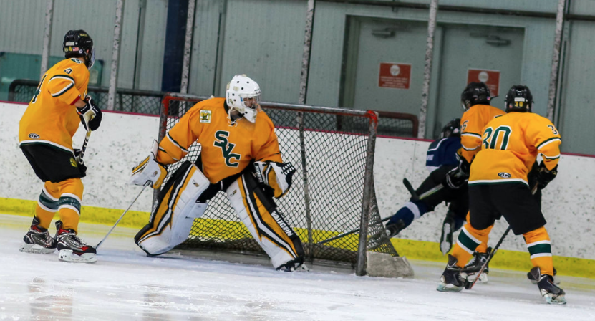

Shane tracks the puck behind the net in a game against Case Wester. Josh Hoffman (#30) and Chris Miller (#4) box out the front of the net.

(Below) Shane stops a puck and clears the rebound to the corner. Game action against WVU in Morgantown during the 2022-2023 season. Shane helped SVC reach the CHE playoffs that year with a 5-3-0 record in the pipes.

