Player Name: | Career Highlights:
Moyer, Tristan  C’ 23 | Hard hitting, versatile, and intense, Tristan played all forward positions, and his senior year also logged a significant number of minutes on defense when players missed games with injuries. Loved his #3. Strong on the ice and as an academic performer his energy and demeanor inspires teammates.  Scoring was secondary to the importance of his overall abilities with a reputation for being hard to play against, while frequently supporting the team with a whatever is needed attitude. His 1’st assist came against Pitt Bradford and, 1’st goal – part of a hat trick effort against Pitt Greensburg including 2 power play scores. Had 7 multi point games and three times has recorded 3 points in a game. Biggest goal was the game winner over RMU in the one game COVID season of 2020-2021. He played with his brother Joe with the bash brothers nickname.

Yr | # | Pos | GP | G | A | TP | S | Pct | + | - | +/- | PM | W | T | P | S
1920 | 3 | Lw | 17 | 8 | 7 | 15 | 68 | 11.8 | 14 | 12 | +2 | 24 | 0 | 0 | 3 | 0
2021 | 3 | Rw | 1 | 1 | 0 | 1 | 6 | 16.7 | 1 | 0 | +1 | 0 | 1 | 0 | 1 | 0
2122 | 3 | Rw | 22 | 4 | 4 | 8 | 57 | 4.0 | 16 | 19 | -3 | 43 | 0 | 0 | 0 | 0
2223 | 3 | C/D | 26 | 1 | 5 | 6 | 39 | 2.5 | 19 | 19 | E | 14 | 1 | 0 | 0 | 0
Totals |  |  | 66 | 14 | 16 | 30 | 170 | 8.2 | 50 | 50 | E | 81 | 2 | 0 | 4 | 0

Intensity. When Tristan wanted the puck, he usually got it. A quick skater for his size, he had the ability to play well in traffic and along the boards.
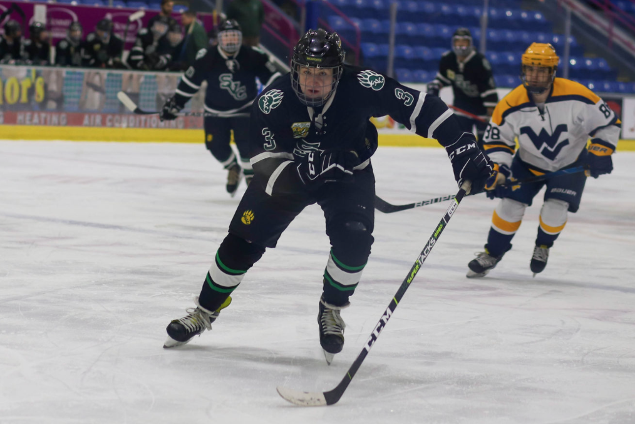

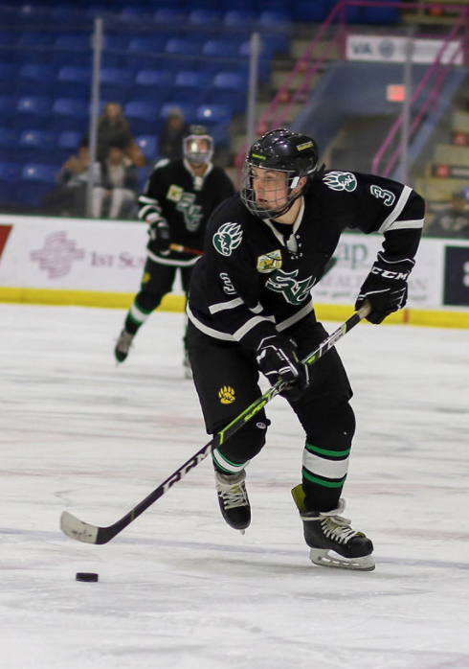
Tristan had the ability to move the puck and had solid demanding tempo to his game. He would have doubled his goal totals if the number of posts he hit could have turned into scores!
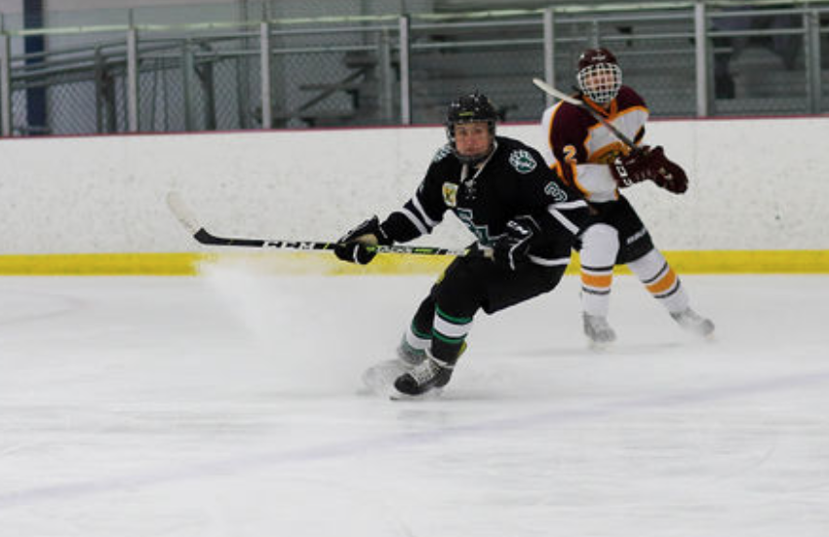
Power skating display as the ice rips against Gannon University. #3 demonstrates the hustle that was a key part of how he played.

