Player Name: | Career Highlights:
McCutcheon, Colten  C’ 24 | “Cutch” ‘s game went well beyond scoring. He was a defensive master who always had the main role of shutting down an opposing team’s top line. He was a fluid skater and stickhandler with incredible positional instincts to support the puck, cover lanes, and backcheck from the inside. This tenacity earned him the Captain’s “C” for his final year. His most outstanding defensive effort came his senior year when he shut down the top player for to seed Kent State as Saint Vincent created an upset win in the playoffs, 4-2.  His game was based on consistency and a Selke Award like approach to the defensive side of playing center. Colten exceled on wining defensive zone draws and the coaching staff always made sure he was on the ice when shutting the other team down was a priority. He wore three different numbers in each season, #45, #21, and #33. An academic star, Colten graduated after only three years at SVC. His first goal started the SVC third period in the one game 20-21 COVID campaign that ended in a 4-2 win over RMU. He had a 2goal game against WVU, and a shorthanded goal in an RMU game as part of his 18 goal 21 assist career. Had 7 multi-point games including 2 scores in an opening playoff round 6-4 win over Akron.

Yr | # | Pos | GP | G | A | TP | S | Pct | + | - | +/- | PM | W | T | P | S
2021 | 45 | C | 1 | 1 | 0 | 1 | 4 | 25.0 | 1 | 0 | +1 | 0 | 0 | 0 | 0 | 0
2122 | 21 | C | 21 | 9 | 13 | 22 | 93 | 9.7 | 43 | 26 | +17 | 15 | 1 | 0 | 3 | 0
2223 | 33 | C | 24 | 8 | 8 | 16 | 70 | 11.4 | 35 | 30 | +5 | 4 | 0 | 0 | 3 | 0
Totals |  |  | 46 | 18 | 21 | 39 | 167 | 10.8 | 79 | 56 | +23 | 19 | 1 | 0 | 6 | 0

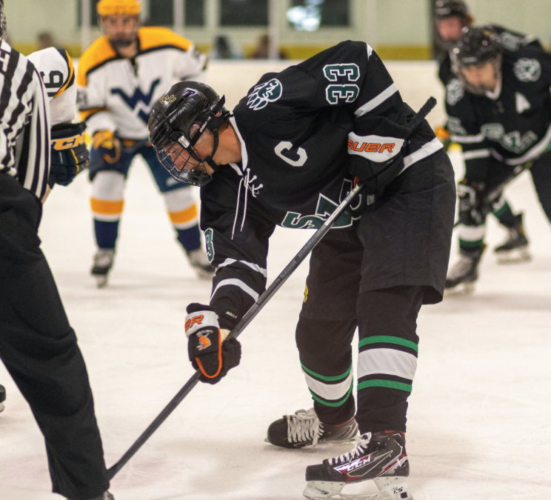
An expert at face offs, Colten was frequently won more than 70% of his draws. Pictured in the SVC away colors during a game in Morgantown against the Mountaineers.

A two sport athlete, Cutch continued the tradition at SVC of also being on the golf team.

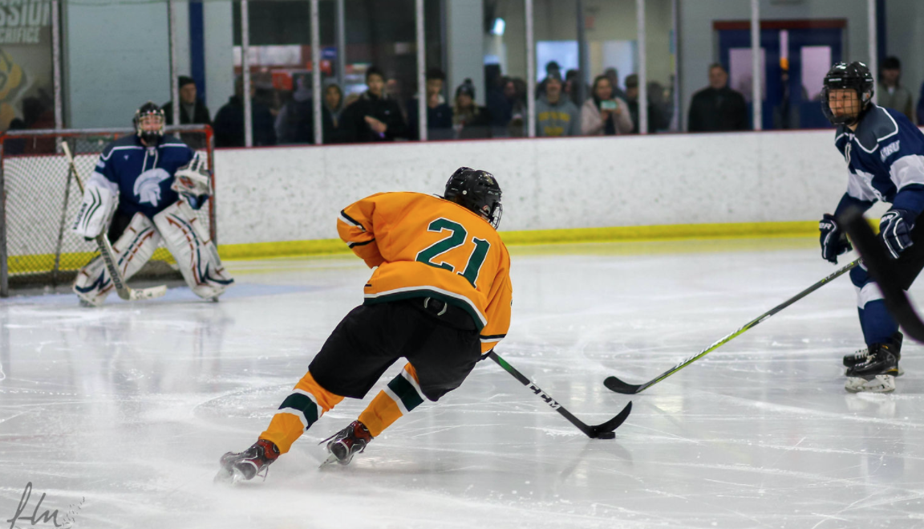

Above. McCutcheon attacking the Case Western zone. Adept at cutting on his edges, his speed backed up many a defender.

Few players had the ice vision of Colten. A perfect example of puck control and ice awareness made his game a fun one to watch!
