Player Name: | Career Highlights:
Knecht, Mitchell  C 23 | The big hands man whose strong corner and wall play could flatten opposing players. Mitchel could be an imposing figure on the ice and yet he was an adept passer with wrist shot that could handcuff opposing goalies. He did not play his freshman year and saw his first action in the one game COVID season of 20-21 when SVC beat RMU 4-2. His first goal came against Cleveland State, a game where he had 4 shots on net and was a plus one. He doubled his goal total his senior year with a hard wrist shot score against WVU and a smart deflected power play goal in the SVC win over Stevenson. His first assist came on the opening score of SVC’s 6-5 win over IUP, setting up a tally by Dino Capozzoli.

Yr | # | Pos | GP | G | A | TP | S | Pct | + | - | +/- | PM | W | T | P | S
2021 | 50 | LW | 1 | 0 | 0 | 0 | 0 | 0.0 | 1 | 1 | E | 2 | 0 | 0 | 0 | 0
2122 | 50 | RW | 22 | 1 | 0 | 1 | 23 | 4.1 | 4 | 16 | -12 | 10 | 0 | 0 | 0 | 0
2223 | 50 | LW | 26 | 2 | 4 | 6 | 21 | 9.5 | 12 | 14 | -2 | 16 | 0 | 0 | 1 | 0
Totals |  |  | 49 | 3 | 4 | 7 | 44 | 6.8 | 17 | 31 | -14 | 28 | 0 | 0 | 1 | 0

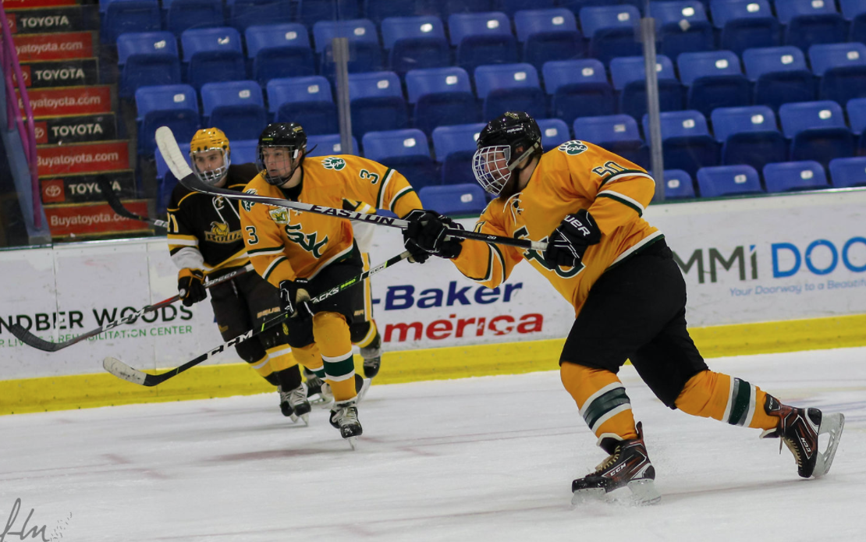
Mitchell lets one fly against Rowan University in the Pitt-Johnstown Invitational tournament. In the background is #3, Tristan Moyer.
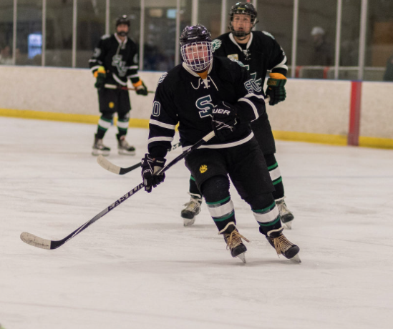

Game action against WVU in Morgantown. (Top) Mitchel moves up ice on the attack. (Bottom) Odds are this encounter did not end well for the West Virginia player.

