Player Name: | Career Highlights:
Hoffman, Joshua  C 24 | Josh suited up for two seasons for the Polar Bearcats including the one game COVID campaign of 20-21 in which Josh set up two goals to help SVC defeat the Robert Morris Colonials 4-2. He usually centered the third line and saw frequent penalty kill time.

Yr | # | Pos | GP | G | A | TP | S | Pct | + | - | +/- | PM | W | T | P | S
2021 | 30 | C | 1 | 0 | 2 | 2 | 1 | 0.0 | 2 | 0 | +2 | 0 | 0 | 0 | 0 | 0
2122 | 30 | C | 21 | 1 | 3 | 4 | 40 | 2.5 | 8 | 23 | -15 | 0 | 0 | 0 | 0 | 0
Totals |  |  | 22 | 1 | 5 | 6 | 41 | 2.4 | 10 | 23 | -13 | 0 | 0 | 0 | 0 | 0

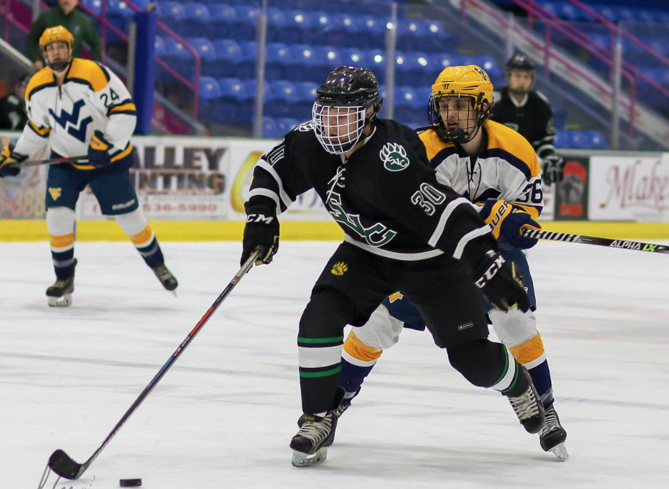

Josh blocks a defender while protecting the puck. Game action against WVU at the Cambria County War Memorial in Johnstown in the 21-22 season. Saint Vincent was a substitute participant in the UPJ Invitational Tournament.
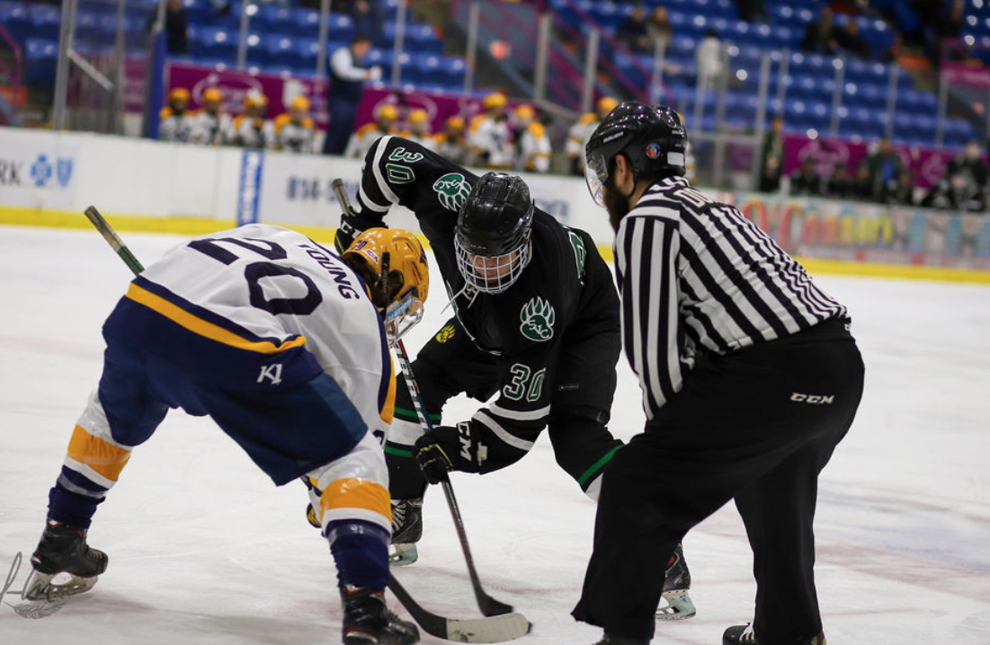
Josh would reverse his hands when trying to draw the puck back to the point during an offensive zone face off.

