Player Name: | Career Highlights:
Zapata, Zachary  C ‘21 | A gifted skater with great playmaking and scoring touch, Zach closed his career passing the 30 goal mark and ended 30’th all-time in SVC scoring history at the time of his graduation. Had he not lost almost the entire 2020-2021 season as a result of COVID restrictions, it is highly likely he would have moved into the top 20. His first goal came against Altoona He scored in bunches and had six 2 goal games and two hat tricks, none bigger than the one in the opening game of his senior year when SVC stunned upper division rival IUP 8-5. Overall he recorded 19 multiple point games with game winning goals against Gannon, Allegheny, and Pitt Greensburg. Put up 2 shorthanded goals (UPG and Duquesne). Not only was he a top line power play contributor, he was also adept and penalty killing. In spite of logging a large number of minutes each season, he took very few penalties which made him easy to coach and use in situations that required level headed play.

Yr | # | Pos | GP | G | A | TP | S | Pct | + | - | +/- | PM | W | T | P | S
1819 | 22 | Lw | 16 | 7 | 13 | 20 | 64 | 10.9 | 22 | 30 | -8 | 4 | 0 | 0 | 0 | 0
1920 | 22 | Lw | 18 | 13 | 14 | 27 | 82 | 15.9 | 27 | 17 | +10 | 4 | 2 | 0 | 5 | 1
2021 | 22 | Lw | 1 | 0 | 0 | 0 | 4 | 0.0 | 1 | 1 | E | 0 | 0 | 0 | 0 | 0
2122 | 22 | Lw | 21 | 15 | 11 | 26 | 96 | 15.6 | 36 | 28 | +8 | 2 | 1 | 0 | 3 | 1
Totals |  |  | 56 | 35 | 38 | 73 | 246 | 14.2 | 86 | 76 | +10 | 10 | 3 | 0 | 8 | 2

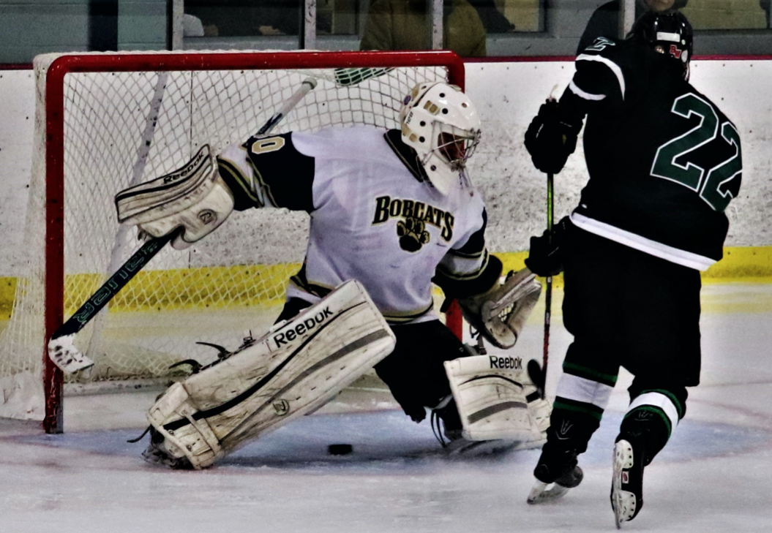
#22 had great hands around the net. Zach opens the legs of the UPG netminder demonstrating his slick hands and ability to feather pucks behind opposing goalies.

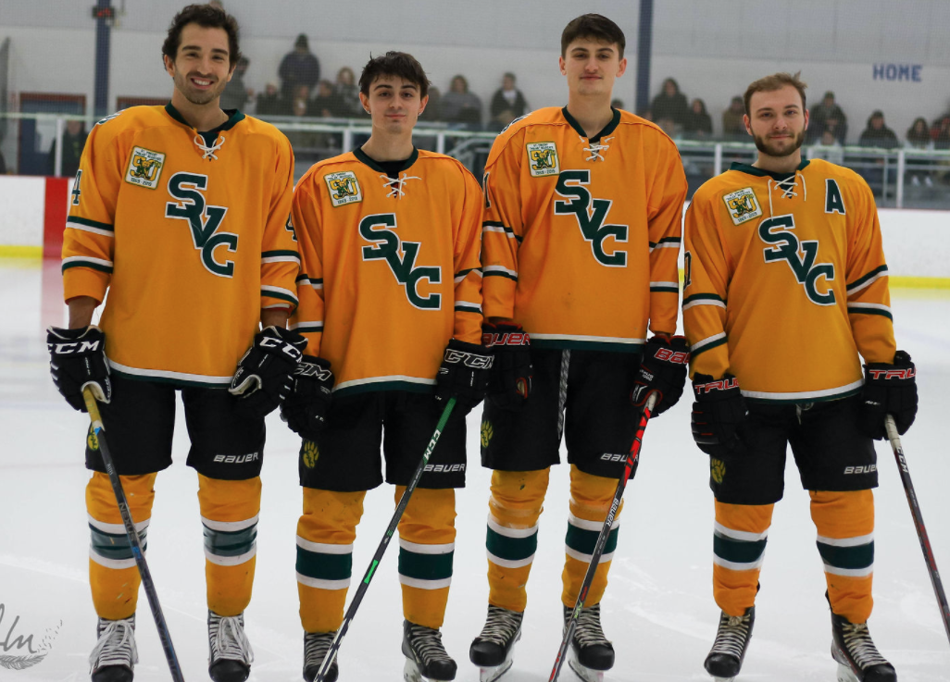

Seniors (L-R): Chris Miller, Zachary Zapata, Clark Josephson and Trent Stead.

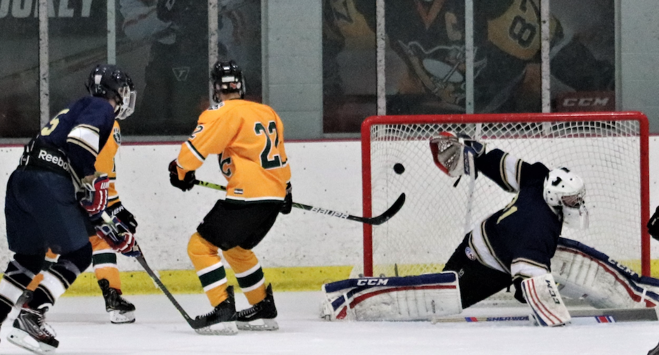
Zach twisted more than one goaltender during his playing years. A great shot of a goal against Pitt Bradford. His and ability to deke and deposit scores made for thrilling hockey!

