Player Name: | Career Highlights:
Stead, Trent  C 21 | A defenseman who brought energy and hustle to the team, Trent’s efforts earned him the role of Assistant Captain starting his sophomore year. A steady defender, he was relied on to capture a large number of minutes his first few years. His loan goal came on a power play in a game against Penn State Altoona. His playing time was impacted by the one game 20-21 COVID season and injuries he sustained during his senior year. Well liked by his teammates and the coaching staff, he had a great bench demeanor and positive approach in the locker room.

Yr | # | Pos | GP | G | A | TP | S | Pct | + | - | +/- | PM | W | T | P | S
1819 | 37 | D | 13 | 0 | 2 | 2 | 13 | 0.0 | 13 | 25 | -12 | 4 | 0 | 0 | 0 | 0
1920 | 37 | D | 18 | 1 | 2 | 3 | 16 | 6.3 | 37 | 26 | +11 | 12 | 0 | 0 | 1 | 0
2021 | 37 | D | 1 | 0 | 0 | 0 | 0 | 0.0 | 0 | 0 | E | 0 | 0 | 0 | 0 | 0
2122 | 37 | D | 6 | 0 | 2 | 2 | 7 | 0.0 | 7 | 5 | +2 | 0 | 0 | 0 | 0 | 0
Totals |  |  | 38 | 1 | 6 | 7 | 36 | 2.8 | 57 | 56 | +1 | 16 | 0 | 0 | 1 | 0

#37, Trent Stead in game action against Robert Morris University. Trent keeps the puck in the zone as teammates Clark Josephson (L) and Zachary Zapata (R) get in position to make an attacking play for SVC.

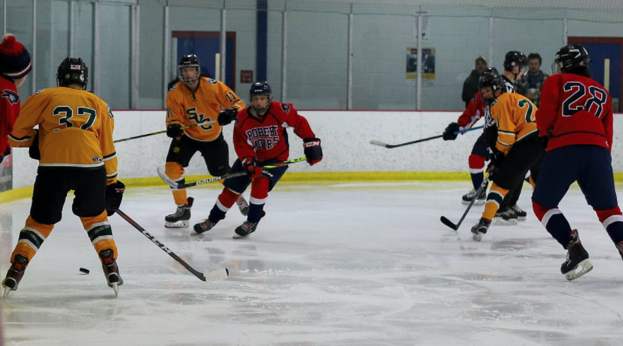

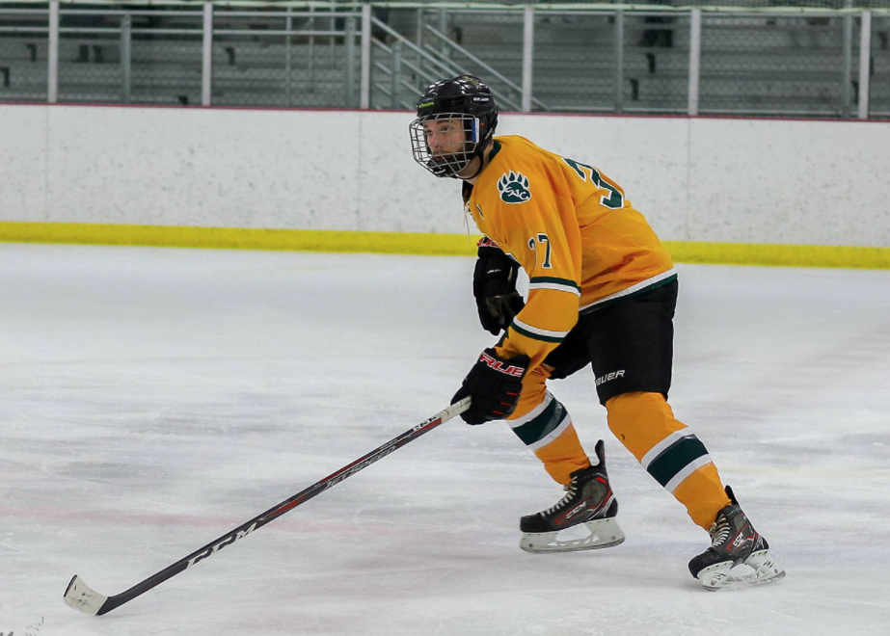

Above: Trent shows his tracking form as he prepares to defend.
Below: Graduating Seniors (L-R) Chris Miller, Zachary Zapata, Clark Josephson and wearing the “A” as an Assistant Captain, Trent Stead.

