Player Name: | Career Highlights:
Reich, George  C ‘23 | George came out when the team needed a practice goaltender and worked hard to improve his ability to play. Coach Z would frequently blast shots at him his first year, The effort was rewarded when George changed on the fly against Duquesne to close a 9-1 SVC win over Duquesne making two saves and allowing zero goals in 3 minutes of play. He was a math major at SVC.

Yr | # | Pos | GP | G | A | TP | S | Pct | + | - | +/- | PM | W | T | P | S
2021 | 31 | G | 0 | 0 | 0 | 0 | 0 | 0.0 | - | - | - | 0 | 0 | 0 | 0 | 0
2122 | 31 | G | 2 | 0 | 0 | 0 | 0 | 0.0 | - | - | - | 0 | 0 | 0 | 0 | 0
Totals |  |  | 2 | 0 | 0 | 0 | 0 | 0.0 | - | - | - | 0 | 0 | 0 | 0 | 0

Yr | # | Pos | GP | MP | GA | AVG | SO | EN | W | L | T | SHOTS | SAVES | PCT
2021 | 31 | G | 0 | 0 | 0 | 0.00 | 0 | 0 | 0 | 0 | 0 | 0 | 0 | 0
2122 | 31 | G | 2 | 6 | 1 | 10.0 | 0 | 0 | 0 | 0 | 0 | 5 | 4 | .800
Totals |  |  | 2 | 6 | 1 | 10.0 | 0 | 0 | 0 | 0 | 0 | 5 | 4 | .800

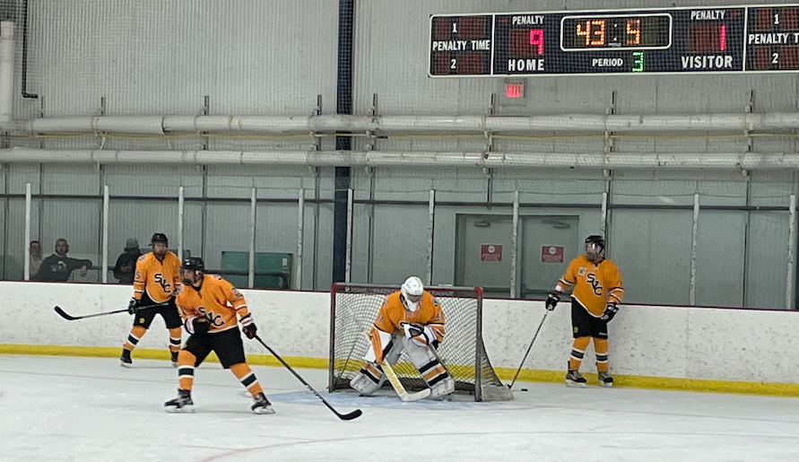

George closes out a 9-1 win over the Duquesne Dukes. In a move seldom seen at any level, Coach Martz had George change on the fly to get into the game!

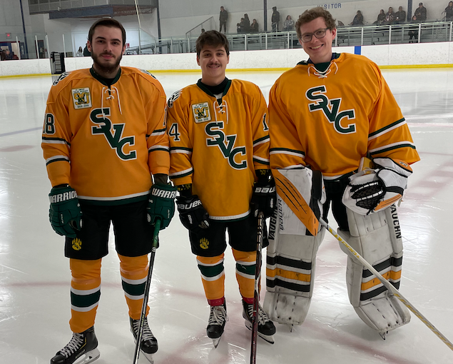

Top: Senior day. (L-R) Taylor Hall, Mitch Fuchs, and George Reich.
Bottom: Shane Stone (L) and George (R). The pair that executed the on-the-fly goaltending change!!

