Player Name: | Career Highlights:
Miller, Chris  C ‘22 | Be hit or get out of the way. A tough aggressive defender who could shoot, skate, move the puck or lift opposing players off the ice with devastating checks. Chris logged an incredible number of minutes when the team dropped to only three defenders in the 21-22 season. Made an immediate impact on the ability of SVC to play hard against bigger schools leading to three consecutive winning seasons each year he played. His 12 goals in the 19-20 season set a new record for defenseman eclipsing the 10 scored by Tim Legath in the 2008-2009 season. He passed Z-Man in total points for a defenseman becoming the 4’th all-time leading scorer for defenseman in only a little over 2+ seasons. But for the lone one game COVID season he had a legitimate shot to be the top scoring defender in history. His 1.71 points per game is best all time among defenders and his 27 assists in his last season eclipsed the 22 of TJ Drake in the 2004-2005 season.  In his 1’st game his 1’st goal was a shorthanded game winner over Robert Morris. Scored a goal in the one game COVID season over RMU and the only goal in SVC’s first ever game against Rowan. Had had 17 multi point games including two 5 assist efforts (Cleveland State and Duquesne), and a monster hat trick 2 assist contribution over Duquesne that included the game winner. His six game winners have terrorized Duquesne 3 times, Cleveland State twice and RMU.

Yr | # | Pos | GP | G | A | TP | S | Pct | + | - | +/- | PM | W | T | P | S
1920 | 4 | D | 16 | 12 | 13 | 25 | 73 | 16.4 | 34 | 23 | +11 | 70 | 3 | 0 | 4 | 1
2021 | 4 | D | 1 | 1 | 0 | 1 | 4 | 25.0 | 4 | 1 | +3 | 2 | 0 | 0 | 0 | 0
2122 | 4 | D | 18 | 7 | 27 | 34 | 140 | 5.0 | 66 | 37 | +29 | 83 | 3 | 0 | 1 | 0
Totals |  |  | 35 | 20 | 40 | 60 | 217 | 9.2 | 104 | 61 | +43 | 155 | 6 | 0 | 5 | 1

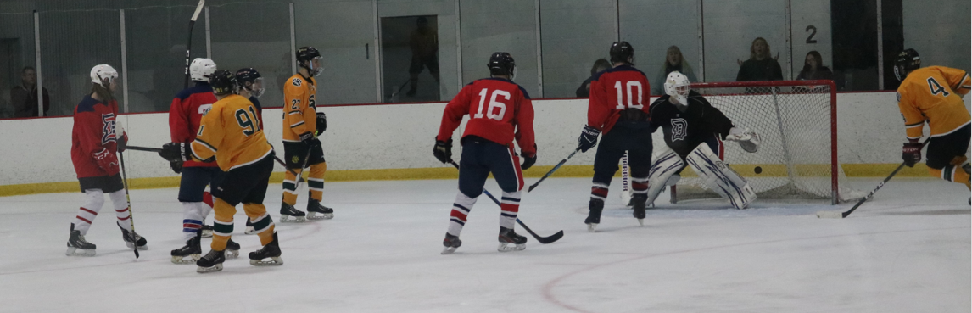
When he was at his best, Chris made it seem as if SVC had a 6’th player on the ice. Making a rush, getting a shot and then going back to defend was an everyday part of his play. A clear shot of a score against Duquesne deep in the attacking zone.

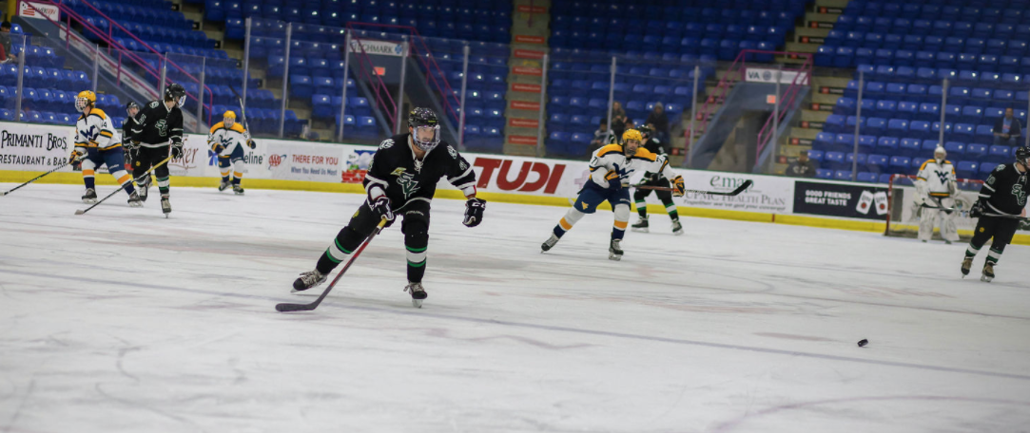
Tracking down puck to transition “D” to “O” was a specialty for Chris.

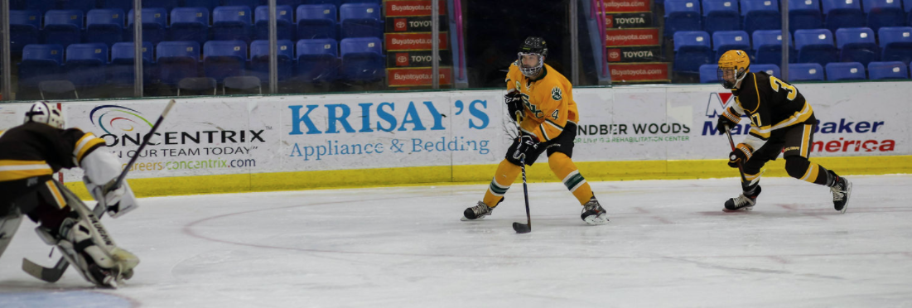

Never a good sign for the opposing team when Miller got behind a defender. Moments before he scores against Rowan University at the UPJ Invitational.

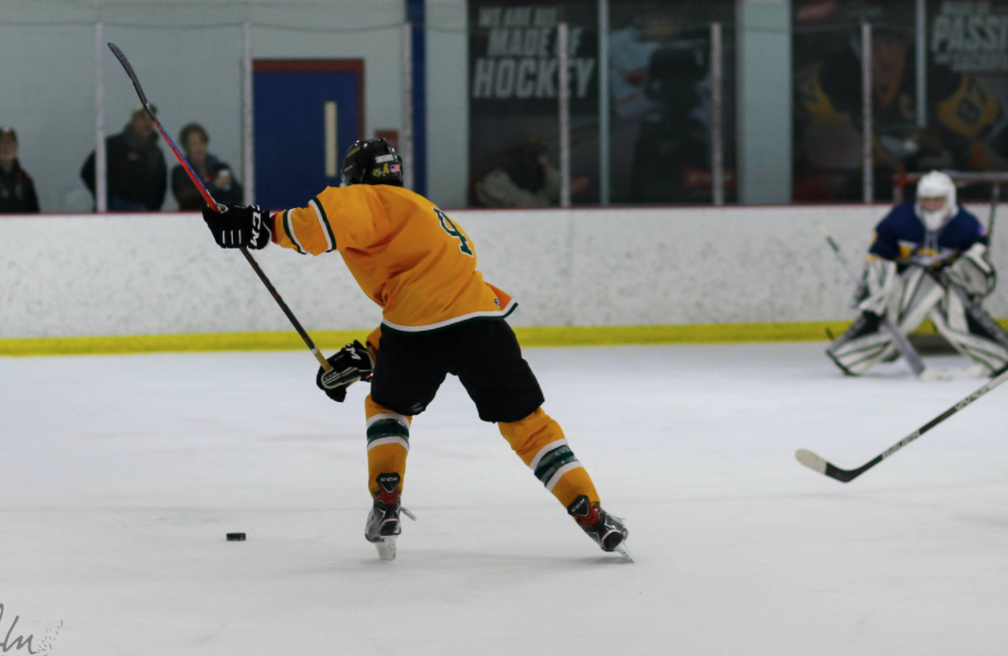
A shot few would want to block. Chris winds up against Allegheny County. He could handcuff a goalie with forwards converting on rebounds or blow a puck past against any netminder.

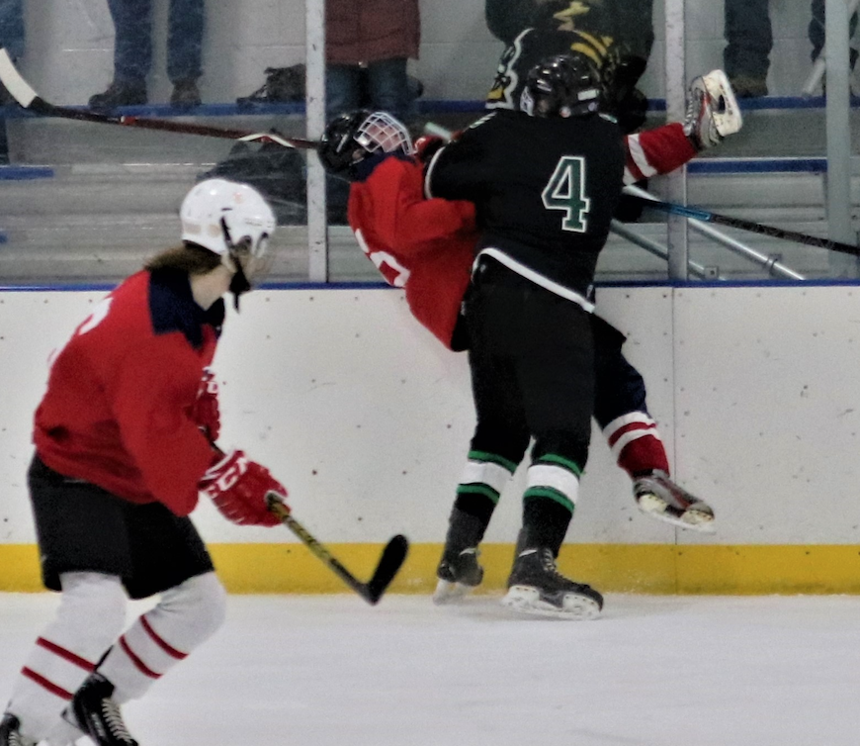

Not only could he score and move the puck, Chris skated with an edge that required the opposition to play with their heads up and to pay the price along the boards and in open ice. An example of how Chris could rock an opponent. He blows up a Duquesne player in game action. He probably scored as well as he loved to torment the Dukes!

