Player Name: | Career Highlights:
Josephson, Clark  C ‘21 | A smooth skater, Clark developed his finesse game to include more power his senior year. More of a play maker, his first point was an assist on a Nick Rogalski goal against UPG his freshman year. His 1’st career goal was combined with an assist against Case. Consistent contributor seldom going back-to-back games without a point, he had 6 multiple point games including a 4 assist effort against Cleveland State. Scored the loan goal in a playoff loss to Case and an opening tally starting SVC to a 5-3 win over Penn State Altoona. Made a big play in the loan game of the COVID year with a board pinch in the RMU zone leading to a turnover and the Colten McCutcheon score. His dad was a huge off ice contributor acting as the locker room manager for home and away games as an extension of the team’s support of its student athletes.

Yr | # | Pos | GP | G | A | TP | S | Pct | + | - | +/- | PM | W | T | P | S
1819 | 41 | Rw | 11 | 2 | 6 | 8 | 22 | 9.1 | 13 | 11 | +2 | 8 | 0 | 0 | 0 | 0
1920 | 41 | Rw | 18 | 3 | 6 | 9 | 33 | 9.1 | 10 | 18 | -8 | 26 | 0 | 0 | 0 | 0
2021 | 41 | Lw | 1 | 0 | 1 | 1 | 0 | 0.0 | 2 | 0 | +2 | 0 | 0 | 0 | 0 | 0
2122 | 41 | Rw | 21 | 3 | 15 | 18 | 51 | 5.9 | 26 | 22 | +4 | 9 | 0 | 0 | 0 | 0
Totals |  |  | 51 | 8 | 28 | 36 | 106 | 7.5 | 51 | 51 | E | 43 | 0 | 0 | 0 | 0

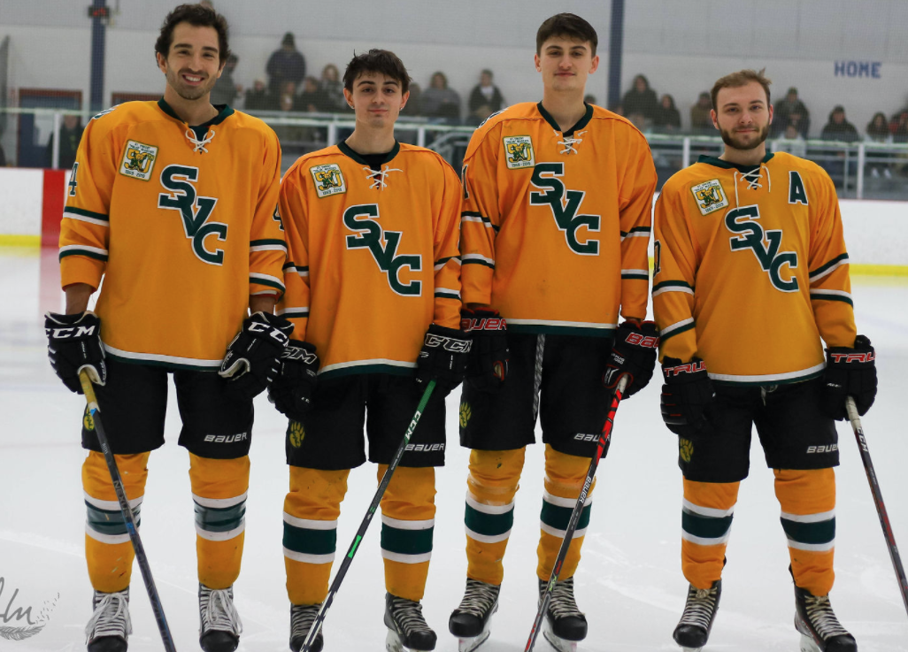
The senior class of 2021. (L-R) Chris Miller, Zachary Zapata, Clark Josephson and Trent Stead.

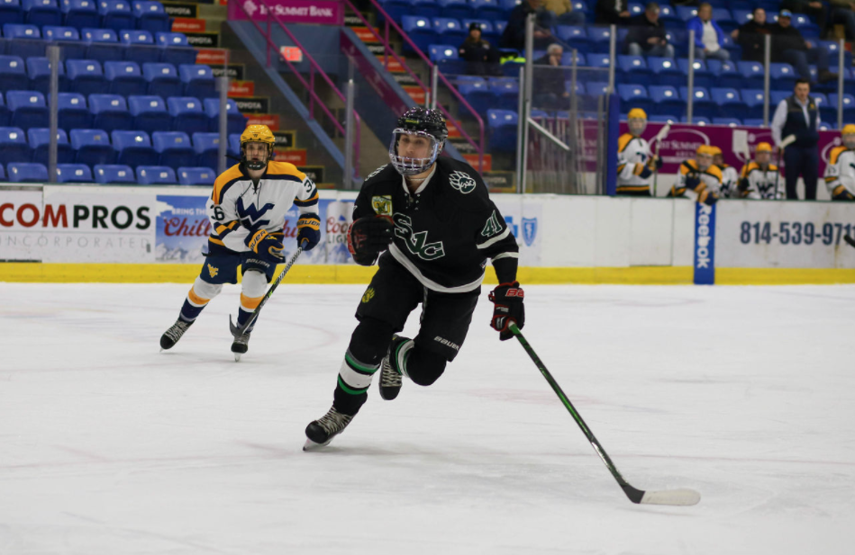
Clark tracks down a puck in game action during the UPJ Invitational tournament. He had 5 assists that helped SVC to a 3-1 record over the weekend.

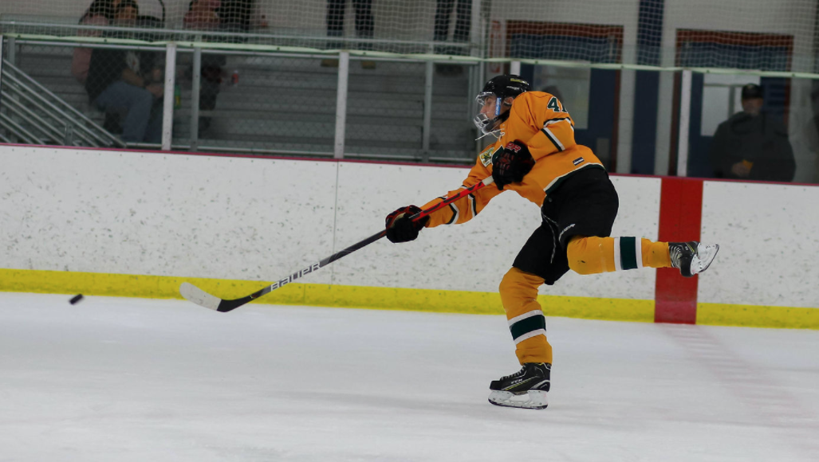

Although most of Clark’s scoring occurred with plays around the net he lets a puck fly from center ice towards the opposing team’s net in this frame.

