Player Name: | Career Highlights:
Hall, Taylor  C 23 | A steady defenseman with good puck moving instincts, Taylor added significant depth when SVC most needed blue liners. Often used to kill penalties, he added a touch of offense as well with the ability to move the puck up ice. He scored his first goal against Penn State Altoona with a helper by teammate Tristan Moyer. His strong play is reflected by his lifetime +5 rating. He loved rushing the puck and making plays deep in the attacking zone and then quickly moving back into defensive positioning along his blue line. He was frequently used in key situations at the end of close games when smart puck clearing or net defensive presence was important.

Yr | # | Pos | GP | G | A | TP | S | Pct | + | - | +/- | PM | W | T | P | S
1920 | 18 | D | 18 | 1 | 4 | 5 | 34 | 2.9 | 26 | 18 | +8 | 26 | 0 | 0 | 0 | 0
2021 | 18 | D | 1 | 0 | 0 | 0 | 1 | 0.0 | 1 | 1 | E | 0 | 0 | 0 | 0 | 0
2122 | 18 | D | 7 | 1 | 1 | 2 | 9 | 11.1 | 10 | 13 | -3 | 4 | 0 | 0 | 0 | 0
Totals |  |  | 26 | 2 | 5 | 7 | 44 | 4.5 | 37 | 32 | +5 | 30 | 0 | 0 | 0 | 0

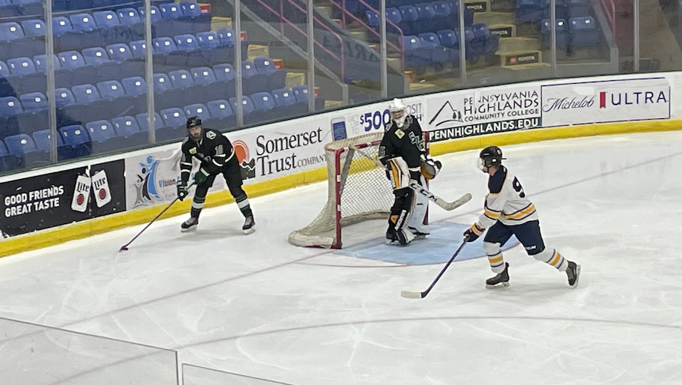

Taylor looking for a breakout play against Pitt Johnstown at the Cambria County War Memorial, the same venue of the classic hockey film “Slapshot”.
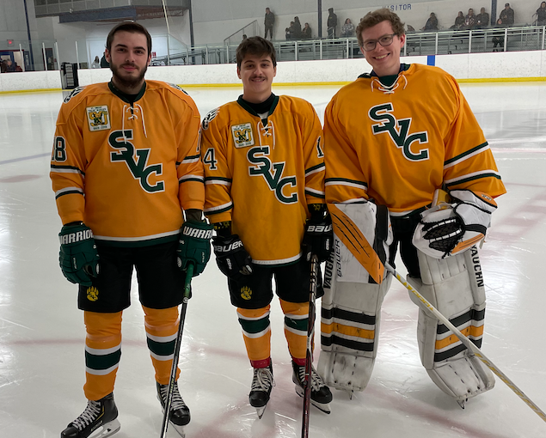
Senior day teammates. (L-R) Taylor, Mitch Fuchs and George Reich.

