Player Name: | Career Highlights:
Fuchs, Mitch  C 22 | Although he did not play his freshman year, Mitch never missed a beat and moved to the #1 Center role his sophomore year after a stellar career at Shaler High School. He graduated tied with two other players at 33’rd on the all time scoring list, in spite of the fact that he only had one true full season with the team with his Junior year impacted by COVID closures and his academic performance leading to an early December graduation. His 2.36 points per game is 7’th all time only bested by the Ward brothers, 70’s stars Ed Rickets and Roland DeFelice, current head coach Brett Martz and Jordan Spallone. A skilled playmaker, he led the team in scoring the last full pre-COVID season racking up 37 assists. Two games with significant impact included 4 goals against Duquesne, and a 2 goal 2 assist effort over Allegheny. But his key was the ability to make an impact on any game he played. Power play sets, penalty kills and shutting down the opposition with strong defensive positional play. Known for growing his “mustache” for his senior season.

Yr | # | Pos | GP | G | A | TP | S | Pct | + | - | +/- | PM | W | T | P | S
1920 | 14 | C | 18 | 11 | 37 | 48 | 86 | 12.8 | 37 | 17 | +20 | 24 | 0 | 0 | 0 | 2
2021 | 14 | C | 1 | 0 | 1 | 1 | 3 | 0.0 | 1 | 1 | E | 2 | 0 | 0 | 0 | 0
2122 | 14 | C | 9 | 10 | 7 | 17 | 45 | 22.2 | 19 | 11 | +8 | 33 | 0 | 0 | 3 | 1
Totals |  |  | 28 | 21 | 45 | 66 | 134 | 15.7 | 57 | 29 | +28 | 59 | 0 | 0 | 3 | 3

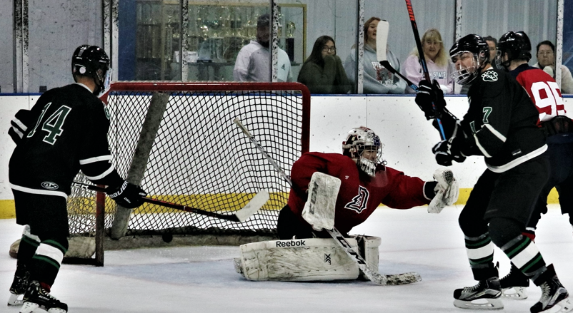

#14 Mitch Fuchs looks at the puck in the net behind a Duquesne goaltender as Nick Rogalski celebrates.

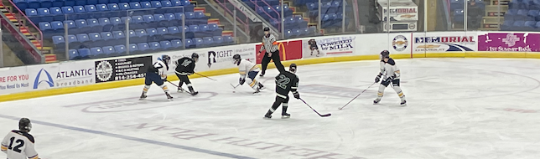

Mitch attacks a UPJ defender at the Cambria County War Memorial. Zach Zapata, #22, was a frequent recipient of a well placed Mitch Fuchs pass.

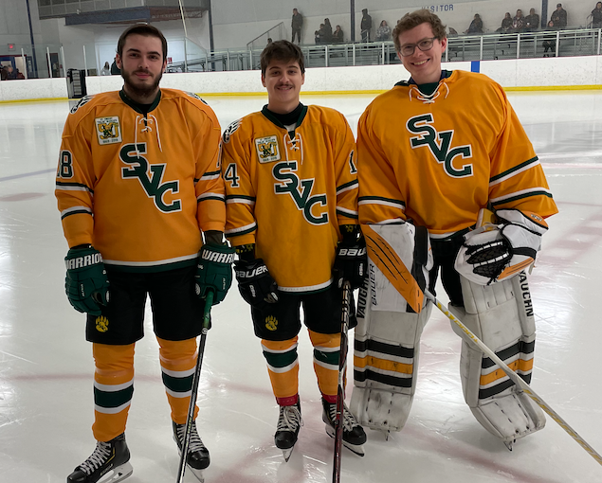

Senior celebrates. (L-R) Taylor Hall, Mitch Fuchs and George Reich.
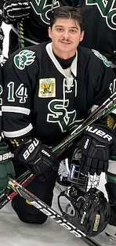
Looking like a movie star from the 1940’s, Mitch displays his senior mustache.

