Player Name: | Career Highlights:
Rogalski, Nick  C 21 | Nick brought an edge to the team with hitting and scoring that had not been seen in a long time, and when he was on, the team was almost unstoppable. He could flat out put the puck in the net, whether it was a tip in, off the rush, or in a scrum looking for a rebound. His size made his skating seem rough but he was always just enough faster than opposing players and almost unmovable when hit. He started slow but once in stride put up some monster games and was a UPG killer. His first goal came against Penn State Altoona followed by his first of 12 power play markers against Denison. He had a hat trick that included three power play goals against Pitt Greensburg, one being the game winner, while in another UPG contest he ended a thrilling come from behind SVC win with an overtime goal. His short handed score came against RMU as SVC outscored the Colonials 4-1. He had several multiple point games but none more incredible than 5 goals on 7 shots against Edinboro.

Yr | # | Pos | GP | G | A | TP | S | Pct | + | - | +/- | PM | W | T | P | S
1819 | 7 | C | 14 | 19 | 5 | 24 | 61 | 31.1 | 15 | 22 | -7 | 4 | 2 | 1 | 8 | 0
1920 | 7 | C | 10 | 9 | 8 | 17 | 30 | 30.0 | 9 | 4 | +5 | 22 | 1 | 1 | 4 | 1
Totals |  |  | 24 | 28 | 13 | 41 | 91 | 30.8 | 24 | 26 | -2 | 26 | 3 | 2 | 12 | 1

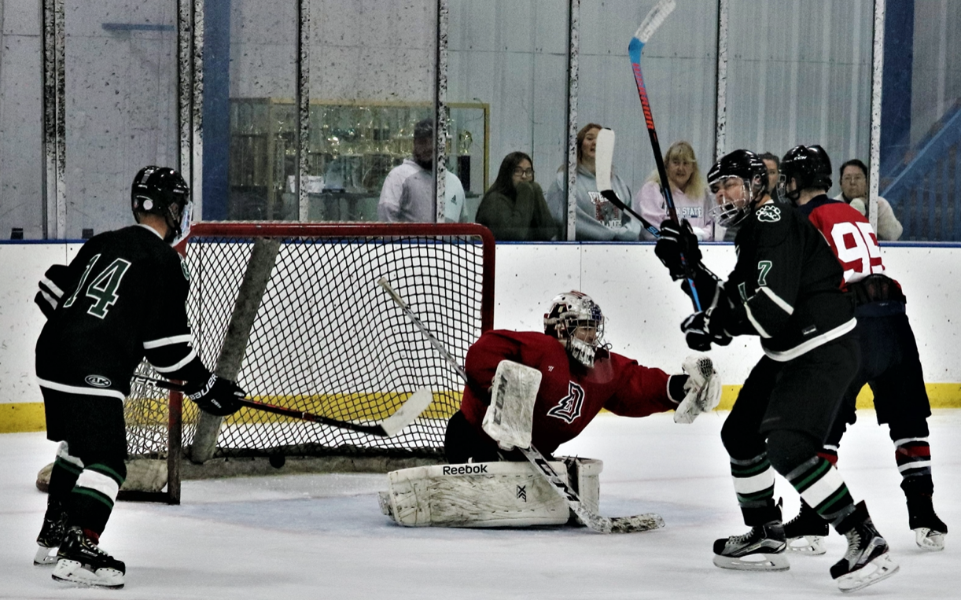

Intensity was always a huge part of Nick’s ice presence. The puck can be clearly seen in the back of the Duquesne net. As he explodes in the confidence of the goal. #14 Mitch Fuchs finds no reason to doubt what just happened.
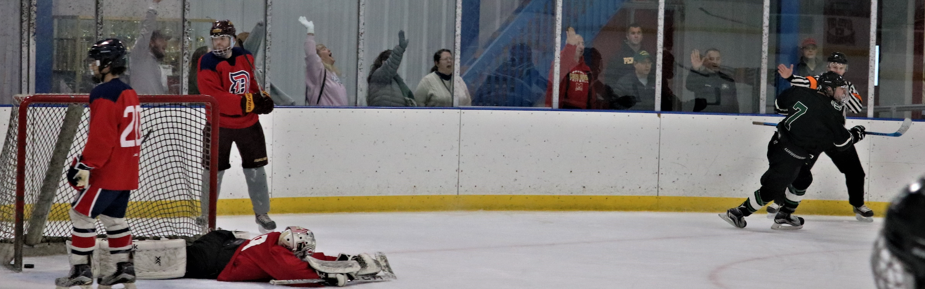
And the celebration continues as the referee affirmatively gives the goal sign.

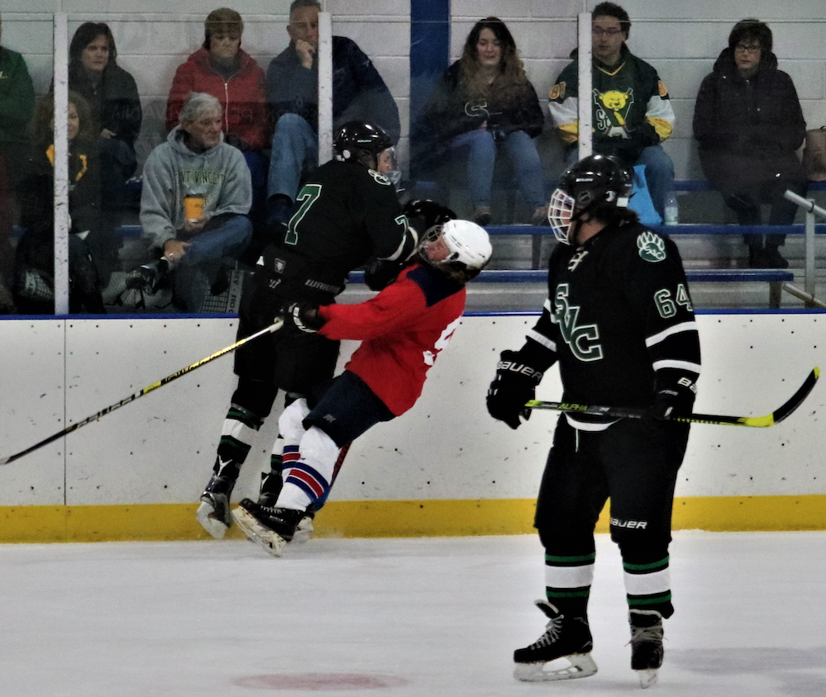

As if scoring was not enough to punish the other team, Nick’s hockey required opposing teams to play with their heads up or face the consequence. No one told this Duke that fast cars still need to avoid freight trains at crossings! Isaac Pesicka watches the hit.

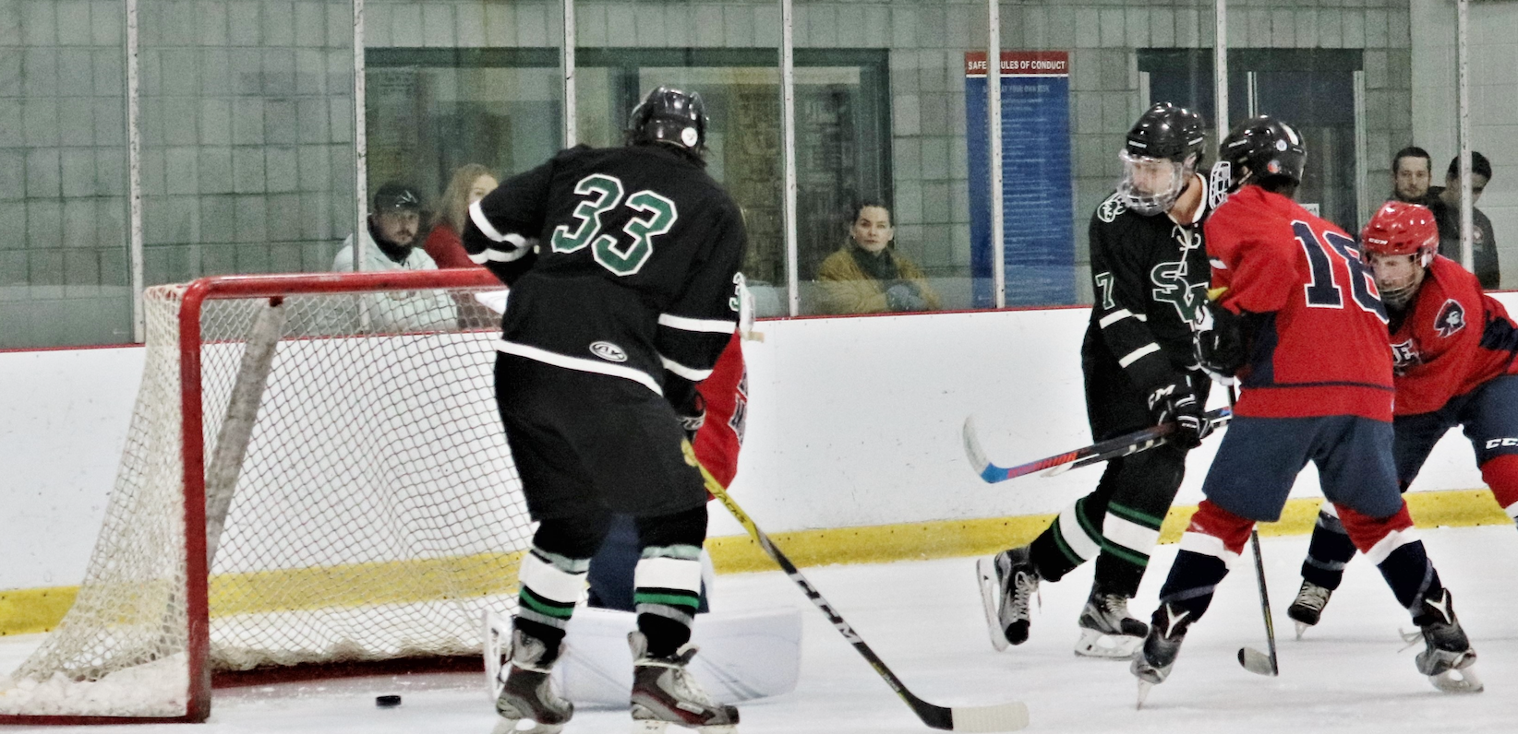

It didn’t have to be only one side of the stick. Nick had the finesse to use his backhand as well in this goal against the RMU Colonials. Cheyton Burchick, #33, is perfectly placed on the far post just in case the puck needed more encouragement to cross the goal line.

