Player Name: | Career Highlights:
Pesicka, Isaac  C’21 | Although a defenseman, on occasion Isaac would be moved to forward and demonstrated enough offensive nous to rack up several scoring streaks. Twice he had games with back to back assists (UPG and Penn State Altoona; Edinboro and UPG) and once had a three game assist streak (Shippensburg, Case, and Gannon). His first goal came against Edinboro while the second was placed behind an RMU netminder in a 9-4 SVC win. In one game against Wheeling he recorded 8 shots on goal. This was in spite of his role as a defensive minded blueliner. His practice battles with Coach Martz were legend. When traveling to Cleveland to play Case the team was treated by his family restaurant’s spaghetti, pizza and salad offerings. Worth the trip to Cleveland!

Yr | # | Pos | GP | G | A | TP | S | Pct | + | - | +/- | PM | W | T | P | S
1718 | 64 | D | 15 | 1 | 7 | 8 | 28 | 3.6 | 23 | 35 | -12 | 12 | 0 | 0 | 0 | 0
1819 | 64 | D | 16 | 0 | 4 | 4 | 17 | 0.0 | 24 | 32 | -8 | 28 | 0 | 0 | 0 | 0
1920 | 64 | D | 18 | 1 | 2 | 3 | 13 | 7.7 | 17 | 12 | +5 | 26 | 0 | 0 | 0 | 0
2021 | 64 | D | 1 | 0 | 0 | 0 | 0 | 0.0 | 1 | 0 | +1 | 0 | 0 | 0 | 0 | 0
Totals |  |  | 50 | 2 | 13 | 15 | 58 | 3.4 | 65 | 79 | -14 | 66 | 0 | 0 | 0 | 0

Isaac blocking the net in front of Alex Ferraro with offensive minded defensive partner Chris Miller working the weak side against Penn State Altoona.

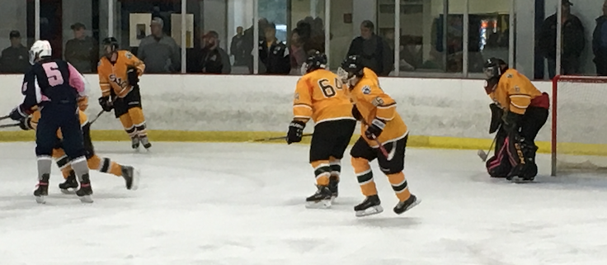

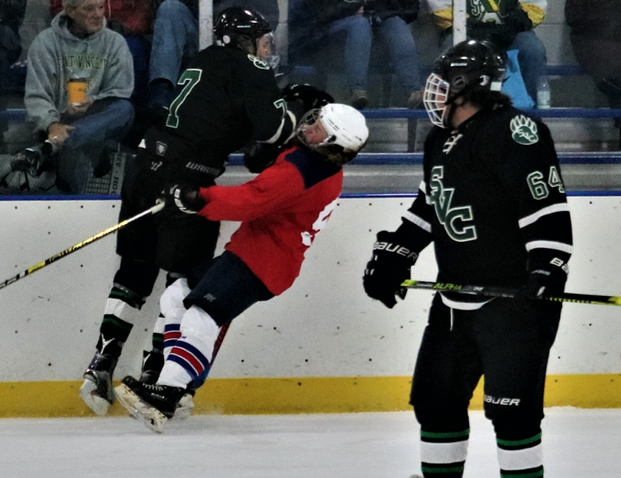
Ouch! Isaac holds the ice while Nick Rogalski runs through a Duquesne University player.

