Player Name: | Career Highlights:
Moyer, Joe  C’21 | An imposing figure on the ice, Joe had a size advantage over most players with the smarts to know exactly when to back off his physical play. As a result, even with his ability to work corners and the front of the net, he took few penalties. His presence on the ice always made opposing teams think twice about taking liberties with teammates. Joe’s consistency made a difference and his demeanor earned him recognition as an Assistant Captain. His first goal came against WVU, he added power play markers against Shipensburg, Pitt Bradford and Case, a short-handed score over Edinboro and game winners over Edinboro and UPB. He had a hat trick at Pitt Bradford that included that game winning goal. A true team player, he would play whatever was needed including time spent on defense when the team was running short of blue liners.

Yr | # | Pos | GP | G | A | TP | S | Pct | + | - | +/- | PM | W | T | P | S
1718 | 40 | Rw | 15 | 5 | 2 | 7 | 21 | 23.8 | 19 | 41 | -22 | 4 | 0 | 0 | 1 | 1
1819 | 40 | Rw | 16 | 5 | 6 | 12 | 38 | 13.2 | 15 | 29 | -14 | 2 | 1 | 0 | 0 | 0
1920 | 40 | Rw | 15 | 6 | 3 | 9 | 33 | 18.2 | 10 | 11 | -1 | 6 | 1 | 0 | 2 | 0
2021 | 40 | Rw | 1 | 0 | 0 | 0 | 1 | 0.0 | 1 | 0 | +1 | 0 | 0 | 0 | 0 | 0
Totals |  |  | 47 | 16 | 11 | 27 | 93 | 17.2 | 45 | 81 | -36 | 12 | 2 | 0 | 3 | 1

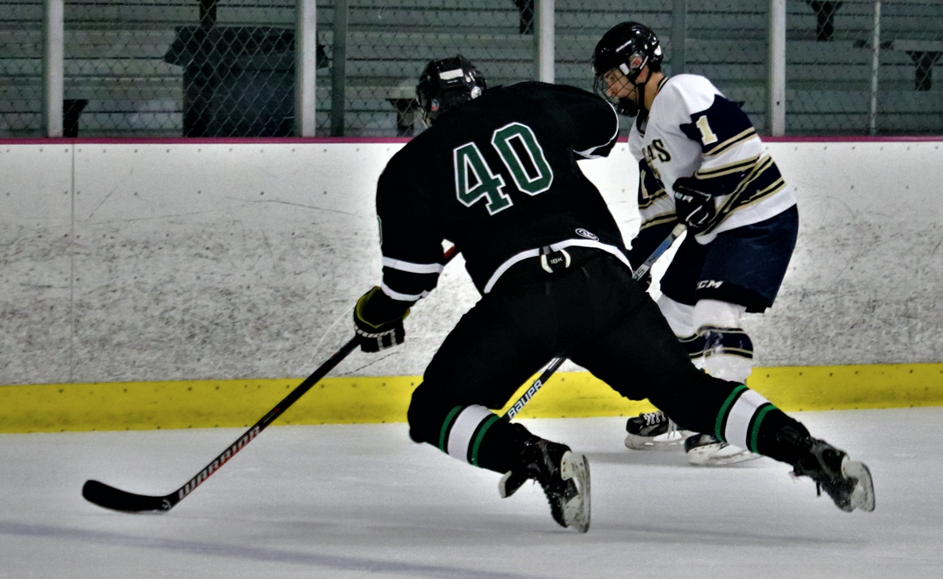
Joe dwarfed other players and made good use of his size to gain pucks in traffic. He teamed with his brother Tristan for two seasons and narrowly missed getting a goal against RMU in the only game of the shortened 2020-2021one game COVID campaign.

