Player Name: | Career Highlights:
Ferraro, Alex  C’21 | It would be difficult to think how SVC could have competed in games without Alex backstopping the team in his four years. His numbers can’t reflect the caliber of his play and how many games were made close or won by his uncanny ability to stop the puck. He made the net look small with his angle play, was deceptively quick coming across the crease, was razor sharp with his glove and rebounds almost never happened. His senior year was stolen by COVID and with an ever-improving team in front of him, he could have moved even higher in the club’s all-time goal tending list. Still, when he ended playing only Shane Brudnock had more saves and a higher save percentage. He also had an edge to his competitiveness and amazingly had 11 games with more than 40 shots, 11 games with more than 50 shots, and 7 games with more than 60. His effort against WVU in an away game may rank as one of the gustiest efforts in the history of collegiate ice hockey at any level. With a depleted SVC squad and an extremely deep and talented WVU squad, Alex faced an incredible 110 shots on goal and made an improbable 100 saves including 39 on 43 shots in the first period alone keeping the game to a respectable 6-2 WVU lead until the final few minutes of the game. His 2-0 shut out of Saint Francis was only the second one in team history since the 2010 season.

Yr | # | Pos | GP | G | A | TP | S | Pct | + | - | +/- | PM | W | T | P | S
1718 | 6 | G | 15 | 0 | 2 | 2 | 0 | 0.0 | - | - | - | 0 | 0 | 0 | 0 | 0
1819 | 6 | G | 16 | 0 | 0 | 0 | 0 | 0.0 | - | - | - | 4 | 0 | 0 | 0 | 0
1920 | 6 | G | 13 | 0 | 0 | 0 | 0 | 0.0 | - | - | - | 6 | 0 | 0 | 0 | 0
2021 | 6 | G | 1 | 0 | 0 | 0 | 0 | 0.0 | - | - | - | 0 | 0 | 0 | 0 | 0
Totals |  |  | 45 | 0 | 2 | 2 | 0 | 0.0 | - | - | - | 10 | 0 | 0 | 0 | 0

Yr | # | Pos | GP | MP | GA | AVG | SO | EN | W | L | T | SHOTS | SAVES | PCT
1718 | 6 | G | 15 | 902 | 87 | 5.79 | 1 | 2 | 7 | 8 | 0 | 751 | 664 | .884
1819 | 6 | G | 16 | 961 | 89 | 5.56 | 0 | 1 | 4 | 11 | 1 | 739 | 650 | .880
1920 | 6 | G | 13 | 814 | 53 | 3.91 | 0 | 1 | 7 | 5 | 1 | 558 | 505 | .905
2021 | 6 | G | 1 | 60 | 2 | 2.00 | 0 | 0 | 1 | 0 | 0 | 24 | 22 | .917
Totals |  |  | 45 | 2737 | 231 | 5.06 | 1 | 4 | 19 | 24 | 2 | 2072 | 1841 | .889
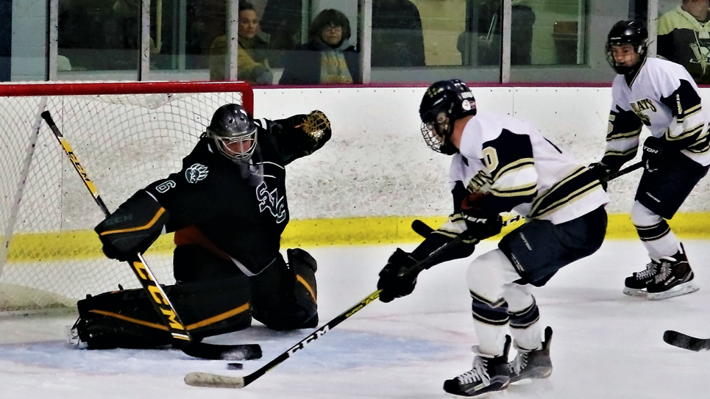
Alex had an incredible edge to his game and frustrated scoring attempt after scoring attempt from the opposition. Here he not only stops a 2on 0 by Pitt Greensburg players but then pokes the puck over the stick and out of danger. He never failed to make a second play when needed, but his rebound control made that a rare occasion. Opposing players played near his crease at their own risk.

