Player Name: | Career Highlights:
Detesta, Tanner  C’21 | Tanner had a high skill level as both a skater and puck mover for a blueliner. He played well above his size which took a toll on him with injuries as he never backed away from traffic or corners. His first point was an assist against Penn State Altoona. He recorded another helper in a game with Denison. His best effort was an opening goal and an assist in an exciting SVC come from behind win over UPG. He took off his Junior year and made a comeback for the 20-21 COVID year. Unfortunately, in spite of surpassing his previous ability in practice, he did not play in the only game of the COVID year, a 4-2 win by SVC over RMU.

Yr | # | Pos | GP | G | A | TP | S | Pct | + | - | +/- | PM | W | T | P | S
1718 | 20 | D | 9 | 0 | 0 | 0 | 11 | 0.0 | 8 | 16 | -8 | 4 | 0 | 0 | 0 | 0
1819 | 20 | D | 6 | 1 | 3 | 4 | 3 | 33.3 | 4 | 11 | -7 | 4 | 0 | 0 | 0 | 0
Totals |  |  | 15 | 1 | 3 | 4 | 14 | 7.1 | 12 | 27 | -15 | 8 | 0 | 0 | 0 | 0

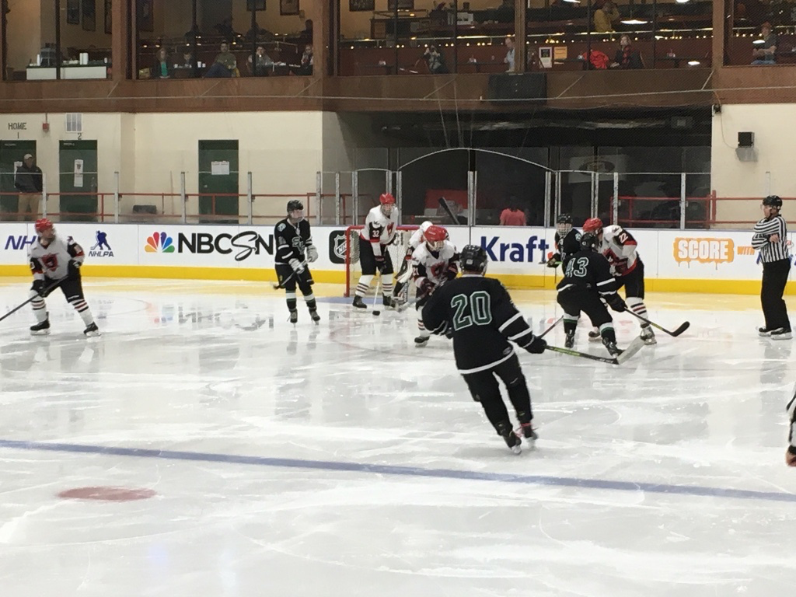

#20 Tanner in game action at Rostraver against Cal. SVC would win the game 4-3 in overtime on a score by Stone Haberstroh.

