Player Name: | Career Highlights:
Zawalsh, Adam  C’03 | Adam was a big part of the team the first two years of play and his skills were not reflected in his stats. A quick skater, he also played with a high level of intensity. Another Greensburg Central Catholic player who opted to continue his hockey at Saint Vincent. He stopped playing after his sophomore year, but came to practice several times after that, though not suiting up again for the Green and Gold.

Yr | # | Pos | GP | G | A | TP | S | Pct | + | - | +/- | PM | W | T | P | S
9900 | 43 | D | 10 | 0 | 1 | 1 | 4 | 0.0 | 6 | 8 | -2 | 16 | 0 | 0 | 0 | 0
0001 | 43 | D | 14 | 0 | 2 | 2 | 5 | 0.0 | 9 | 18 | -9 | 56 | 0 | 0 | 0 | 0
Totals |  |  | 24 | 0 | 3 | 3 | 9 | 0.0 | 15 | 26 | -11 | 72 | 0 | 0 | 0 | 0

Still sporting the maroon colors of Greensburg Central Catholic, Adam was one of the first in a long line of SVC GCC players.

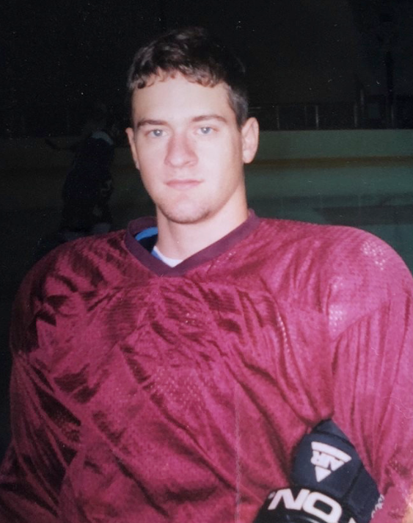

Adam flanked by teammates Chris Stiles #91 (Left) and Matt Grand #24 (Right).



