Player Name: | Career Highlights:
Speagle, Mike  C’06 | A key player for four years at the SVC blue line, Mike had one of the hardest shots of any player to lace up the skates at St. Vincent. He had a great head for the game and could rifle passes across the ice to breaking forwards. Mike never missed a contest in four years and saw significant time on the power play both as a shooter from the point and as down low attacker to screen the goalie. His best point totals came his junior year when he recorded 6 power play goals while being the main man in front of opposing goaltenders and when he was a nominee to the CHE All Star game. At the end of his career he held the record for most career power play goals by an SVC defenseman with 9 and was the teams all time penalty minute leader with 232. One of his most memorable moments was playing in both SVC ACHA D III National Tournament appearances, especially the 2003-2004 series in Phoenix, Arizona. Although hailing from Michigan, his parents were regular attendees of SVC contests, making regular trips to Western Pa and away games.

Yr | # | Pos | GP | G | A | TP | S | Pct | + | - | +/- | PM | W | T | P | S
0203 | 4 | D | 22 | 2 | 8 | 10 | 69 | 2.2 | 35 | 19 | +16 | 80 | 1 | 0 | 1 | 0
0304 | 4 | D | 26 | 1 | 11 | 12 | 32 | 3.1 | 28 | 23 | +5 | 18 | 0 | 0 | 1 | 0
0405 | 4 | D | 26 | 8 | 10 | 18 | 49 | 16.3 | 37 | 20 | +17 | 78 | 1 | 0 | 6 | 0
0506 | 4 | D | 24 | 1 | 5 | 6 | 29 | 3.4 | 33 | 22 | +11 | 62 | 0 | 0 | 1 | 0
 |  |  | 98 | 12 | 34 | 46 | 179 | 6.7 | 133 | 84 | +49 | 238 | 2 | 0 | 9 | 0

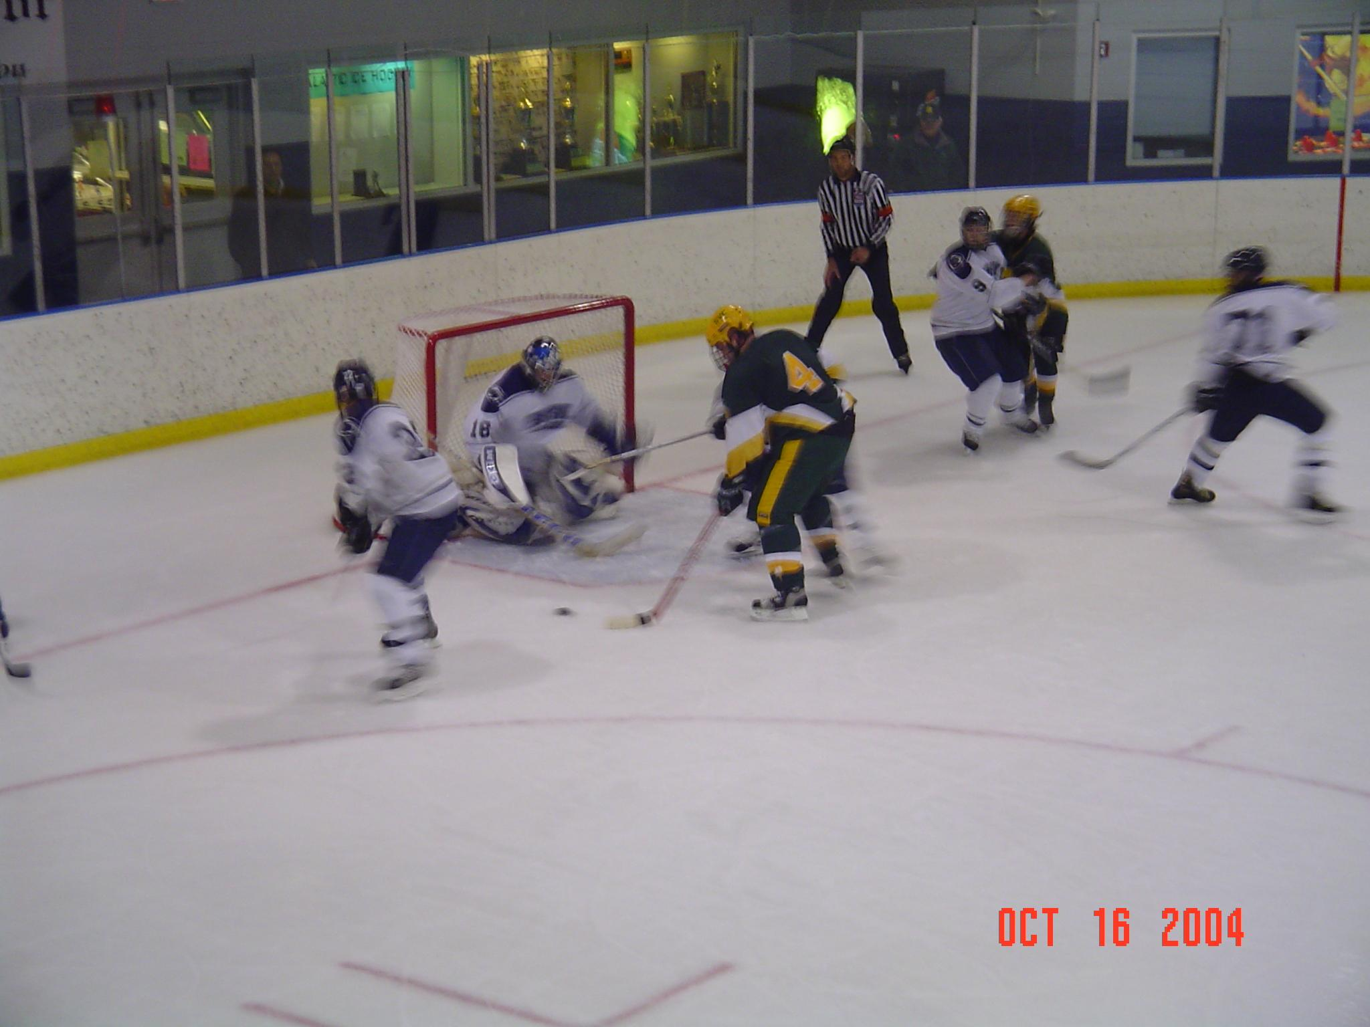
#4 Mike Speagle on the power play against Penn State at Altoona. Mike’s size and hands made him a formidable presence in front of opposing net minders when SVC had the man advantage.

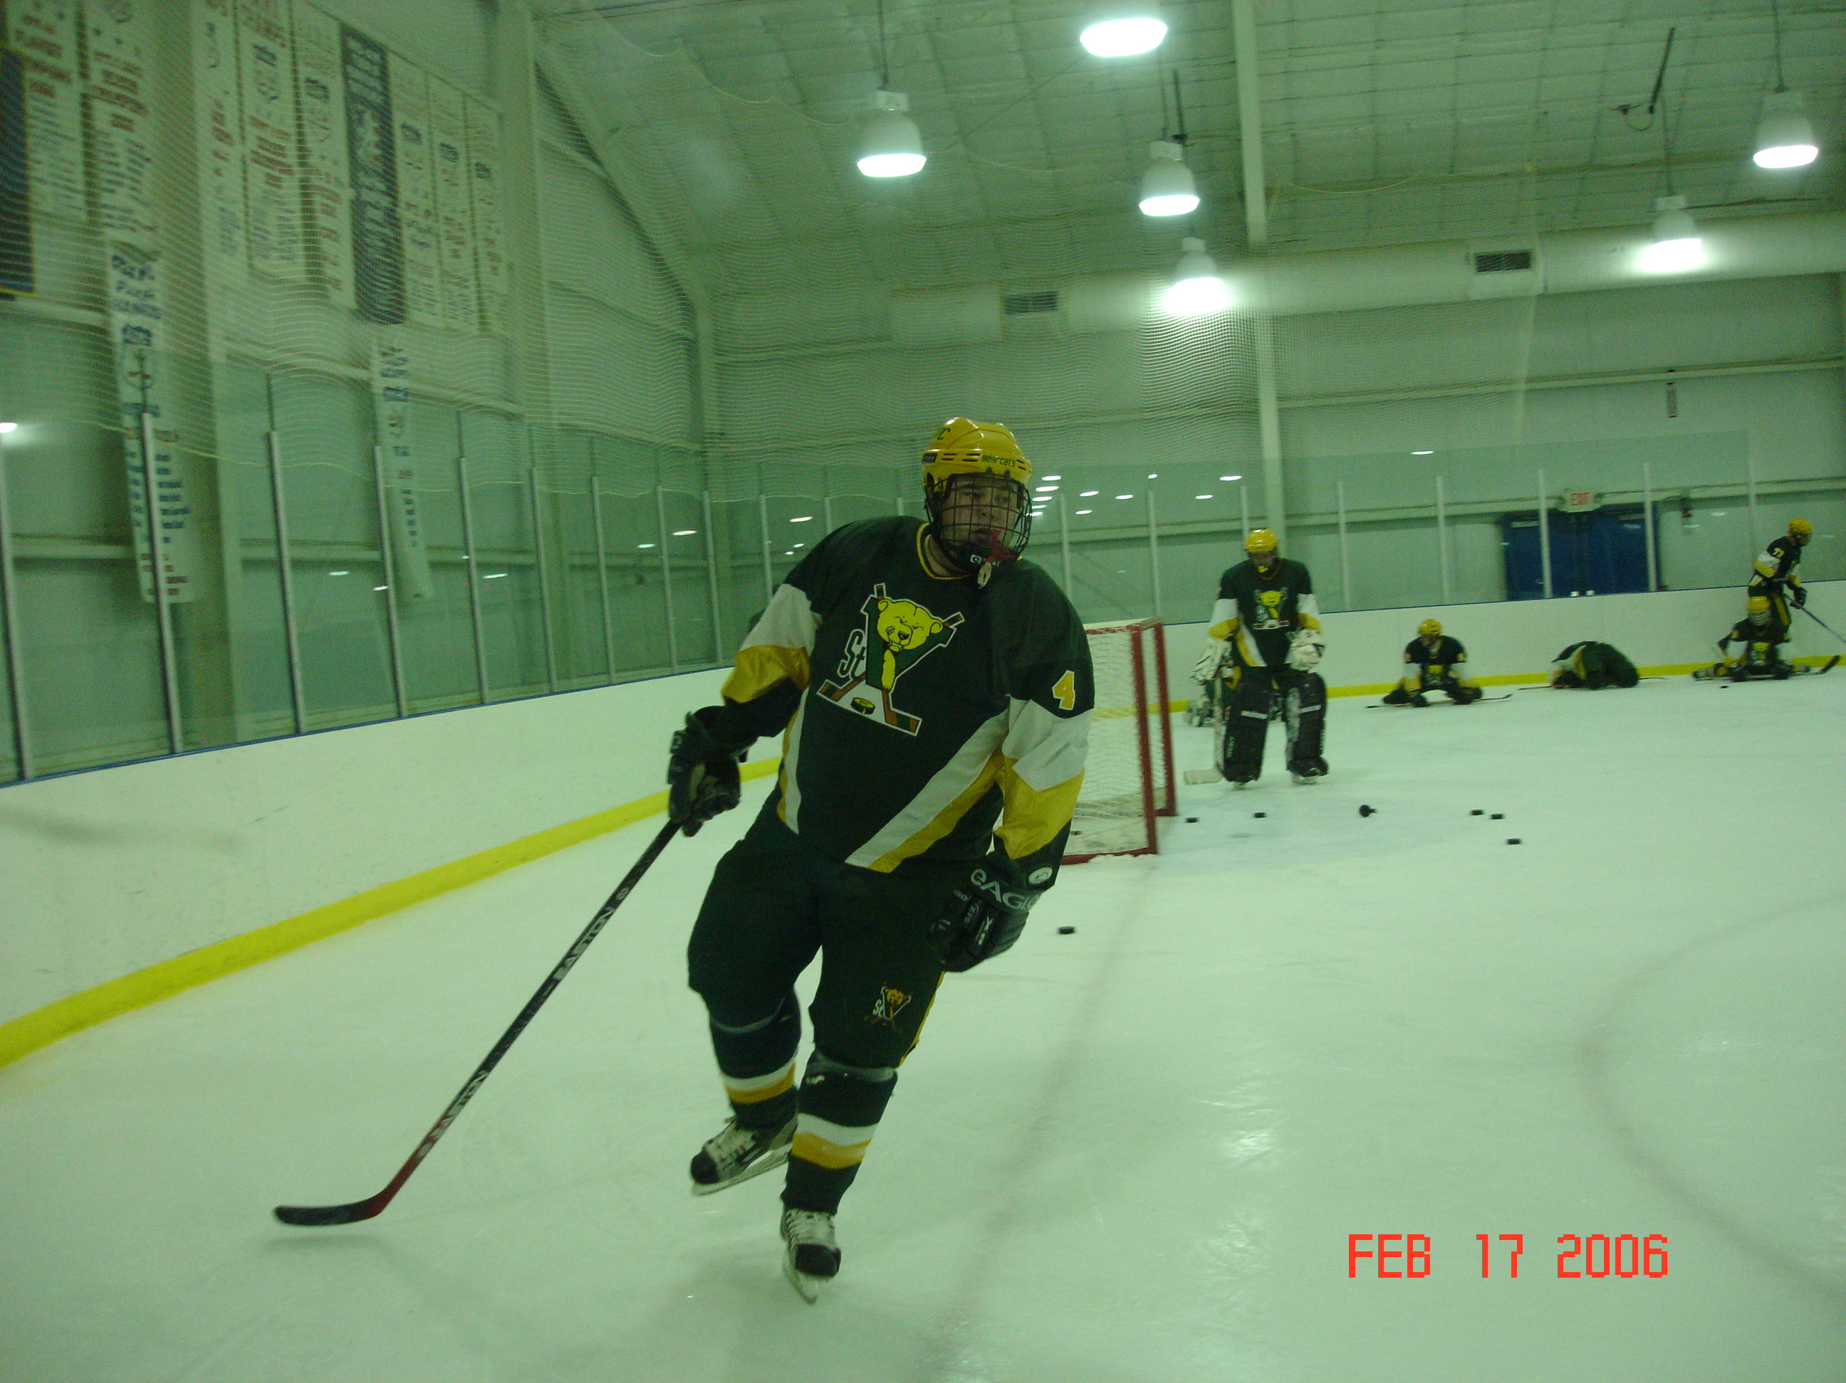

Mike in pre-game warm ups before a CHE playoff game against California University.

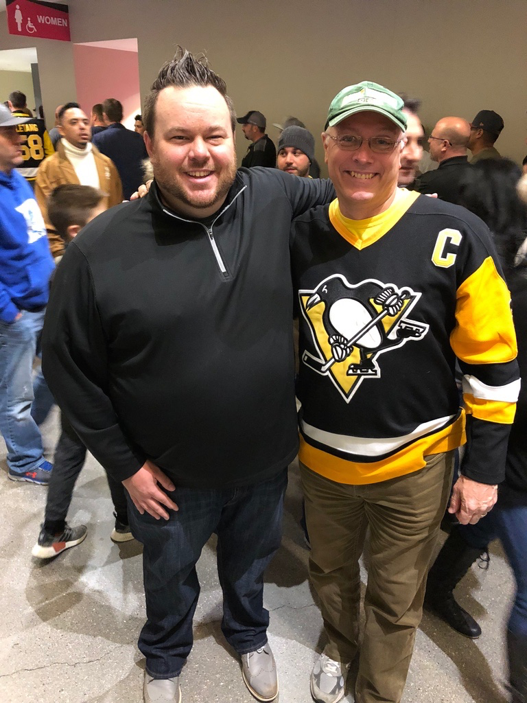
Mike with Coach Z at T-Mobile Arena in Las Vegas during a Pittsburgh Penguins Las Vegas Golden Knights game.

