Player Name: | Career Highlights:
Dell, Rick  C’78 | Rick was an important offensive threat for the team during his playing days. He constantly worked at his game and improved enough to become a key contributor during the team’s 76-77 championship season. His efforts earned him a promotion to the first line during his senior year. Always known for his heavy slap shot, he had the ability to simply over power goalies. Rick also had an excellent soft touch around the net and became an excellent playmaker as well during his junior and senior years. In spite of his mild manner, he also was able to step up his game and be an enforcer. He was a strong supporter and participant in the early alumni games.

Yr | # | Pos | GP | G | A | TP | S | Pct | + | - | +/- | PM | W | T | P | S
7475 | 11 | Rw | 9 | 1 | 5 | 6 | 4 | 25.0 | - | - | - | 16 | 0 | 0 | 0 | 0
7576 | 11 | Rw | 10 | 2 | 2 | 4 | 16 | 12.5 | - | - | - | 27 | 0 | 0 | 0 | 0
7677 | 11 | Rw | 12 | 10 | 20 | 30 | 71 | 14.1 | - | - | - | 21 | 0 | 0 | 2 | 0
7778 | 8 | Rw | 16 | 10 | 12 | 22 | 61 | 16.4 | - | - | - | 10 | 0 | 0 | 2 | 0
Totals |  |  | 47 | 23 | 39 | 62 | 152 | 15.1 | - | - | - | 74 | 0 | 0 | 4 | 0

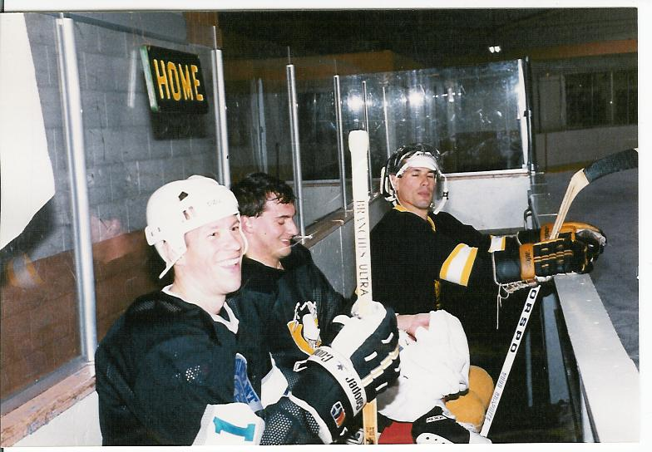
Rick Dell (Left) with brothers Kevin DeFelice (Middle) and Roland DeFelice (Far Right) during an alumni game.
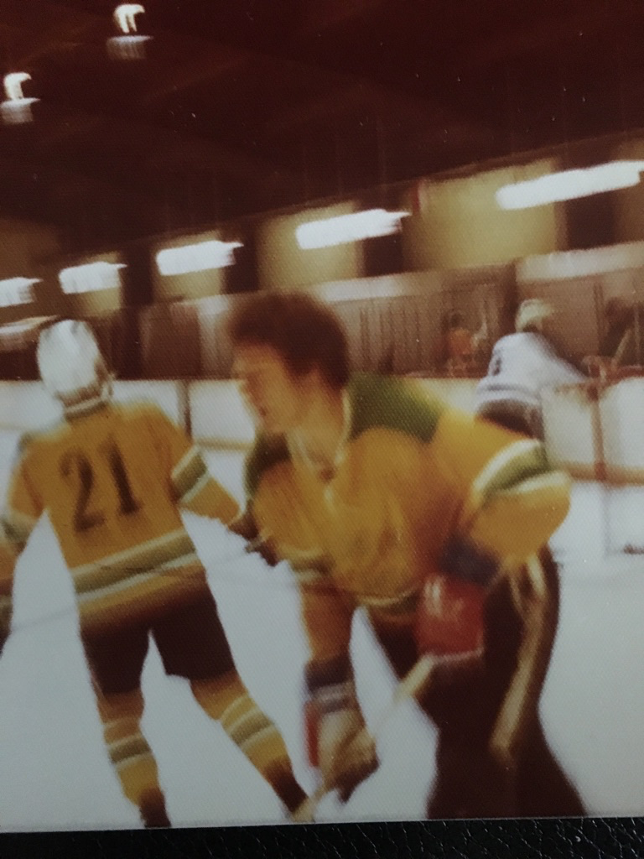
Rich sporting an old style SVC Gold & Green sweater from the mid 70’s. #21 is Rich Grochmal. Warm ups against Penn State McKeesport.

