Player Name: | Career Highlights:
Chakrabarti, Suman C’01 | Although one of the smallest players on the team during his two seasons, Suman recklessly through his body into opponents and was an outstanding hustler whenever he participated in the play. His tempo and attitude lead others by example and he often proved to be an inspiration whether in the locker room, on the bench, or on the ice. His two most memorable moments: throwing several body checks in an inspired shift against IUP that woke up the team and scoring a critical goal in the final game of the 1999-2000 season. After St. Vincent blew a lead against Youngstown State University, Suman picked up a puck in traffic in front of the YSU net to tie the score. His effort psyched the entire team to fight to a come from behind 9-7 victory over the Penguins. His last season was unfortunately cut short by an ankle injury, forcing him to miss the last few games of his senior year.

Yr | # | Pos | GP | G | A | TP | S | Pct | + | - | +/- | PM | W | T | P | S
9901 | 7 | Lw | 11 | 1 | 2 | 3 | 7 | 14.3 | 9 | 9 | E | 4 | 0 | 0 | 0 | 0
0001 | 7 | Lw | 8 | 0 | 1 | 1 | 3 | 0.0 | 5 | 8 | -1 | 0 | 0 | 0 | 0 | 0
Totals |  |  | 19 | 1 | 3 | 4 | 10 | 10.0 | 14 | 17 | -3 | 4 | 0 | 0 | 0 | 0

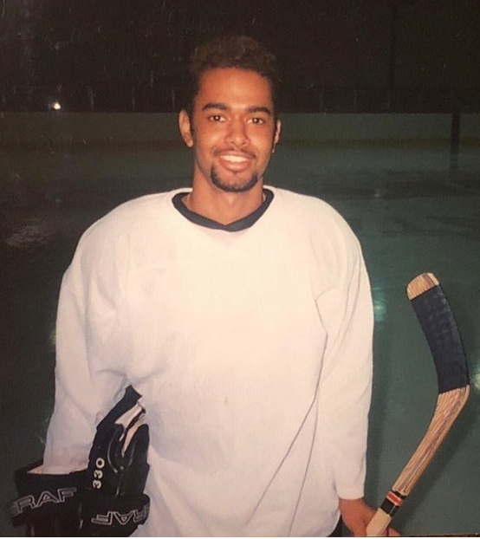

Suman at one of the first practices held by Coach Ziemianski during the rebirth of the SVC hockey program.

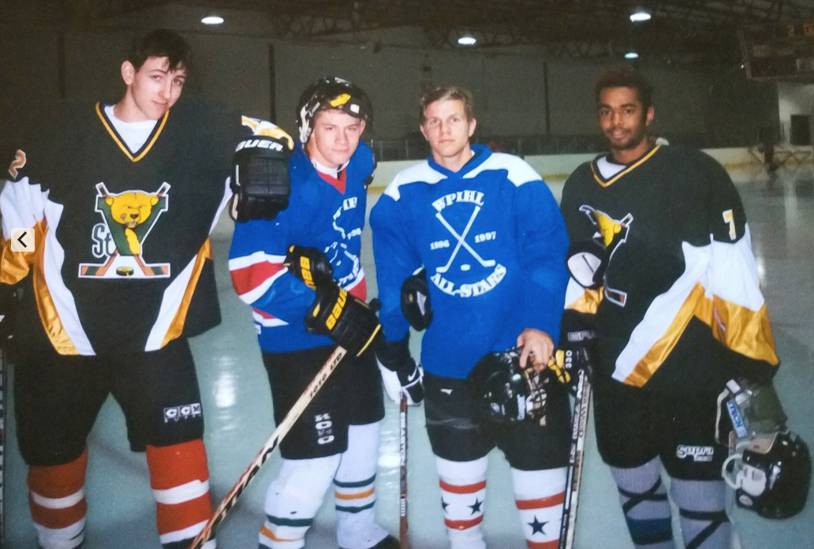
From the 1999-2000 season. Left to Right. Tim Holowaty, Brett Martz, Todd Evans and Suman.

