Player Name: | Career Highlights:
Santoro, Joel  C 20 | Joel evolved his game each year becoming a hard-hitting corner player. He became adept at separating players from the puck along the walls and moving the play to teammates to finish with a score. Capable of playing both wing and center in his career, he even took shifts at defense when asked.  He recorded his first point with an assist his Sophomore year against WJU and made his first goal count as a game winner against Shippensburg in an away game in Hershey Park Arena, the original, home of the AHL’s Hershey Bears. Had the first goal of the 2018-2019 season with a power play tally in his home rink against IUP.

Yr | # | Pos | GP | G | A | TP | S | Pct | + | - | +/- | PM | W | T | P | S
1617 | 52 | Lw | 16 | 0 | 0 | 0 | 11 | 0.0 | 2 | 19 | -17 | 4 | 0 | 0 | 0 | 0
1718 | 52 | Lw | 15 | 1 | 4 | 5 | 19 | 5.3 | 13 | 35 | -22 | 6 | 1 | 0 | 0 | 0
1819 | 12 | C | 14 | 1 | 3 | 4 | 15 | 6.7 | 4 | 23 | -19 | 16 | 0 | 0 | 1 | 0
1920 | 12 | C | 18 | 1 | 5 | 6 | 20 | 5.0 | 11 | 12 | -1 | 32 | 0 | 0 | 0 | 0
Totals |  |  | 63 | 3 | 12 | 15 | 65 | 4.6 | 30 | 89 | -59 | 58 | 1 | 0 | 1 | 0

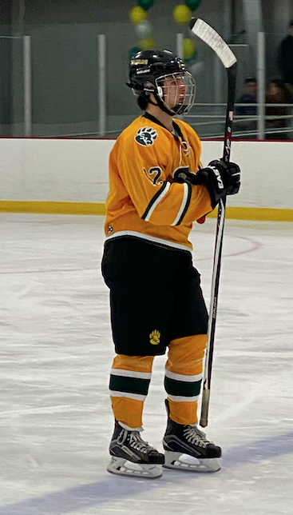
Joel takes the ice for the Senior day game against Duquesne University. Saint Vincent would carry the day by a 9-7 margin.
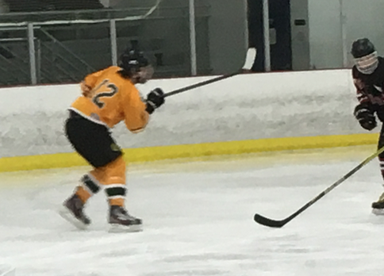
Joel fires the puck for a shot on goal against Edinboro.

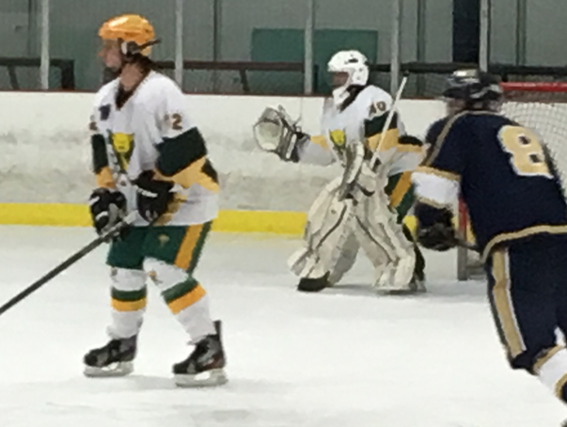
A rare shot of Joel on defense against Pitt Greensburg with Rob Wynn in the nets.

