Player Name: | Career Highlights:
Lauff, Roman  C 19 | Resilience and perseverance are two great words to describe Roman’s desire to compete on the ice. He overcame injuries and adapted his game to move from a forward to a defenseman during his last season and was a huge factor in two playoff runs for SVC. He was a traffic and corner man who played the body well and made good defensive decisions.  He had six multiple point games during his playing days. His first 2 point game included a power play marker goal against CMU. He also collected 2 assists against Daemen, a game winning score vs. W&J, 2 assists vs. Gannon and a 3 helper game against CMU.  Some of his best hockey came in the 2015-2016 National tournament. He had a goal and an assist twice, against Bullfalo and Cal Lutheran and was a +3 in the tournament. His loan goal senior year was part of an incredible come back against Denison. Because of his tough net play, Coach Ziemianski, in a substitute role, used him as the 6’th attacker. Roman scored on a net front scramble. SVC almost pulled the victory. With the goaltender pulled a second time Joe Moyer slid the puck behind the Denison goalie just after time expired  During Senior Day against UPG Roman had with two late assists including setting up game wining goal in overtime to position SVC for the playoffs.

Yr | # | Pos | GP | G | A | TP | S | Pct | + | - | +/- | PM | W | T | P | S
1415 | 89 | Rw | 18 | 0 | 4 | 4 | 18 | 0.0 | 10 | 11 | -1 | 4 | 0 | 0 | 0 | 0
1516 | 89 | Rw | 25 | 6 | 10 | 16 | 52 | 11.5 | 22 | 18 | +4 | 24 | 1 | 0 | 1 | 0
1617 | 89 | Rw | 15 | 0 | 0 | 0 | 25 | 0.0 | 5 | 13 | -8 | 8 | 0 | 0 | 0 | 0
1718 | 89 | Rw | 3 | 0 | 0 | 0 | 7 | 0.0 | 0 | 2 | -2 | 0 | 0 | 0 | 0 | 0
1819 | 9 | D | 14 | 1 | 7 | 8 | 24 | 4.5 | 16 | 16 | -1 | 27 | 0 | 0 | 1 | 0
Totals |  |  | 75 | 7 | 21 | 28 | 126 | 5.6 | 53 | 60 | -7 | 63 | 1 | 0 | 2 | 0

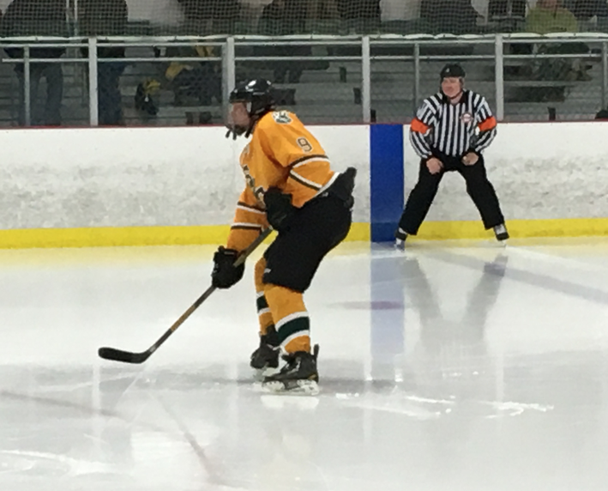

Roman switched to defense his Senior year and solidified a blue line in need of help.

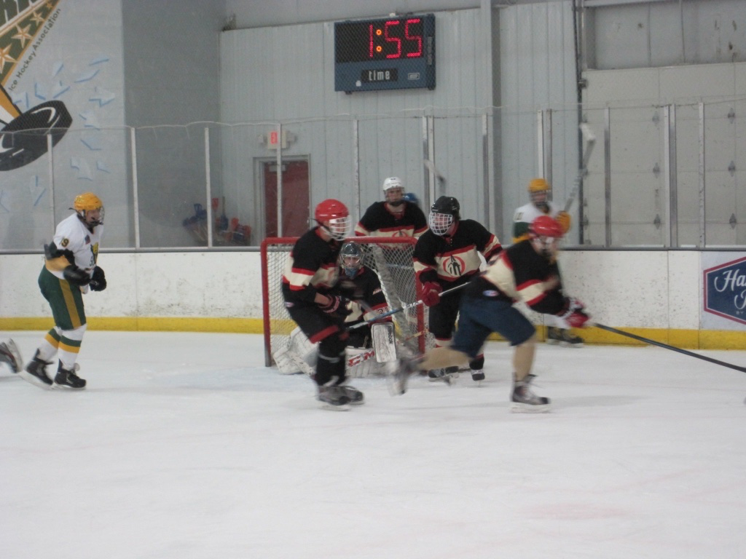

Whether defending or attacking, Roman was fixture in any traffic area. Seen here playing against Otterbein in the 2015-2016 NIHA National Tournament.

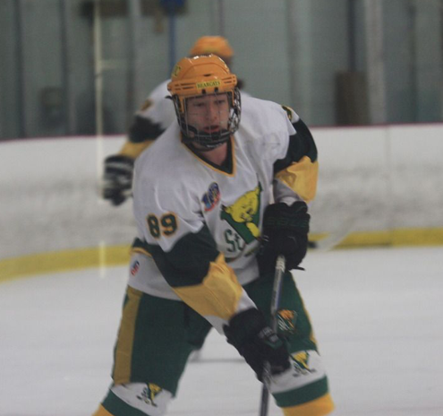
Eyes up and awareness of the ice often positioned Roman to make good choices with or without the puck.

