Player Name: | Career Highlights:
Reith, Eli  C’18 | Eli was a complete defenseman. He had great technique while defending 1:1 attackers, was strong when moving the puck from his zone and had the ability to create scores with exciting end-to-end rushes. Extremely coachable he was a great locker room presence and his words carried weight with his teammates. His numbers were diminished by several injuries including a vicious head-shot by a Penn State Altoona player during the NCHA National tournament in the 2015-2016 season. A strong student, he was an early graduate from SVC completing his degree in only 7 semesters. An Assistant Captain, a testament to his character made him a recipient of the Al Reinshagen Excellence Award, given to the player best able to represent the team and the school.

Yr | # | Pos | GP | G | A | TP | S | Pct | + | - | +/- | PM | W | T | P | S
1415 | 3 | D | 13 | 5 | 4 | 9 | 51 | 7.8 | 11 | 12 | -1 | 6 | 1 | 0 | 4 | 0
1516 | 3 | D | 22 | 5 | 10 | 15 | 53 | 9.4 | 45 | 29 | +16 | 16 | 1 | 0 | 2 | 1
1617 | 3 | D | 13 | 4 | 8 | 12 | 44 | 9.1 | 20 | 23 | -3 | 8 | 0 | 0 | 0 | 0
1718 | 3 | D | 8 | 3 | 10 | 13 | 29 | 10.3 | 23 | 17 | +6 | 2 | 0 | 0 | 0 | 0
Totals |  |  | 56 | 17 | 32 | 49 | 177 | 9.6 | 99 | 81 | +18 | 32 | 2 | 0 | 6 | 1

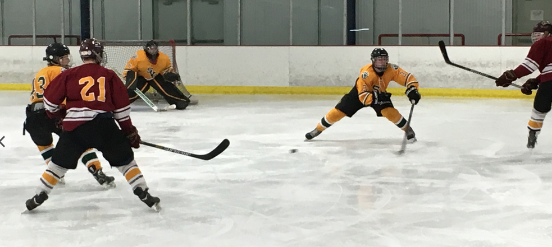

Eli defending against Gannon University. He used a wide stable stance and had a very quick stick stripping pucks from opponents. One of his outstanding characteristics was ice vision and awareness.

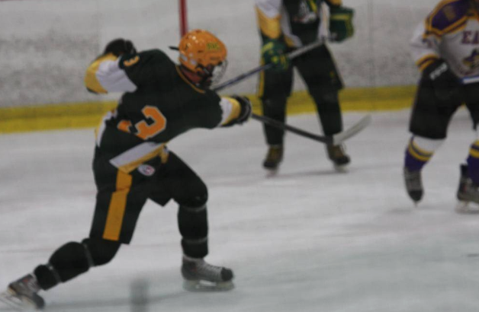
Although stopping attacks was Eli’s strength, his offensive capabilities produced some great numbers for a blue liner. A power play quarterback, Eli lets one fly in this shot against East Carolina University.

