Player Name: | Career Highlights:
Ziemianski, Mike  C’79 | Z-Man has become a living history of the ice hockey program. He played for 4 seasons while a student at SVC and came back to help the team the year after graduation being an Assistant Coach under Bob Farrell, while playing in several games. Switched from Center to Defense early in his Freshman year and became a fixture on the blue line. A tireless on ice worker who trained hard, he also played soccer for conditioning. An uncanny ability to block shots and excelled at breaking the puck out of the zone to the forwards. He could also deliver devastating checks and played an enforcer when needed. Played part of a game in goal as an emergency his senior year when John Konfala became injured in a match against Cleveland State. Assistant Captain in his Junior and Senior years and Co-Director of the team with roommate Jay Murray. Twice won the Andy Vahaly Award for Most Team Spirit and received the Rafferty Award as the schools top scholar athlete as a senior. After playing at St. Vincent he developed a long history of participating in men’s leagues, became a USA Hockey Level 3 Certified Referee and Coach and taught hundreds of Pittsburgh area youth to play the game including three of his own children. He organized alumni games during the years the school did not field a team. When the program was resurrected in the 1999-2000 season he was approached by Tom Holowaty to become the Head Coach of the newly formed team and remained in that capacity for 15 years. Named College Hockey East Coach of the Year in 2003-2004. He lead SVC to 11 CHE playoff births, a Southern Division CHE Title, 2 National and 2 Regional tournaments. Twice had the team ranked 11’th in the country. He ended his coaching career after 312 games and a record of 164-128-20. He was the first ever ice hockey player to be inducted into the Saint Vincent College Sports Hall of Fame. Getting that honor in the autumn of 2012.

Yr | # | Pos | GP | G | A | TP | S | Pct | + | - | +/- | PM | W | T | P | S
7576 | 27 | C/D | 17 | 2 | 4 | 6 | 21 | 9.5 | - | - | - | 8 | 1 | 0 | 1 | 0
7677 | 21 | D | 12 | 3 | 5 | 8 | 6 | 50.0 | - | - | - | 26 | 1 | 0 | 0 | 0
7778 | 21 | D | 17 | 1 | 10 | 11 | 11 | 9.1 | - | - | - | 42 | 0 | 0 | 0 | 0
7879 | 21 | D | 18 | 3 | 21 | 24 | 25 | 12.0 | - | - | - | 24 | 0 | 0 | 0 | 0
7980 | 21 | D | 8 | 0 | 10 | 8 | 17 | 0.0 | - | - | - | 14 | 0 | 0 | 0 | 0
Totals |  |  | 72 | 9 | 50 | 59 | 80 | 11.3 | - | - | - | 114 | 2 | 0 | 0 | 0

Yr | # | Pos | GP | MP | GA | AVG | SO | EN | W | L | T | SHOTS | SAVES | PCT
7879 | 21 | G | 1 | 18 | 4 | 10.00 | 0 | 0 | 0 | 0 | 0 | 13 | 9 | .692
Totals | 21 | G | 1 | 18 | 4 | 10.00 | 0 | 0 | 0 | 0 | 0 | 13 | 9 | .692

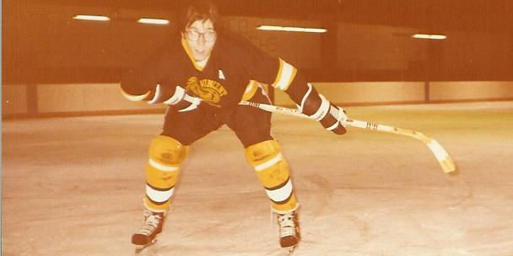

The “Z-Man”, Mike Ziemianski patrolled the blue line as a four year starter at SVC and suited up for parts of a fifth season after graduation.

Coach Z on the bench with his tweed leather patched shooting jacket and ubiquitous clipboard. A numbers guy, he kept constant notes during the game to manage line changes, match ups, and tendencies he noticed during the course of action. Seen here are #96, Joe Manning, #47 Adam Petrovich, #9 Phil Ivkovich, #8 Dave Glunt, and #88 Tim Legath. Talk about a power play line!

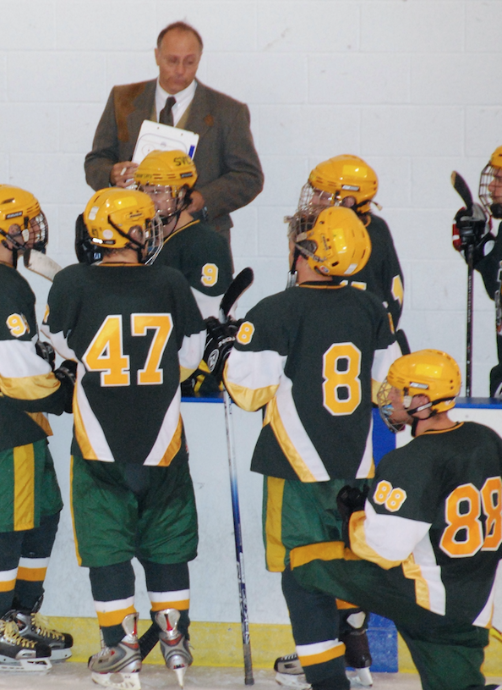

A glimpse of the famous clipboard.



