Player Name: | Career Highlights:
Ulishney, Dave  C ‘10 | “Bam-Bam” played with as much intensity as anyone in the history of the SVC Ice Hockey Club. He exploded his checks into opposing players and hustled on every shift. Although predominately a checking forward and penalty killer he still had a nice scoring touch as he recorded 12 multi-point games in his career and had several noted offensive efforts: a 2 goal game that included shorthanded tally and a tying goal against Penn State Altoona; a key score to knot RMU at 4-4 in a game won by SVC 6-4; 2 power play goals in a win over Allegheny; 2 goals including a game winner vs. UPJ; 2 power play goals against Penn State Behrend and another game winner against the Erie based school. His career game however had to be against a Nationally ranked Farmingdale team in one of the CHE Met showcase tournament matches. Dave notched a hat trick to propel SVC into overtime. His first goal his freshman year was scored at CMU. His aggressive style made him only one of 5 players to exceed 200 career penalty minutes at the time of his graduation. His 95 games played makes one of only a handful of players to cross the 90 mark. His leadership earned him a role as an Assistant Captain his last two seasons. He was part of key penalty killing forward tandem for much of his career often paired with Chris Hilling, two of the highest energy forward defenders in the era they played.

Yr | # | Pos | GP | G | A | TP | S | Pct | + | - | +/- | PM | W | T | P | S
0607 | 12 | Rw | 24 | 1 | 8 | 9 | 33 | 3.0 | 11 | 8 | +3 | 55 | 0 | 0 | 0 | 0
0708 | 12 | Rw | 19 | 6 | 3 | 9 | 27 | 22.2 | 7 | 13 | -6 | 50 | 0 | 1 | 1 | 1
0809 | 12 | Rw | 18 | 7 | 4 | 11 | 42 | 16.7 | 11 | 14 | -3 | 55 | 0 | 0 | 2 | 1
0910 | 12 | Rw | 21 | 10 | 6 | 16 | 67 | 14.9 | 14 | 21 | -7 | 41 | 1 | 0 | 4 | 1
1011 | 12 | Rw | 13 | 1 | 4 | 5 | 26 | 3.8 | 5 | 6 | -1 | 24 | 1 | 0 | 1 | 0
Totals |  |  | 95 | 25 | 25 | 50 | 195 | 12.8 | 48 | 62 | -14 | 225 | 2 | 1 | 8 | 3
Text book play. Guilday centers the puck to Chris Hilling while Dave takes up a perfect position driving to the far post against Allegheney College.

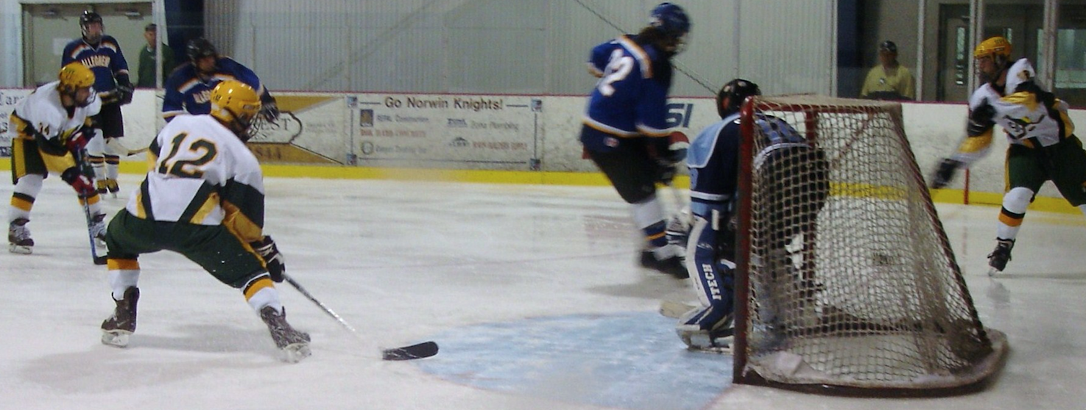
Why “Bam Bam”? Dave had great strength and would leverage under opposing players to deliver crushing checks. In this picture he takes out a Fredonia State forward.



