Player Name: | Career Highlights:
Peoples, Sam  C 12 | Simply nasty as a defenseman with a missile for a slap shot and tremendous puck rushing and passing capabilities, the SVC program took a step backwards when Sam left after his first semester. Within only a few games he became noted around the league as a top talent and on several occasions took control of contests. He blew pucks past goaltenders in games against Pitt Greensburg, WVU, Pitt, and Robert Morris. On one occasion he had 6 shots on goal as a defenseman.

Yr | # | Pos | GP | G | A | TP | S | Pct | + | - | +/- | PM | W | T | P | S
0809 | 82 | D | 13 | 4 | 2 | 6 | 30 | 13.3 | 18 | 10 | +8 | 21 | 0 | 0 | 1 | 0
Totals |  |  | 13 | 4 | 2 | 6 | 30 | 13.3 | 18 | 10 | +8 | 21 | 0 | 0 | 1 | 0

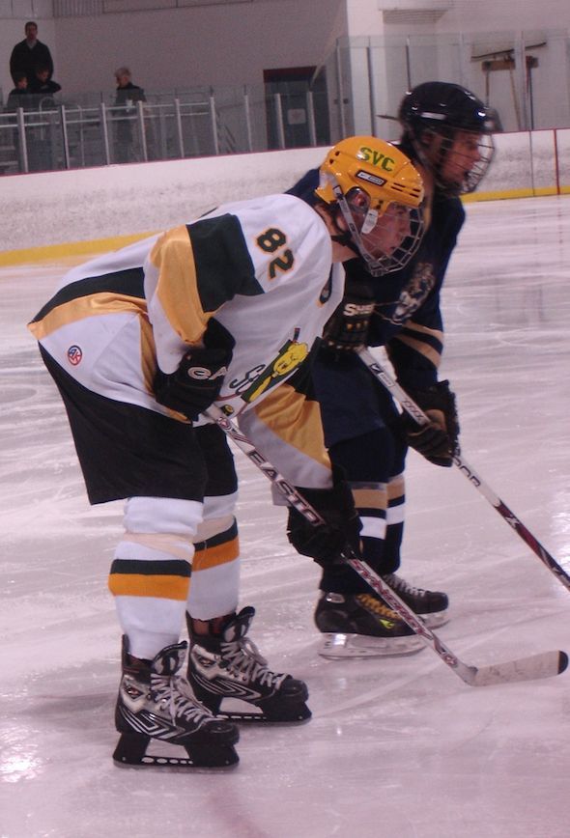
Sam lining up on a face off against Pitt Greensburg.

