Player Name: | Career Highlights:
Mahlotra, Akhil  C 07 | “Icky” transferred to Saint Vincent after an All Star year at Allegheny College. Because of transfer issues his playing time was limited over two seasons to non-CHE and non-ACHA games. A goalie with outstanding technical skills, he excelled in every contest. He shut out Wheeling Jesuit his first season and recorded a win against Navy at Annapolis during his second year.

Yr | # | Pos | GP | G | A | TP | S | Pct | + | - | +/- | PM | W | T | P | S
0304 | 1 | G | 2 | 0 | 1 | 1 | - | - | - | - | - | 0 | 0 | 0 | 0 | 0
0405 | 1 | G | 2 | 0 | 0 | 0 | - | - | - | - | - | 2 | 0 | 0 | 0 | 0
 |  |  | 4 | 0 | 1 | 1 | - | - | - | - | - | 2 | 0 | 0 | 0 | 0

Yr | # | Pos | GP | MP | GA | AVG | SO | EN | W | L | T | SHOTS | SAVES | PCT
6970 | 1 | G | 2 | 102 | 1 | 0.50 | 1 | 0 | 2 | 0 | 0 | 17 | 16 | .941
Totals | 1 | G | 2 | 102 | 3 | 1.76 | 0 | 0 | 2 | 0 | 0 | 39 | 36 | .923
 |  |  | 4 | 204 | 4 | 1.00 | 1 | 0 | 4 | 0 | 0 | 56 | 52 | .929

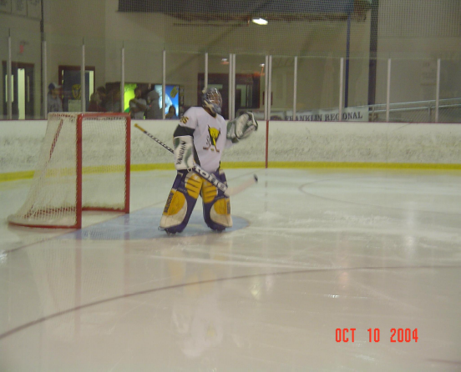
Akhil on home ice at the start of the third period against against Youngstown State University.

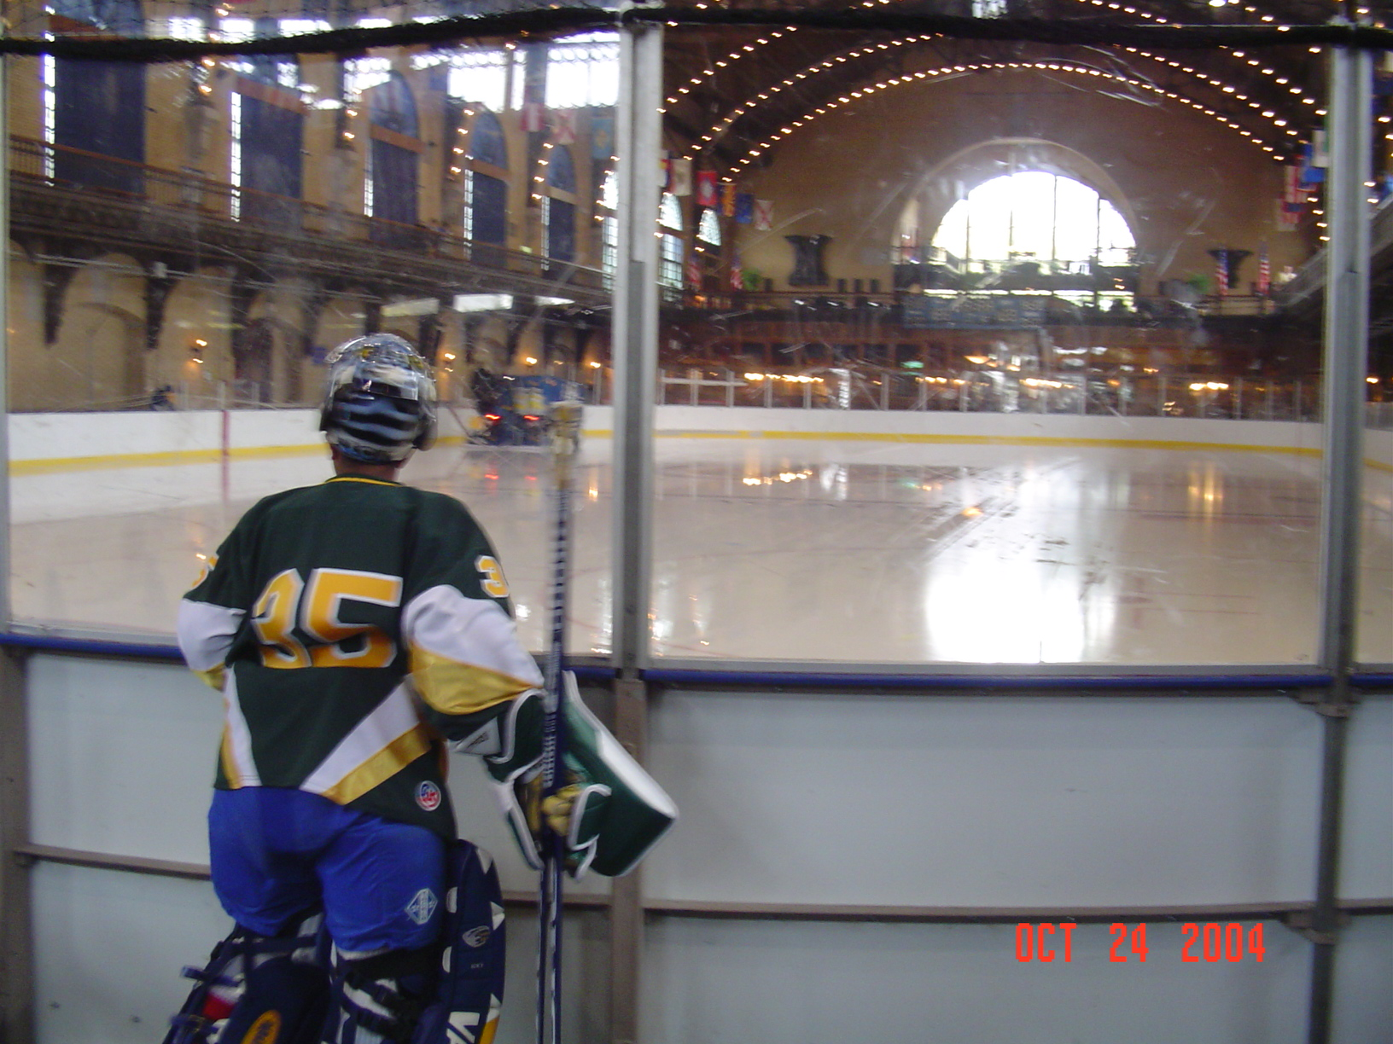
Away against Navy. Icky looks onto the surface of the U.S. Naval Academy ice rink.

