Player Name: | Career Highlights:
Jamiolkowski, AJ  C 07 | AJ came to SVC after playing with several amateur associations in Pittsburgh including Central Pittsburgh, The Artic Foxes, and Beaver. He was a strong stay at home defenseman with an extremely heavy shot from the point. In both of his playing years the team went to the ACHA D III National Tournament with his first taste of National Action coming against Georgia Tech. Always a positive attitude, he scored against WVU during his freshman year on a wicked shot from the point on the power play.

Yr | # | Pos | GP | G | A | TP | S | Pct | + | - | +/- | PM | W | T | P | S
0304 | 52 | D | 13 | 1 | 3 | 4 | 5 | 20.0 | 5 | 3 | +2 | 19 | 0 | 0 | 1 | 0
0405 | 52 | D | 15 | 0 | 2 | 2 | 5 | 0.0 | 12 | 5 | +7 | 6 | 0 | 0 | 0 | 0
Totals |  |  | 28 | 1 | 5 | 6 | 10 | 10.0 | 17 | 8 | +9 | 25 | 0 | 0 | 1 | 0

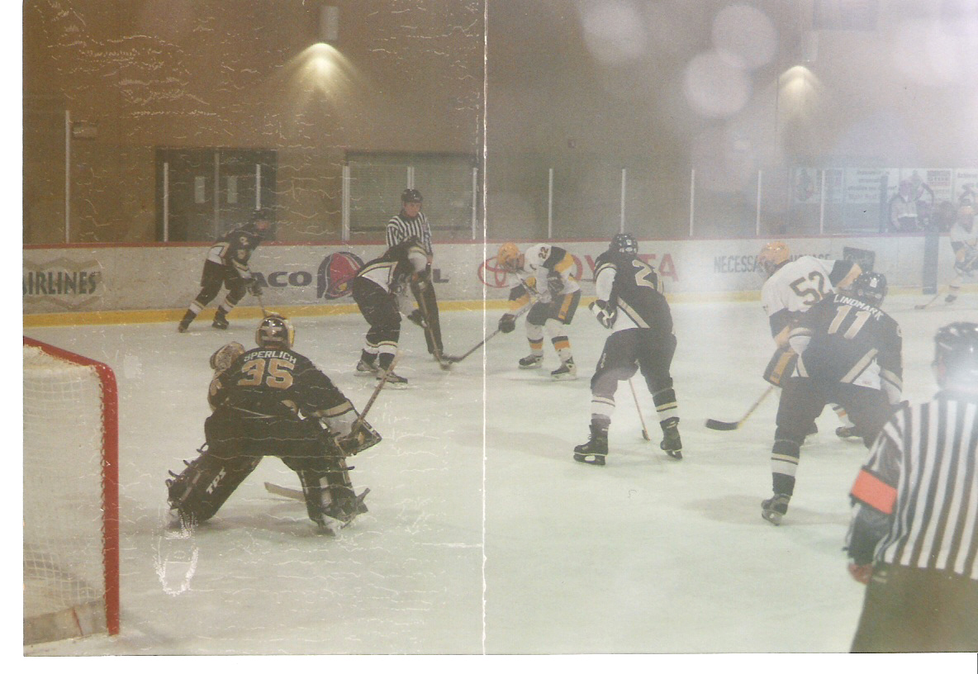
AJ vs. Georgia Tech at the National Tournament in 2004-2005 in Phoenix. The job, screen the goalie on the power play.

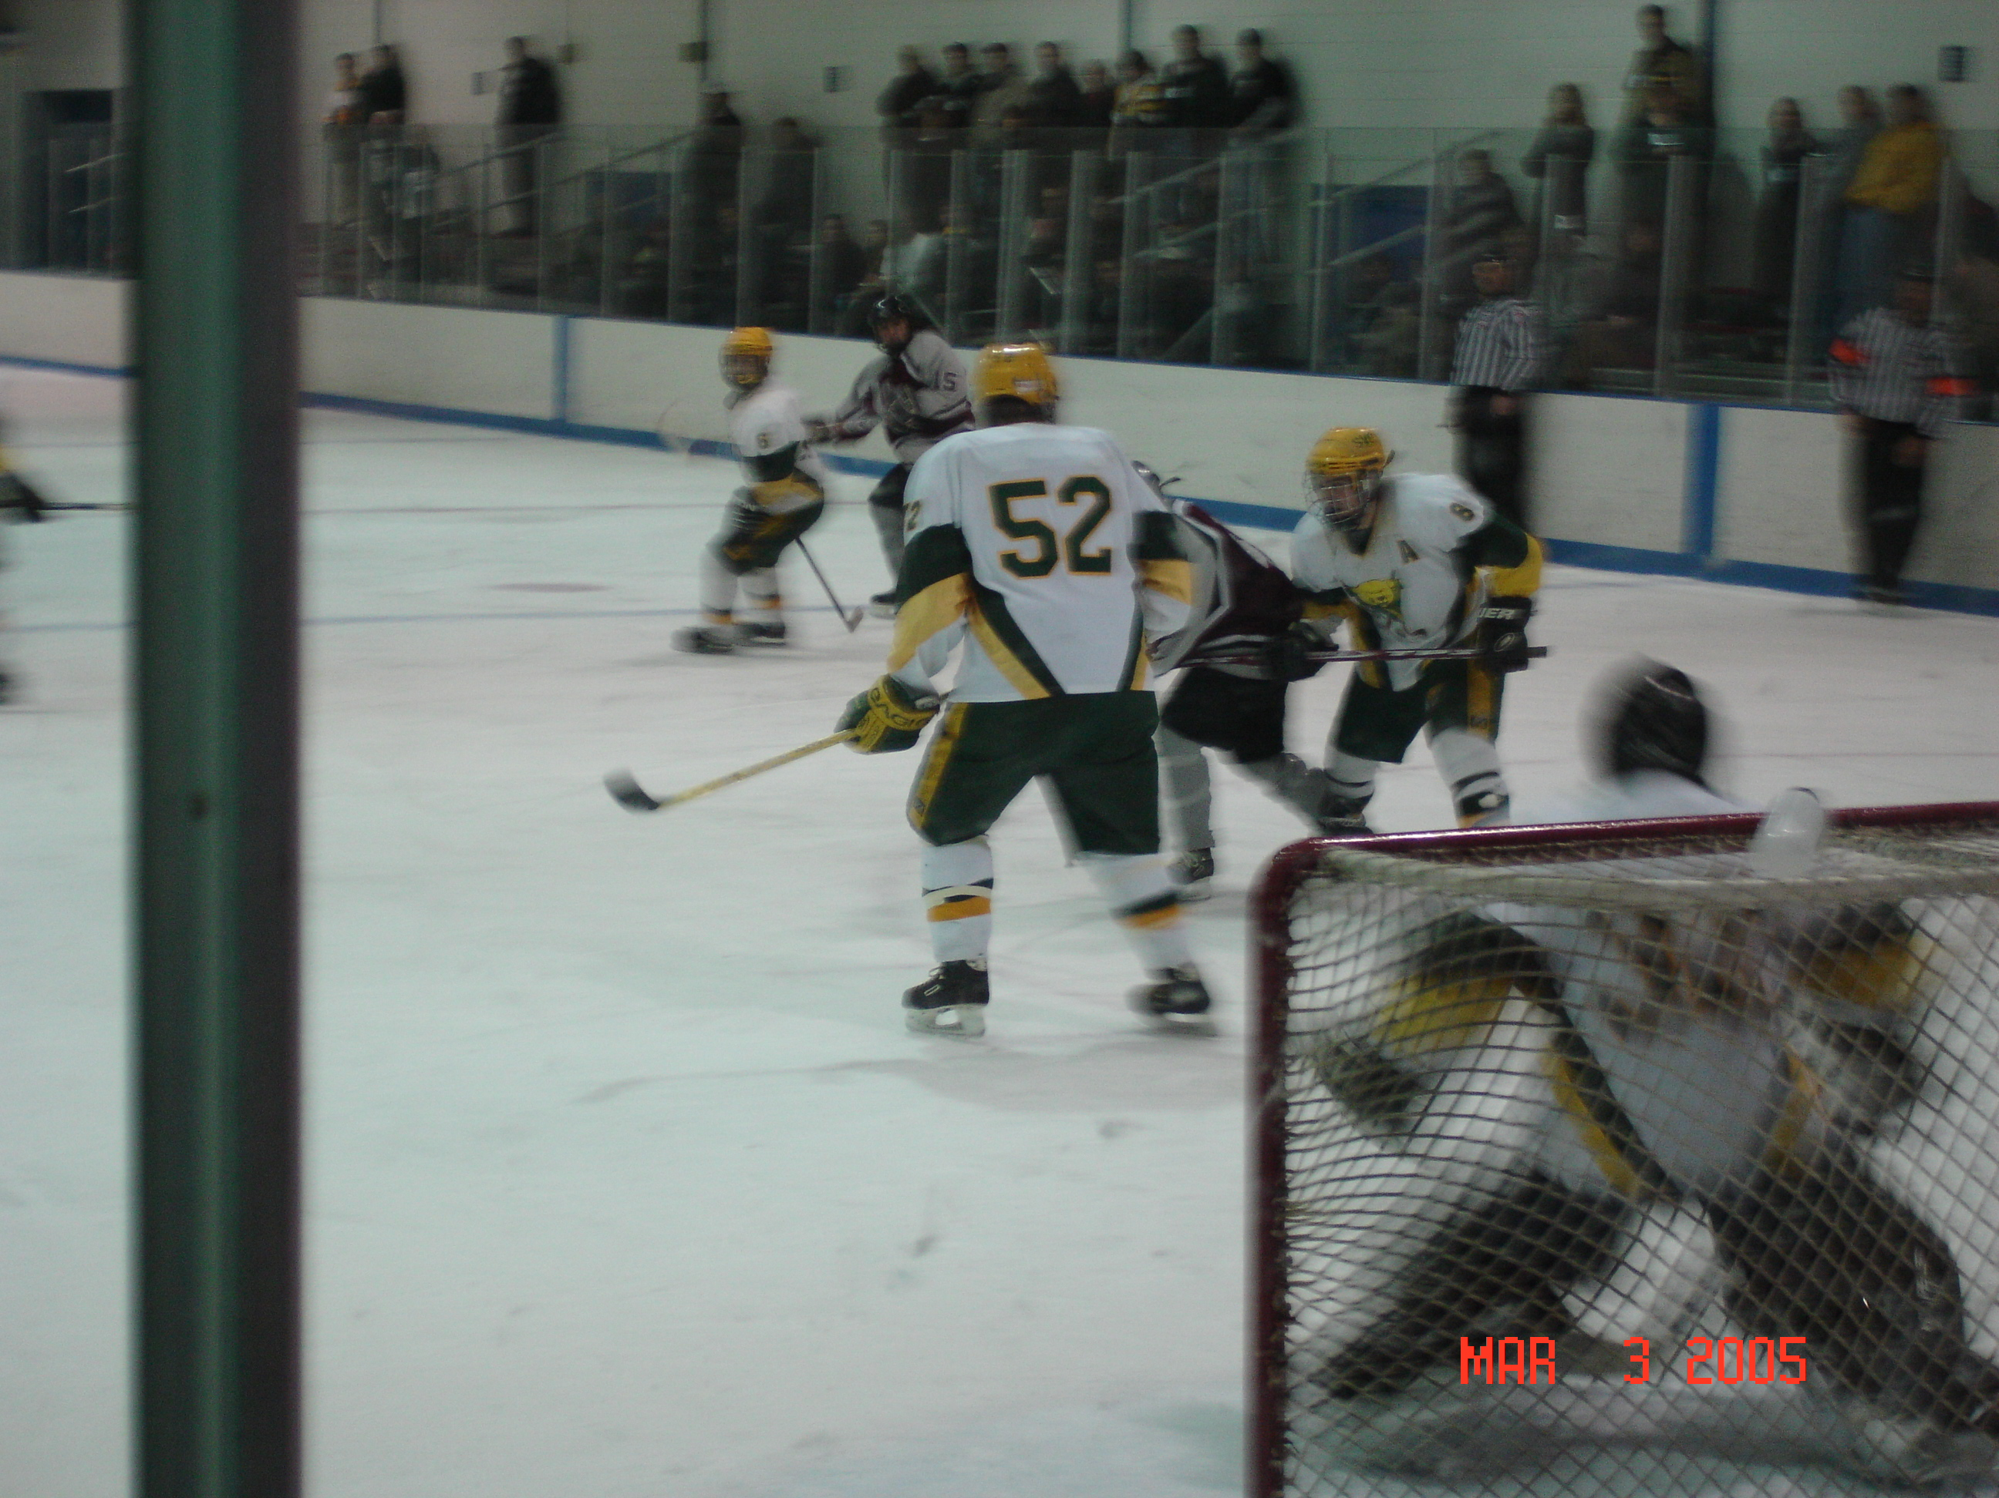
#52 guards the slot in game action against IUP at the 2005-2006 ACHA D III tournament held in Pittsburgh.

