Tom Holowaty, General Manager

There would be no ice hockey team at Saint Vincent if not for “Big Tom”. As the founding General Manager, he has more than 350 games under his belt over 17 seasons, and still counting.

When Tom’s son, Tim Holowaty, decided to attend SVC after graduating from and playing for Ligonier, Tom assessed the possibility of forming a team at the school. He publicized the formation of a program on campus, worked with admissions to identify potential incoming players, contacted other teams to create a pro-forma schedule and went looking for a coach. It all came together at an initial meeting held in The Shack when Tom introduced C’79 graduate and former player Mike Ziemianski to a group of students that included, Tim, Bryan Messina, Latrobe High School player Brian Kosczuk and several others. Tom pulled it all together, found an incredible goaltender, Joshua Sokolowski, late in the summer, and the team started practice in the fall of 1999.

Since then Tom has shepherded more than 165 players through the program. During his administration he took the team from playing an exhibition schedule, to entering a league that was to become College Hockey East, successfully qualified the program to become a member of the American Collegiate Hockey Association and then a member of the National Collegiate Hockey Association. But it doesn’t end there. Three trips to National Tournaments, two more to Regional’s and twelve post-season playoff appearances add to his contributions. For years his efforts were not recognized until he finally received the GM of the Year Award from College Hockey East following the 2012-2013 season.

Off ice Tom made sure the program worked as well or better than any school associated with the sport at the D III level. Schedules were often completed by mid summer. He mastered traveling in good weather and found ways to make the second semester filled with home games. Even when opponents were at a distance, Tom would still drive his van in case there was an injury and he needed stay with the player overnight. Students were registered with the league and the national associations well in advance of any deadline. He made it a point to make sure the coaches were aware rule changes and potential student athletes, meeting many of them during campus visits and talking about the school, the team and the advantages of attending Saint Vincent to help them make the best decision for their combined academic and athletic continuation. He regularly appeared in Naples, Florida for the annual ACHA Nationwide Conference. The team visited Baltimore Harbor, played the Naval Academy at Annapolis, made road trips to the Eastern Seaboard, played Bucknell, and in short, competed for years at a level well beyond the size of the school hooking up against giants like Arizona State,and Georgia Tech. And no player can ever forget the now expected end of season banquet at Sharky’s.

And still the story goes on. As of this writing tom still teaches accounting at Saint Vincent and looks forward to when he passes the 400 game mark!

Left to Right: Assistant Coach Vince Kadlubek, “Big Tom” Holowaty and Head Coach Mike Ziemianski. SVC just passed the 100 win total in Tom’s tenure as General Manager in an away contest against Johns Hopkins.
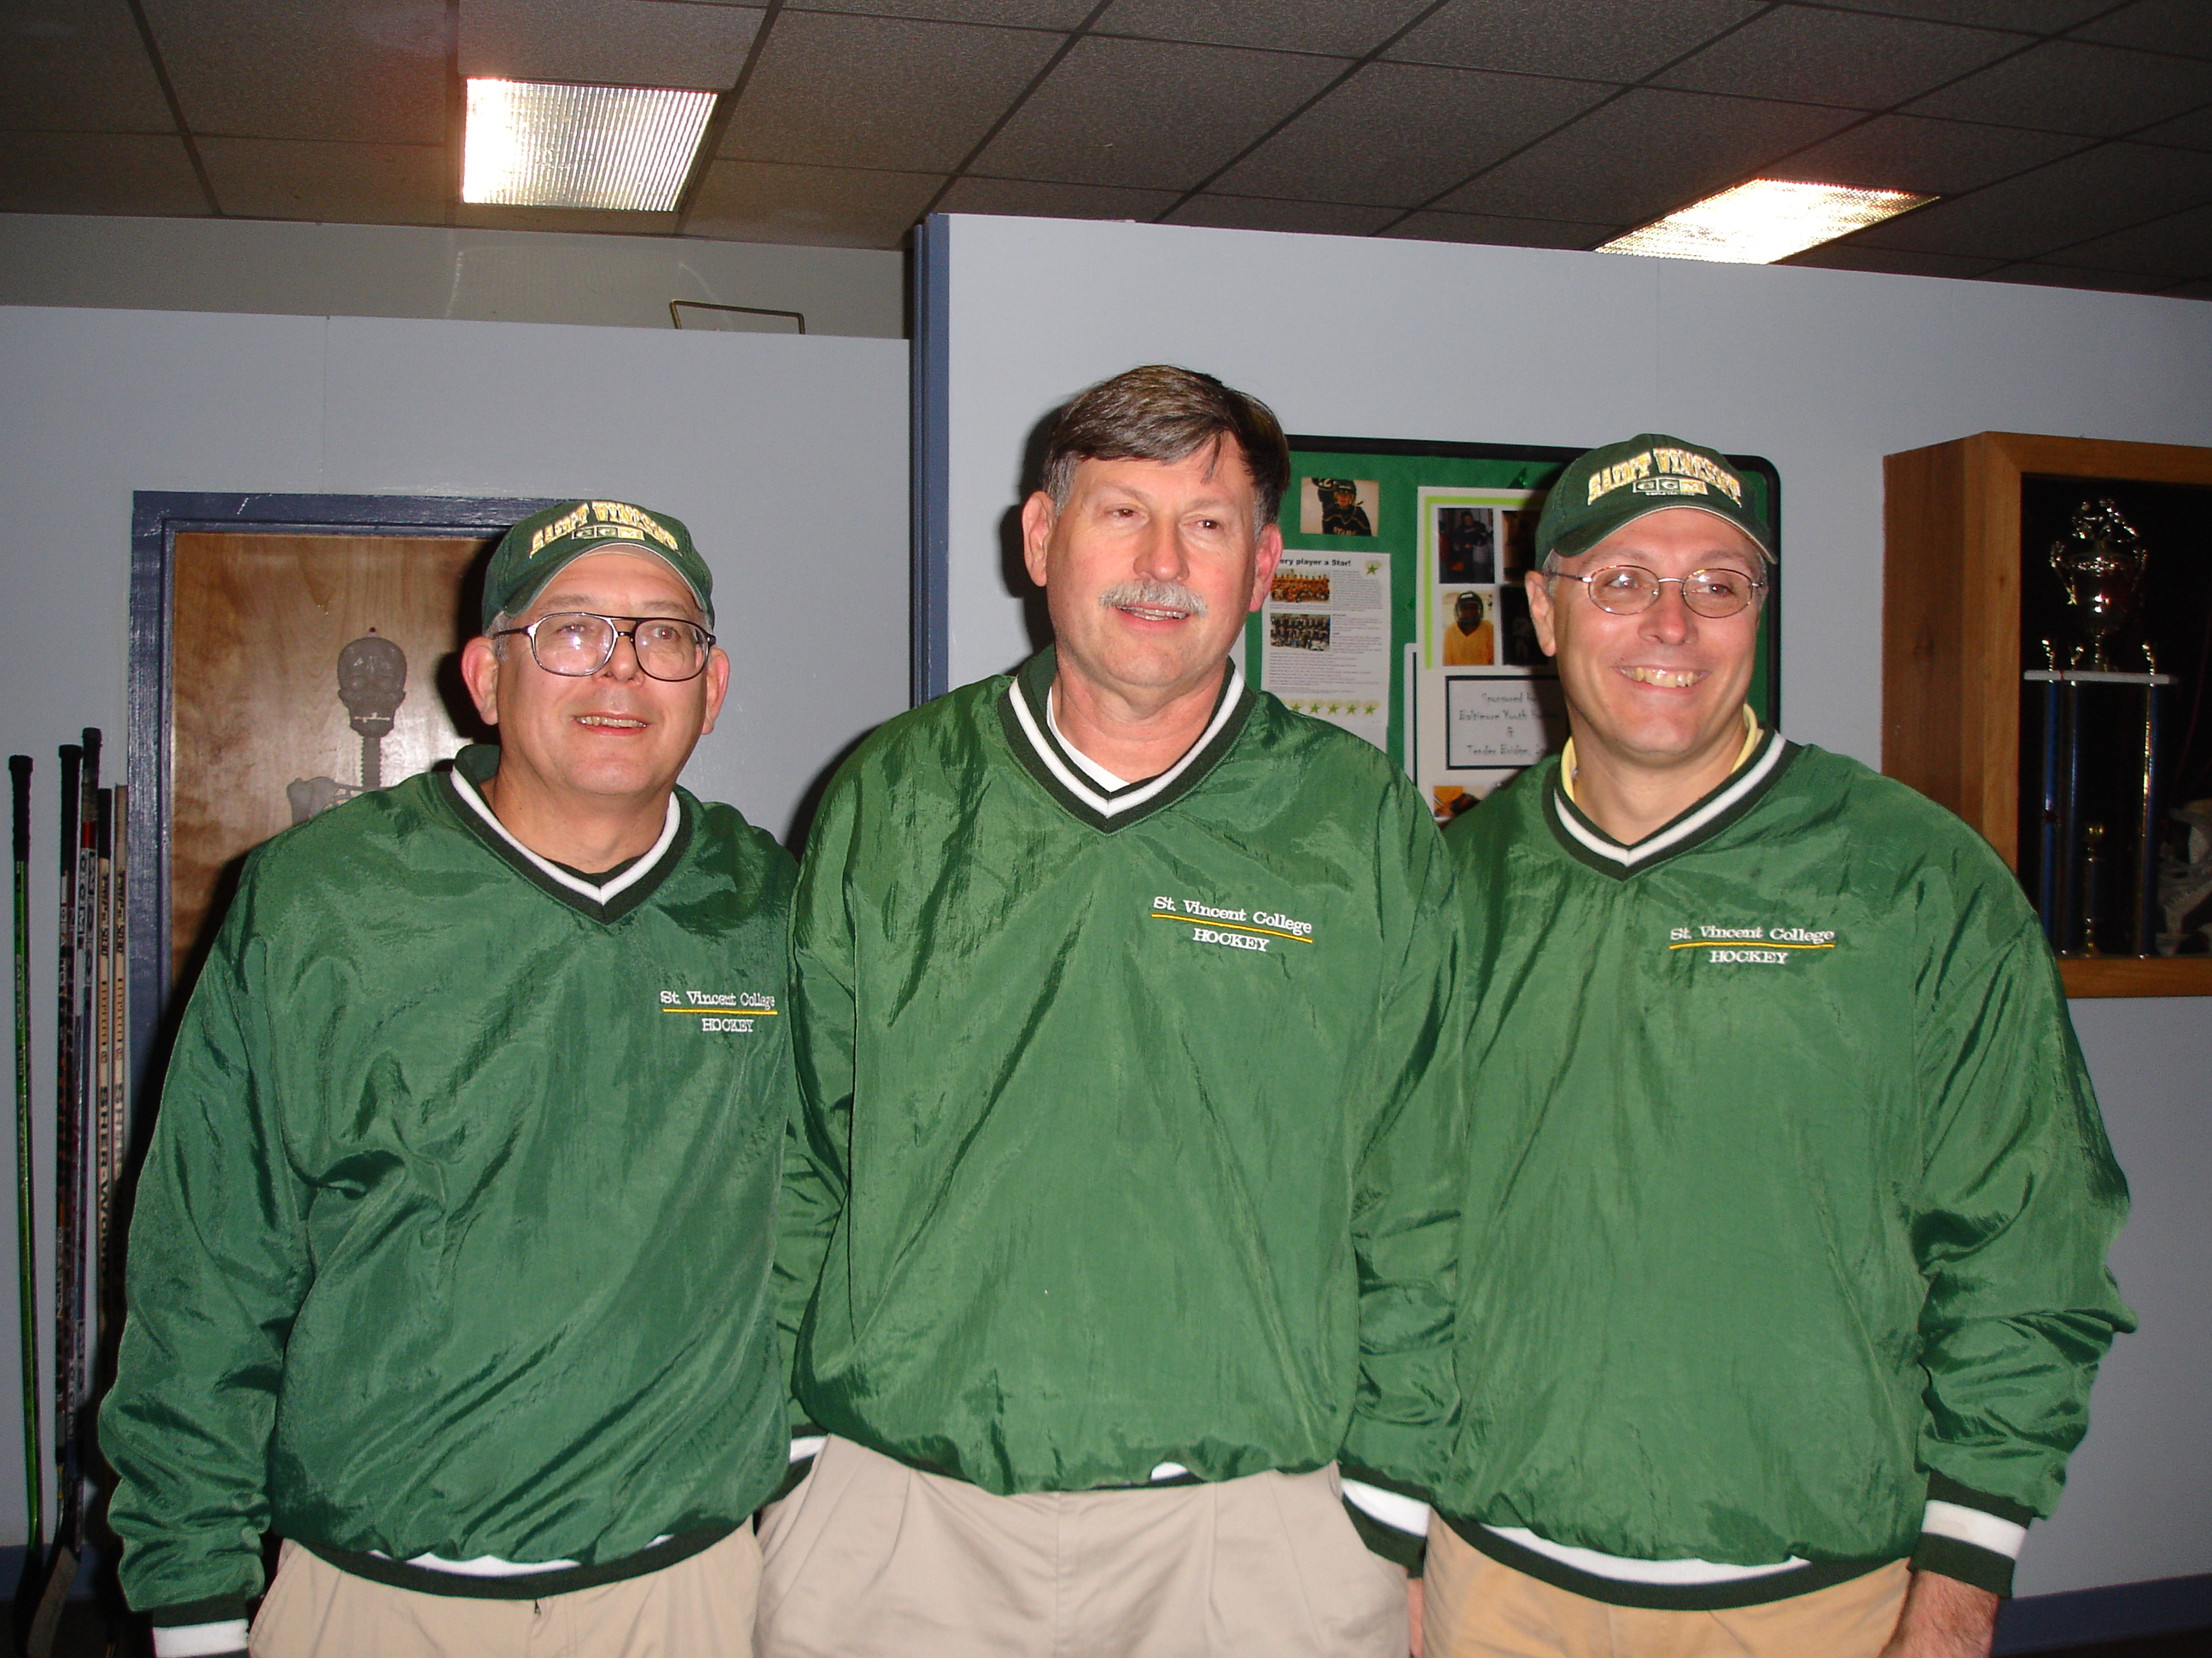
A familiar site on the fall campus of SVC. A hockey road trip. Tom made these trips go without a hitch. Players always had food, drinks and when it called for it, meal money. There was never a pizza deal Tom could not find for after the game!

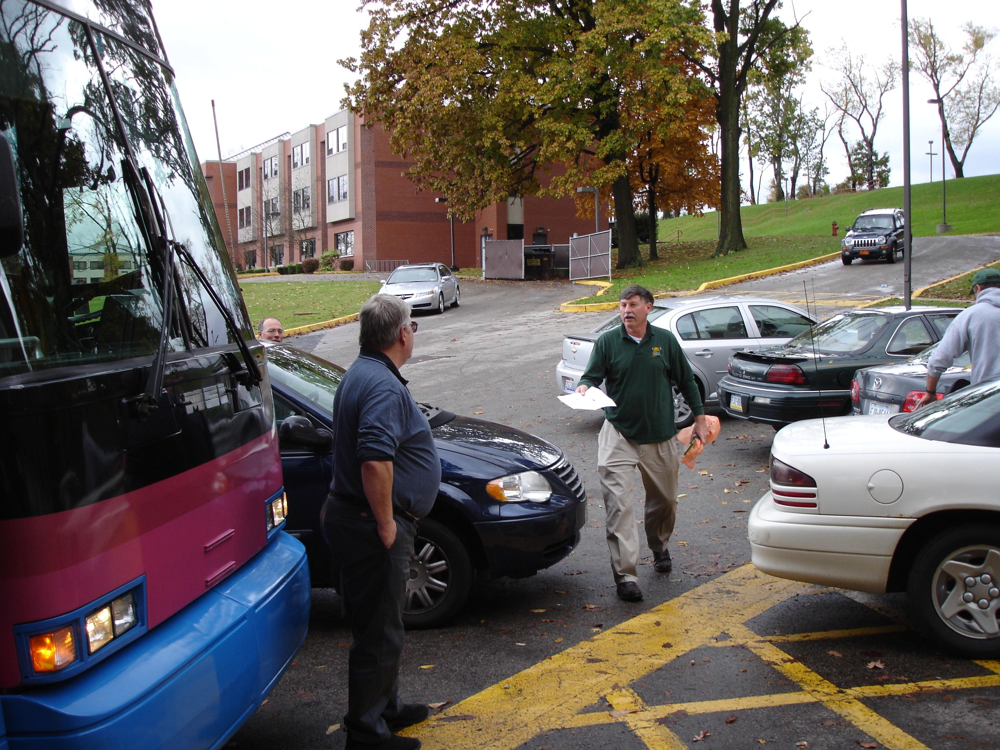

Herding ‘Cats. (Pun intended!) Tom always found a way to make these trips fun and even managed lodging when the team had its first ever female player, Chantal Ziemianski. Also seem here are Jason Seidling, Cory Tucek and “Little Chunk”, Adam Ziemianski.

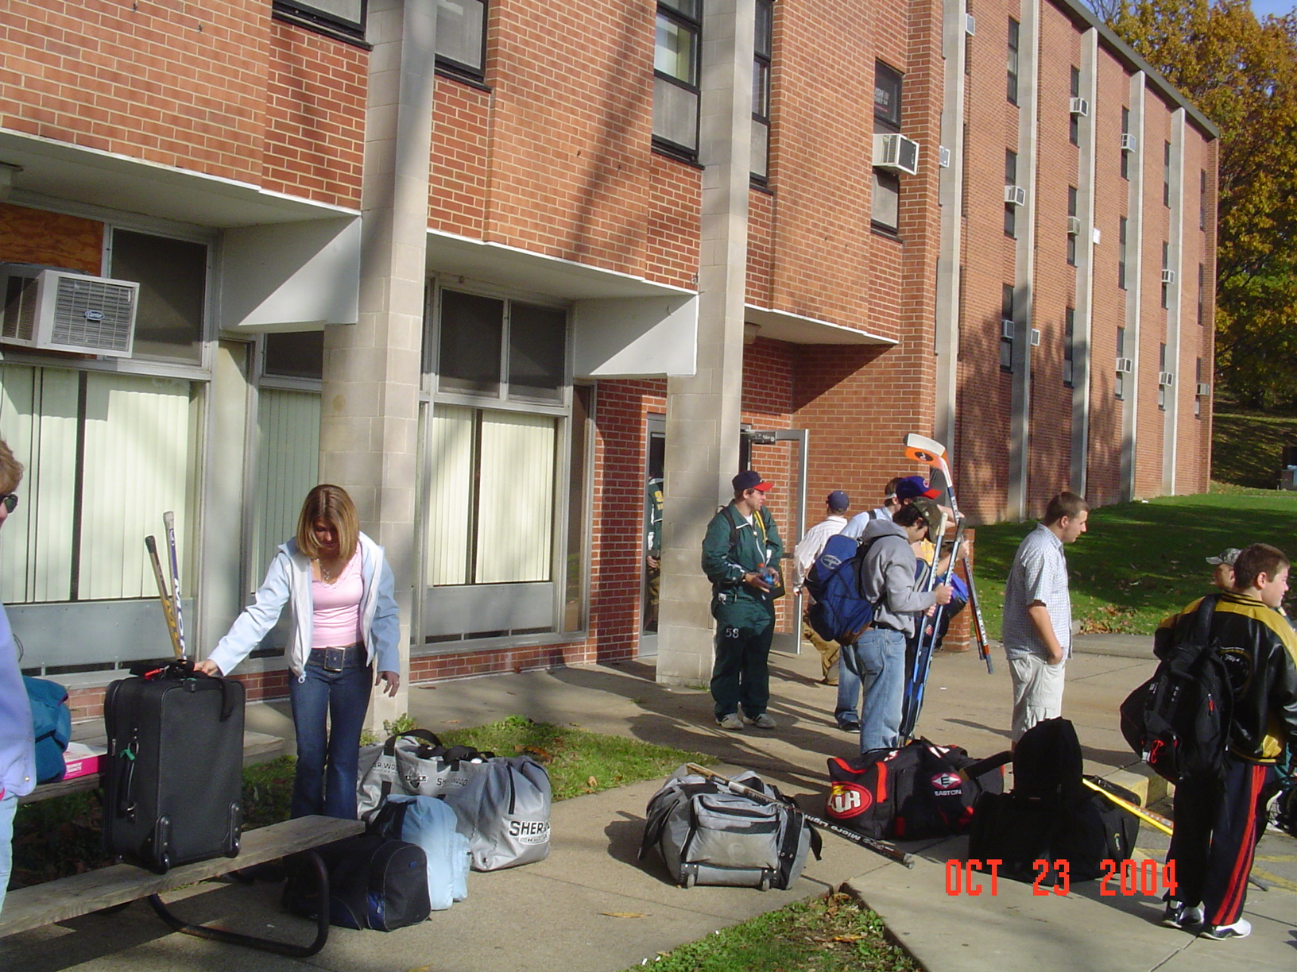
Baltimore Harbor and crab cakes in October. This is not your typical ACHA D III program. Two Toms standing on the peer in front of the USS Constellation. Tom McDonald left and Tom Holowaty right.



Tom with Assistant Coach Vince Kadlubek. Discussing the next 40 years of Saint Vincent Hockey?



