Player Name: | Career Highlights:
Hilling, Chris  C’ 11 | Always a coach’s favorite, pound for pound Chris was an outstanding checking line center. He often had the responsibility to pester opposing forwards and to keep pucks deep in the attacking zone with cycling plays. His high energy, fearless up-tempo play made him a valuable penalty killer, frequently teamed with Dave Ulishney as the first two off the bench when SVC went shorthanded. A well conditioned athlete, Chris would often skate extra sprints after practice and demonstrated a positive leadership style that earned him an Assistant Captaincy his senior year along with the Coach’s Award his Junior year and the Andy Vahaly Team Spirit honor his senior year. Injuries cut some of his time short, especially his junior campaign when he sustained a concussion and a broken arm on a vicious hit into the boards at the Johnstown War Memorial in a contest against UPJ. Although Chris did not have scoring responsibilities he came up with some big points in key games. His first goal came against Penn State Altoona in a 5-3 SVC win; and three times he collected assists against IUP. The owner of 4 multiple point games, Chris notched 3 assists against Gannon, a goal and assist vs. Pitt in a 7-5 St. Vincent defeat, a goal vs. UPJ in a 7-3 win, 2 assists against Neuman College in a 6-5 victory, and 3 helpers in the final game of his senior year against Pitt Greensburg.

Yr | # | Pos | GP | G | A | TP | S | Pct | + | - | +/- | PM | W | T | P | S
0708 | 24 | Rw | 20 | 0 | 3 | 3 | 17 | 0.0 | 13 | 15 | -2 | 32 | 0 | 0 | 0 | 0
0809 | 24 | C | 19 | 2 | 4 | 6 | 20 | 10.0 | 8 | 14 | -6 | 28 | 0 | 0 | 0 | 0
0910 | 24 | C | 13 | 1 | 6 | 7 | 10 | 10.0 | 8 | 8 | E | 28 | 0 | 0 | 0 | 0
1011 | 24 | C | 17 | 1 | 3 | 4 | 12 | 8.3 | 7 | 14 | -7 | 25 | 0 | 0 | 0 | 0
Totals |  |  | 69 | 4 | 16 | 20 | 59 | 6.8 | 36 | 51 | -15 | 113 | 0 | 0 | 0 | 0

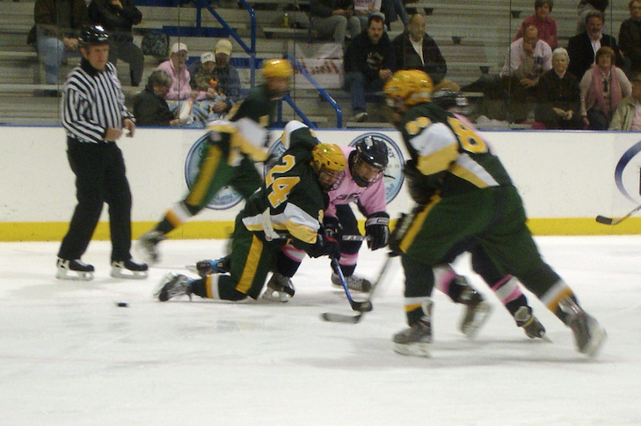
Facing off against Penn Sate Behrend in an away game at the Mercyhurst Ice rink.
Chris playing against Robert Morris University.

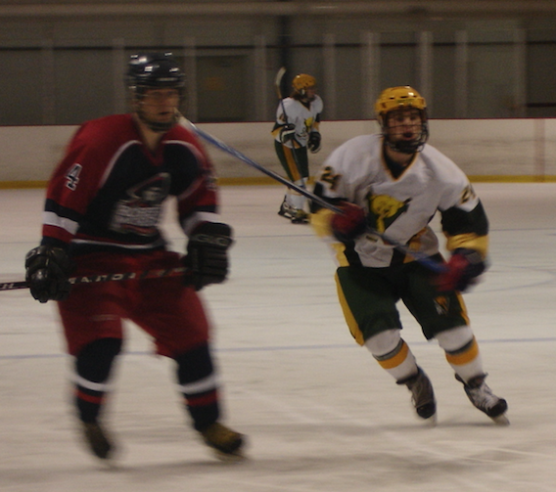

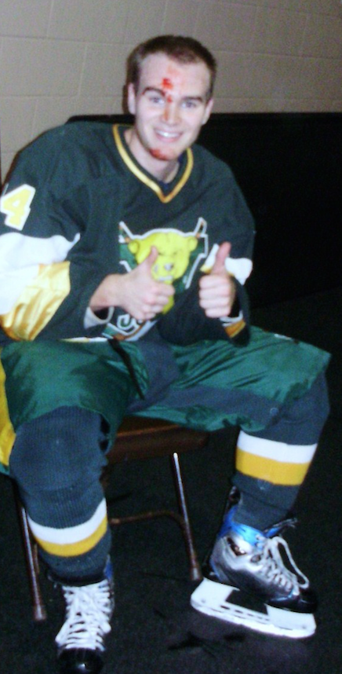
This was a frequent site for Chris. His aggressive play in all facets of his game, whether in the defensive zone, forechecking or killing penalties. He spent a lot of time getting to know the EMT’s at games.

