Player Name: | Career Highlights:
Drake, T.J.  C’06 | For four years T.J. was one of the best one on one defenseman to ever lace up skates in College Hockey East. After a strong career at Fox Chapel High School, he was noticed by the coaching staff of SVC at the 2001-2002 local high school all star game as a quiet defenseman who did a lot of little things right. He hated to lose, was a fierce on ice competitor, and had an unparalleled knowledge of the game. His ability earned him recognition as the first player in SVC history to be nominated and play in four consecutive CHE All Star Games. In addition to his defensive abilities, he also put up outstanding offensive numbers. At the time of his graduation he was the all time leading scorer for defenseman in the history of the program. This was an amazing accomplishment since he regularly saw time against the opposing team’s top forwards and was one of the lead penalty killers during his career. He finished with an amazing +123 plus minus! His junior season he was awarded the team’s Andy Vahaly Award for the most team spirit and his senior year he received the Al Resinhagen Award given to the player who best represents excellence in their game and representation of the school and the team. His dedication and leadership earned him the Captain’s C during both his Junior and Senior years. He played in both ACHA D III National Tournaments in 2003-2004 in Phoenix and 2004-2005 in Pittsburgh. In each season SVC finished ranked 11’th in the Nation. The Polar Bearcats had a 67-23-4 record while T.J. played for an outstanding .734 winning percentage. The pictures below show a great shot sequence of T.J. against South Dakota State University. He brings the puck up the ice, finds a shooting opportunity and lets one fly!

Yr | # | Pos | GP | G | A | TP | S | Pct | + | - | +/- | PM | W | T | P | S
0203 | 26 | D | 22 | 1 | 8 | 9 | 34 | 2.9 | 38 | 19 | +19 | 8 | 0 | 0 | 1 | 0
0304 | 36 | D | 26 | 4 | 11 | 15 | 44 | 9.1 | 44 | 19 | +25 | 38 | 0 | 0 | 2 | 0
0405 | 36 | D | 26 | 2 | 22 | 24 | 59 | 3.4 | 67 | 27 | +40 | 24 | 1 | 0 | 1 | 0
0506 | 36 | D | 24 | 5 | 11 | 16 | 45 | 11.1 | 59 | 20 | +39 | 34 | 0 | 0 | 3 | 1
 |  |  | 98 | 12 | 52 | 64 | 182 | 6.6 | 208 | 85 | +123 | 104 | 1 | 0 | 7 | 1

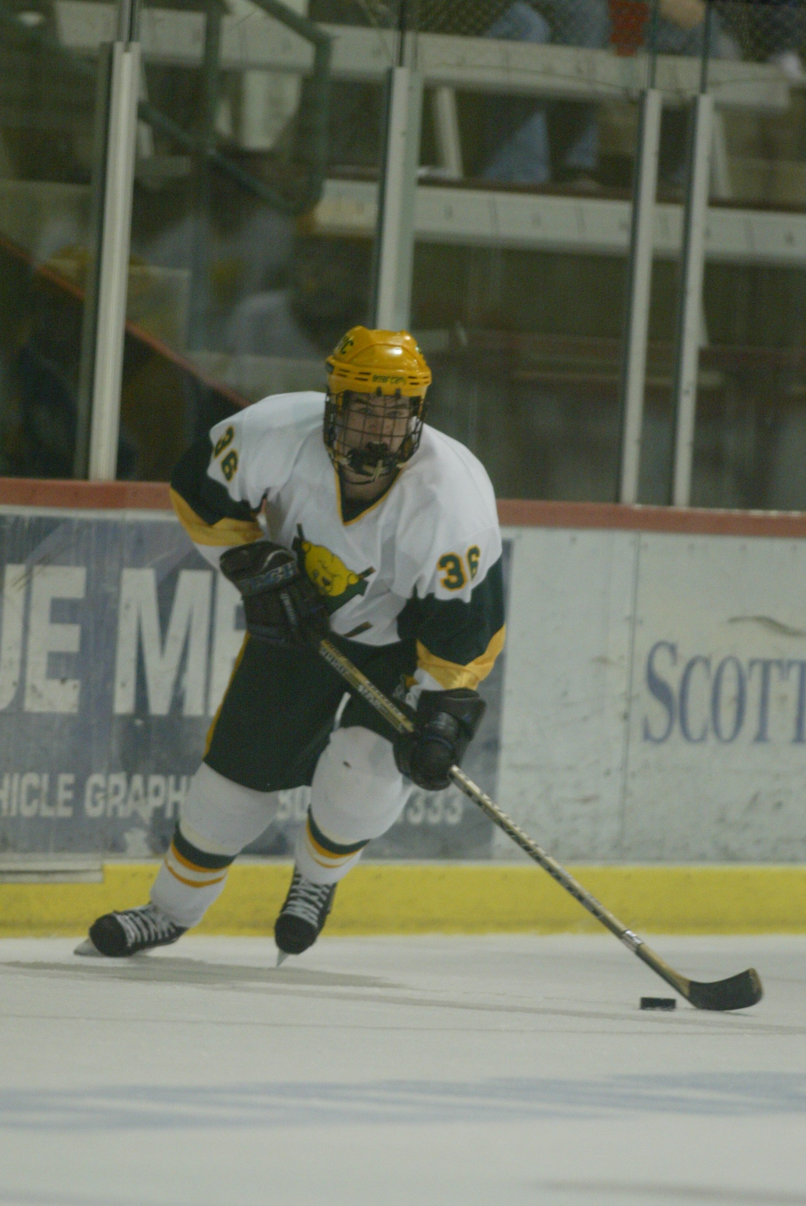
A classic T.J. rush with the eyes focused on the center of the ice.

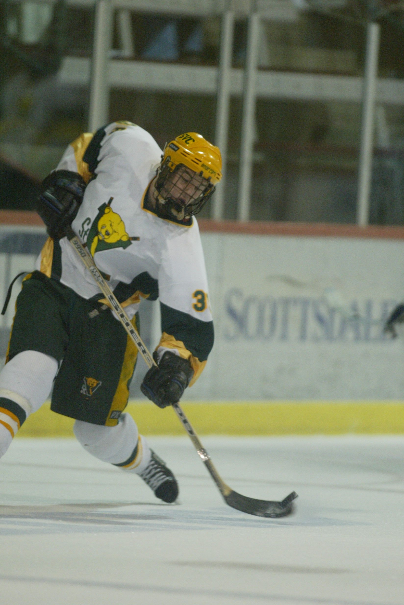
Leverage is the key…

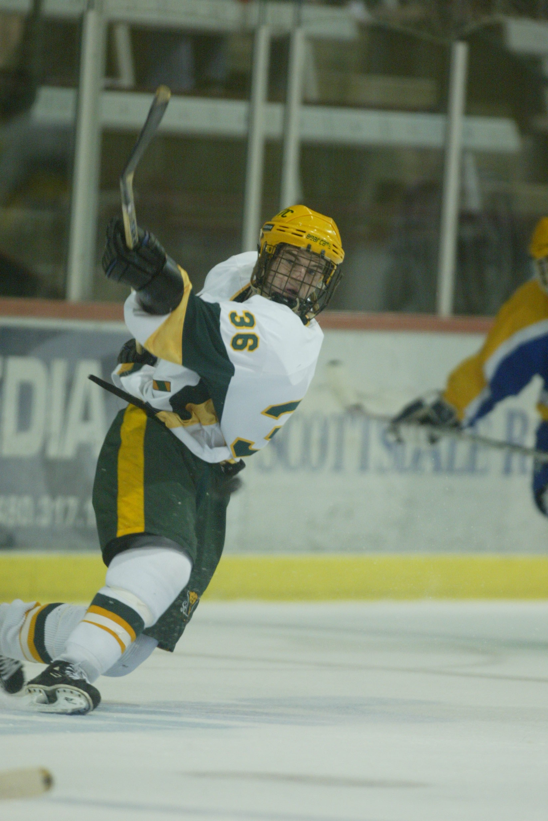
…and don’t forget the follow through! Action against South Dakota State University.

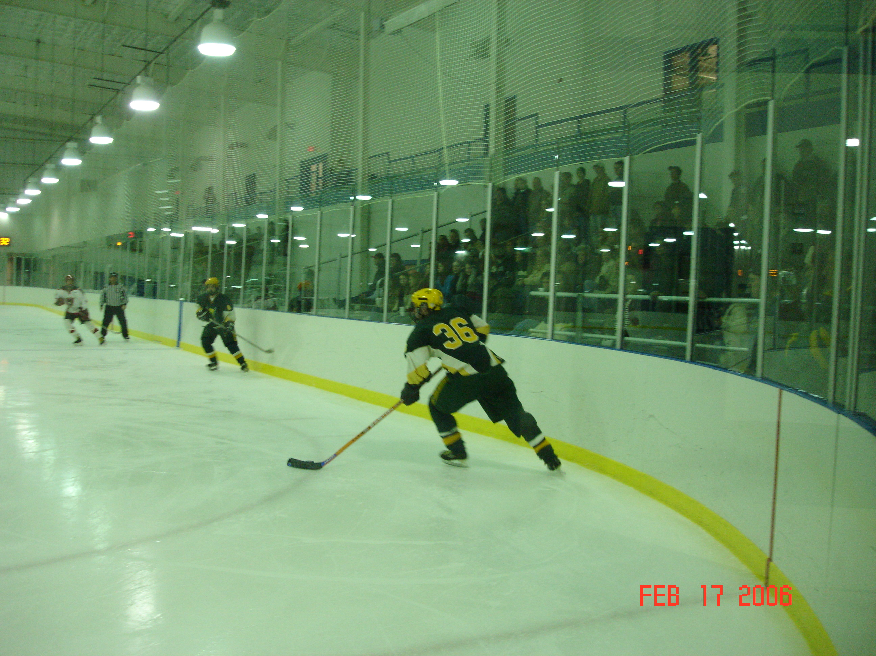
T.J. in game action. Executing a breakout against Cal U. in a CHE playoff game won by SVC with a 4-2 margin of victory. Matt Ward is in position along the boards.

