Player Name: | Career Highlights:
Craft, Chris  C’07 | Dedication is perhaps the best word to describe the approach that Chris took to the game. A novice player as a freshman, “Milan” continued to work hard throughout his years with the team to significantly improve his ability. He was tenacious when on the ice and enjoyed physical play. He developed a strong shot and his perseverance paid off when he scored his first goal against CMU. He played in the 2004-2005 ACHA D III National Tournament and when the team ran short of goaltenders during his senior year, he strapped on the pads in practice and served as the back up net minder in the 2005-2006 CHE playoffs for SVC. He played the first semester during the 2006-2007 season and scored another goal against Penn State Behrend on a deflection of a Tony Duco shot. Chris finished with a sold +9 rating.

Yr | # | Pos | GP | G | A | TP | S | Pct | + | - | +/- | PM | W | T | P | S
0203 | 7 | Rw | 12 | 0 | 0 | 0 | 1 | 0.0 | 1 | 0 | +1 | 2 | 0 | 0 | 0 | 0
0304 | 7 | Rw | 3 | 0 | 1 | 1 | 0 | 0.0 | 2 | 0 | +2 | 0 | 0 | 0 | 0 | 0
0405 | 7 | Rw | 17 | 0 | 2 | 2 | 4 | 0.0 | 5 | 5 | E | 0 | 0 | 0 | 0 | 0
0506 | 7 | Rw | 3 | 1 | 0 | 1 | 8 | 12.5 | 7 | 0 | +7 | 2 | 0 | 0 | 0 | 0
0607 | 7 | Rw | 12 | 1 | 0 | 0 | 2 | 50.0 | 1 | 2 | -1 | 0 | 0 | 0 | 0 | 0
 |  |  | 47 | 2 | 3 | 5 | 15 | 13.3 | 16 | 7 | +9 | 4 | 0 | 0 | 0 | 0

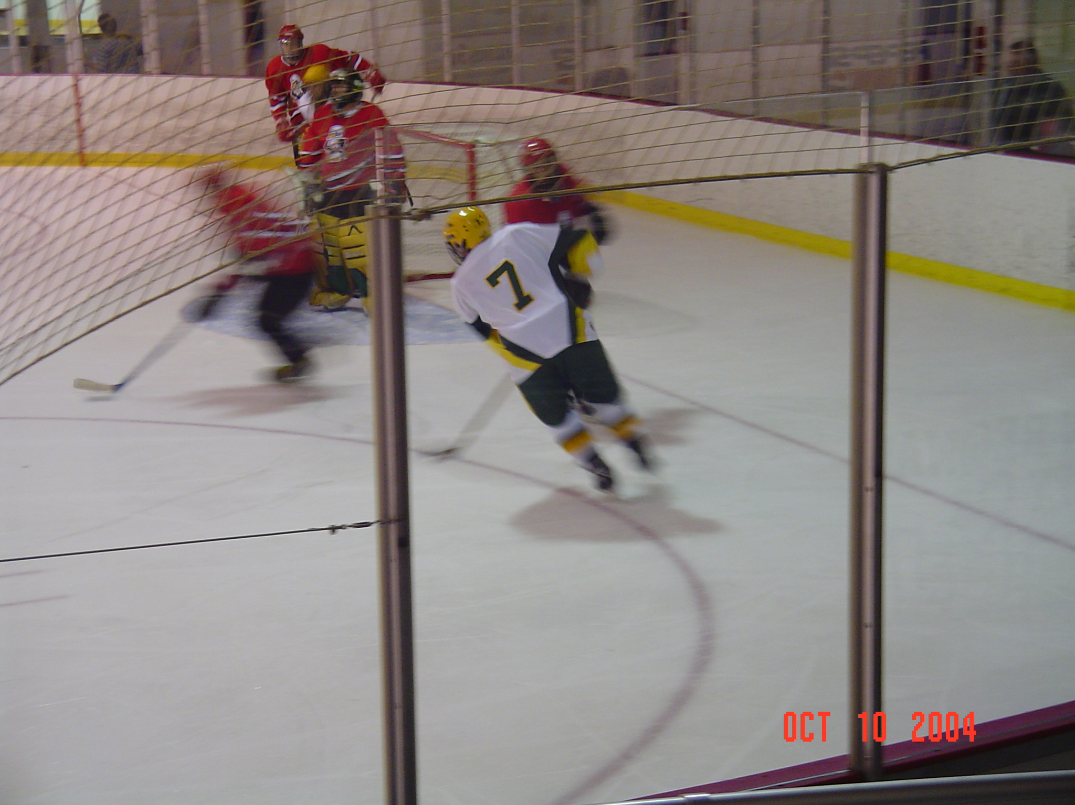
#7 Chris Craft in action against the Youngstown State University Penguins, October, 2004.

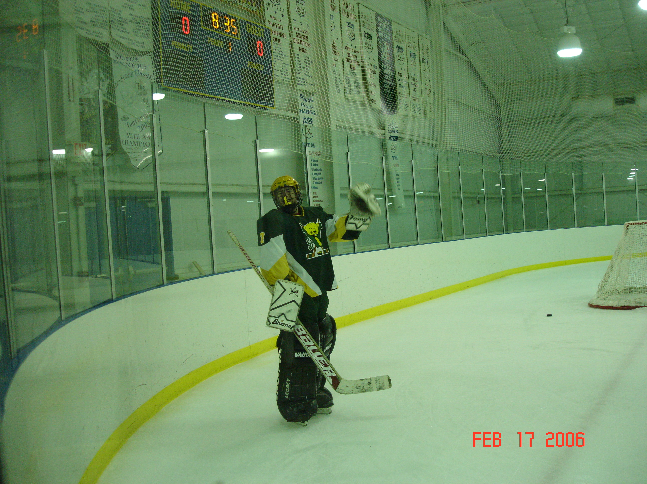
Living proof of Chris as a goalie. During warm ups against Cal U during a 2005-2006 CHE playoff game. SVC won 4-2.

