Player Name: | Career Highlights:
Coyne, Shane  C’14 | “Squeek” was approached by Coach Z after one of his games with the South Fayette High School program, decided to attend Saint Vincent and was a regular over his four years of play. Shane got as much out of size as he could and would not hesitate to give up the body to block a shot or angle an opposing player. He played solid position and took advantage of opportunities when they presented themselves. Most of his scores were wrist shots in and around the net, but his most impressive goal came in a home game against Fredonia Sate University. He crossed the attacking blue line and in full stride ripped one of the hardest shouts of the season form the top of the slot and absolutely blew the puck by the FSU goalie. Nobody, perhaps not even Shane, knew he could shoot the puck that hard. His leadership earned him the role of Assistant Captain his senior year. He had a great attitude on the bench and in the locker room with a very understated but very well liked sense of humor. His brother, Michael, played goal while Shane was on the team as well. Marking one of the many brother combos to play at SVC.

Yr | # | Pos | GP | G | A | TP | S | Pct | + | - | +/- | PM | W | T | P | S
1011 | 22 | Lw | 13 | 0 | 1 | 1 | 1 | 0.0 | 2 | 8 | -6 | 2 | 0 | 0 | 0 | 0
1112 | 22 | Lw | 18 | 1 | 2 | 3 | 7 | 14.3 | 5 | 9 | -4 | 0 | 0 | 0 | 0 | 0
1213 | 22 | C | 19 | 2 | 7 | 9 | 22 | 9.1 | 13 | 17 | -4 | 10 | 0 | 0 | 0 | 0
1314 | 22 | Rw | 17 | 2 | 8 | 10 | 23 | 8.7 | 18 | 30 | -12 | 6 | 0 | 0 | 1 | 0
Totals |  |  | 67 | 5 | 18 | 23 | 53 | 9.4 | 38 | 64 | -26 | 18 | 0 | 0 | 1 | 0
Shane (#22) in action against Robert Morris University. Alex Sepesy makes a save. Also in the frame are #8, Jake Hendrick, #16 DK Kirschner, and #23 Cody Ray. Allen Wolfe is the other SVC player.

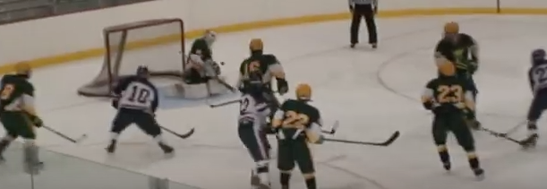

A great example of how smart Shane was on the ice. Just moments before, Alex Sepesy lost his goal stick. Shane skated behind Alex and executed a perfect double knee drop shot block preventing an RMU shot on goal.

