Player Name: | Career Highlights:
Colainane, Curt  C’12 | After playing at Latrobe High School, Curt gave St. Vincent great depth in goal. He had a lanky frame that enabled him to make stretch saves and a quick glove hand that robbed more than a few opposing players of scoring opportunities. One his great games came in an away contest against Penn State Behrend. A flat Polarbearcat team was outshot by a wide margin in every period with a three period total of 21 shots for SVC and 53 for PSB. Curt came up huge on multiple occasions throughout the game and made several incredible saves in the last 15 seconds. SVC 3 PSB 2. He was a workhorse his junior year and joined the 2,000 plus minutes played and 1,000 plus save clubs for his career.

Yr | # | Pos | GP | G | A | TP | S | Pct | + | - | +/- | PM | W | T | P | S
0809 | 33 | G | 8 | 0 | 1 | 1 | 0 | 0.0 | - | - | - | 0 | 0 | 0 | 0 | 0
0910 | 33 | G | 13 | 0 | 1 | 1 | 0 | 0.0 | - | - | - | 4 | 0 | 0 | 0 | 0
1011 | 33 | G | 16 | 0 | 0 | 0 | 0 | 0.0 | - | - | - | 0 | 0 | 0 | 0 | 0
1112 | 33 | G | 6 | 0 | 0 | 0 | 0 | 0.0 | - | - | - | 0 | 0 | 0 | 0 | 0
Totals |  |  | 43 | 0 | 2 | 2 | 0 | 0.0 | - | - | - | 4 | 0 | 0 | 0 | 0

Yr | # | Pos | GP | MP | GA | AVG | SO | EN | W | L | T | SHOTS | SAVES | PCT
0809 | 33 | G | 8 | 268 | 26 | 5.82 | 0 | 0 | 1 | 2 | 1 | 172 | 146 | .849
0910 | 33 | G | 13 | 690 | 48 | 4.17 | 0 | 0 | 7 | 4 | 0 | 387 | 339 | .876
1011 | 33 | G | 16 | 847 | 84 | 5.95 | 0 | 0 | 4 | 10 | 1 | 543 | 462 | .851
1112 | 33 | G | 6 | 295 | 26 | 5.29 | 0 | 0 | 3 | 2 | 0 | 141 | 115 | .816
Totals |  |  | 43 | 2100 | 184 | 5.26 | 0 | 0 | 15 | 18 | 2 | 1243 | 1062 | .854

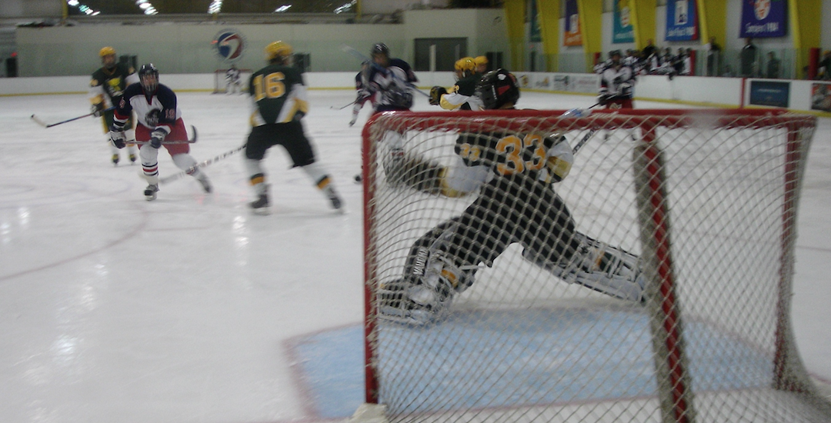
Glove save against RMU. Curt wearing his Rolling Rock “33” jersey.
Face off against RMU. Dan Cox holds the inside with Joe Manning (#96) taking the draw.

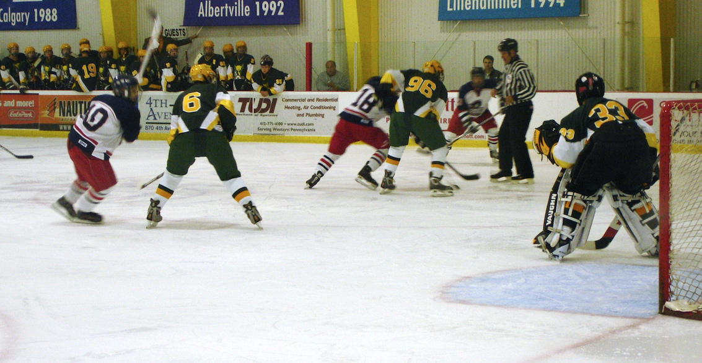

Just say no. Curt stuffs a breakaway.

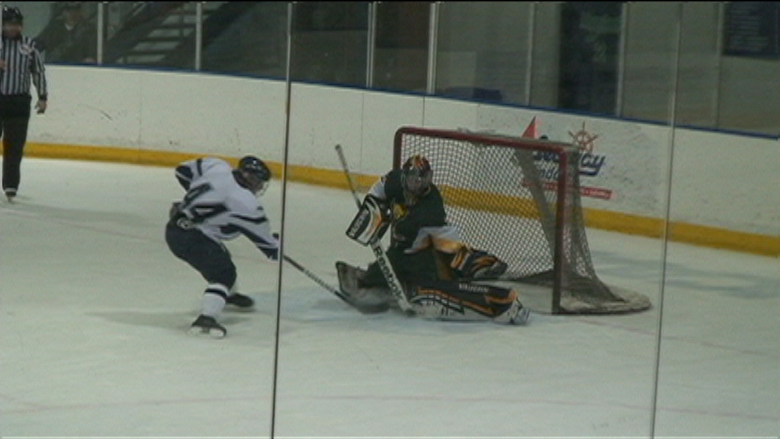

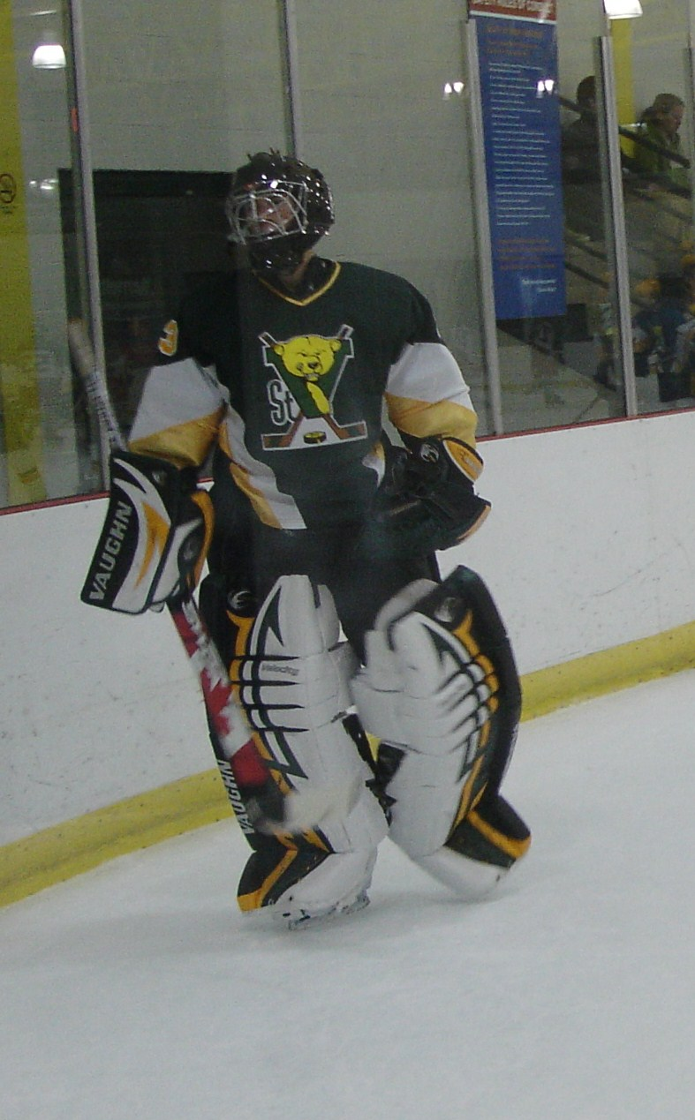
Curt had without a doubt the sharpest matching set of pads in the league and perhaps all of ACHA D III.

