Player Name: | Career Highlights:
Beitel, DJ  C’12 | There may not be as many pictures of DJ as other players, but that is because there were too many video highlights. An intense competitor with perhaps the best hands and goal scoring ability of anyone who has yet played in the school’s history. He had an incredible number of highlight goals against the top teams in ACHA DIII throughout his playing days. It is hard to pick one as more thrilling than the other. Consider, a score while rolling on his back against Alvernia. A breakaway over East Carolina University to win a game late in the third. The famous breakaway score against Pitt Greensburg when he shot the puck with his stick between his legs. During a CHE All Star game skills competition scoring during the penalty shot competition by perfectly executing a La Crosse like move called the Hurricane where he scooped the puck from the ice spun around 360 degrees and threw the puck into the net off the blade of his stick. Or the diving empty score against Robert Morris to seal an SVC win.  DJ would rank as one of the all time greats for the Polarbearcats by scoring alone. But that was only part of his game. He killed penalties, blocked shots without concern, and delivered crushing body checks that by themselves could change a game. If a face needed to be one, it was his responsibility to win it. It was never a good day for opposing teams when #49 showed up at the rink. He wore the “C” as the Captain his senior year. He is only one of three SVC skaters to crack the 200 point mark as he averaged 2 points per game over his career.

Yr | # | Pos | GP | G | A | TP | S | Pct | + | - | +/- | PM | W | T | P | S
0708 | 49 | C | 19 | 11 | 15 | 26 | 78 | 14.1 | 26 | 30 | -4 | 49 | 1 | 0 | 3 | 0
0809 | 49 | C | 19 | 20 | 23 | 43 | 108 | 18.5 | 33 | 17 | +16 | 51 | 0 | 0 | 7 | 1
0910 | 49 | C | 21 | 22 | 26 | 48 | 140 | 15.7 | 32 | 22 | +10 | 70 | 3 | 0 | 8 | 0
1011 | 49 | C | 20 | 23 | 16 | 39 | 108 | 21.3 | 27 | 28 | -1 | 61 | 1 | 0 | 5 | 3
1112 | 49 | C | 21 | 19 | 25 | 44 | 140 | 13.6 | 35 | 33 | +2 | 62 | 3 | 0 | 4 | 2
Totals |  |  | 100 | 95 | 105 | 200 | 574 | 16.6 | 153 | 130 | +23 | 293 | 8 | 0 | 27 | 6

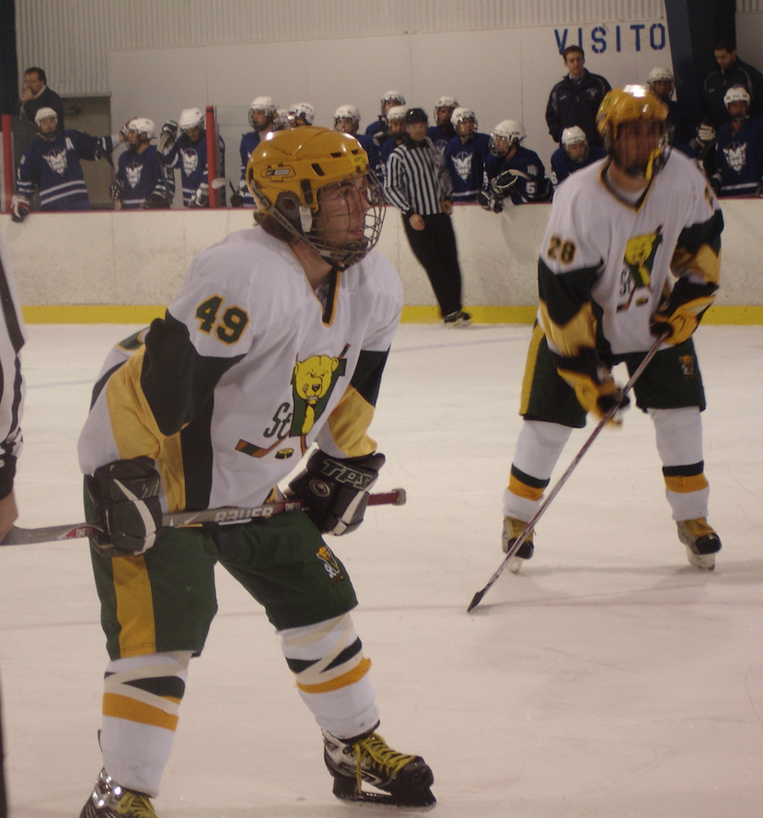
Opening face off with winger Mario Saird against Fredonia State.

There was nowhere on the ice where DJ could not turn a play. He makes a centering pass from behind the Penn State Behrend net.

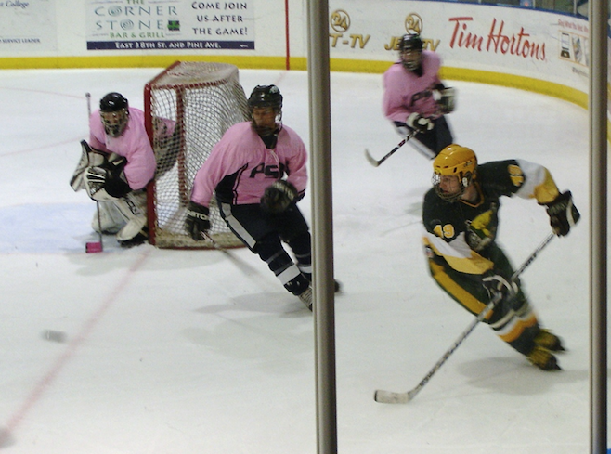

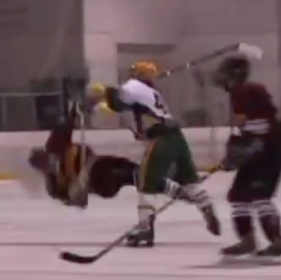
One of hundreds of heavy checks thrown by DJ.

This was never a good sign for a defenseman. Once DJ got low on his edges with his stick fully extended, he used his arm to ward off the opposing player, and was able to curl in for a shot on goal.

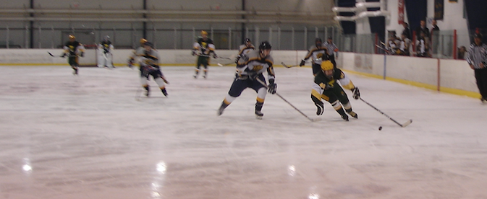

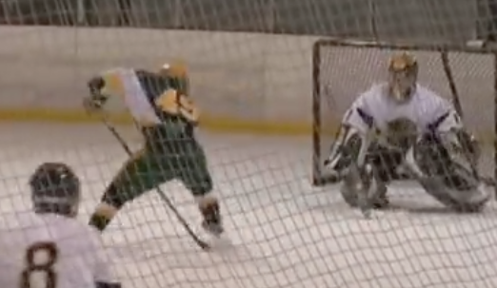
Incredible goal is seen in this two frame sequence. Notice the stick backwards and between DJ’s legs.
The outcome. Notice the puck going into the net as DJ’s stick is still between his legs. This was not an accident. It was a planned move on a breakaway!

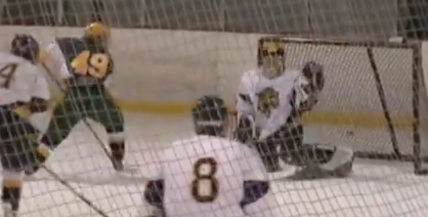

Use this link to watch how he did it!

https://www.youtube.com/watch?v=pgJaT_E2tes

